**INDEX**

|  |  |
| --- | --- |
| **S.NO** | **Topic** |
| **1** | **Creation of Dimensions and Fact tables.** |
| **2** | **Create Data Source using SSAS  (SQL Server Analysis Services.)** |
| **3** | **Create Data Source View using SSAS (SQL Server Analysis Services.)** |
| **4** | **Create cube using SSAS (SQL Server Analysis Services.) and process the cube.** |
| **5** | **View cube data in multidimensional Format.(Excel Pivot Chart.)** |
| **6** | **Working with measures in the cube.** |
| **7** | **Creating an Excel Pivot Table and Pivot Chart by using the OLAP cube data.** |
| **8** | **Firing Queries on Tables.** |
| **9** | **Data Preprocessing** |
| **10** | **Data Discretization** |
| **11** | **Classification Problems** |
| **12** | **Clustering Analysis** |
| **13** | **Association Rule Mining** |

**Practical No 1**

**Aim:** Creation of Dimensions and Fact tables.

**Solution:**

Open Application -> Microsoft SQL Server 2008 R2 -> SQL Server

Management Studio

1. Select Connect Tab -> Database Engine -> Select Server Name(local)

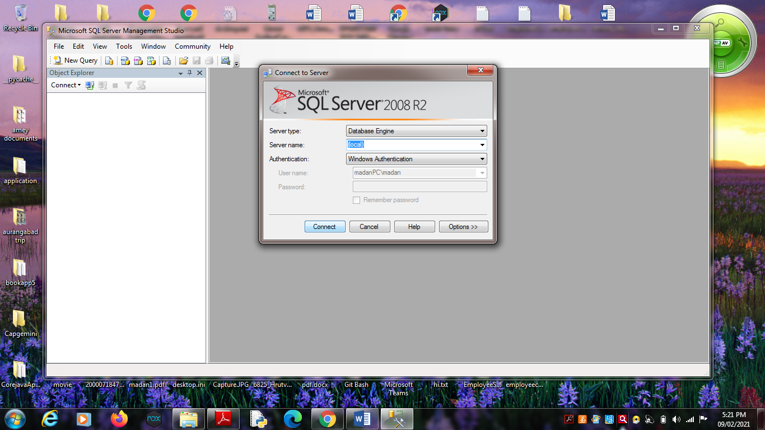

2. Right Click the Database -> New Database

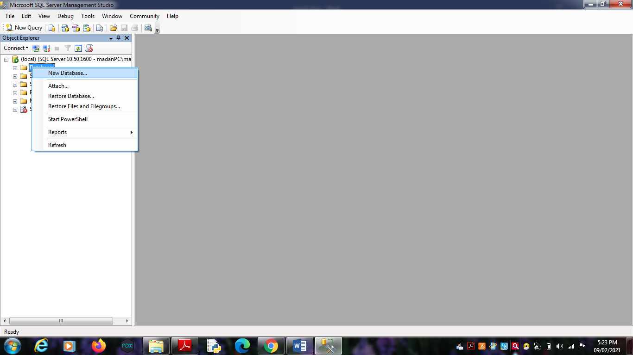

3. Types “SalesProduct” as the database name, click on OK to close the

dialog box and to create the database.

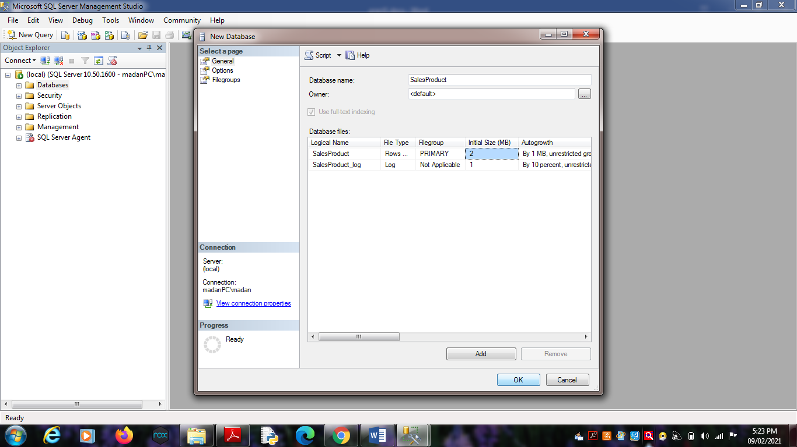

**Create a Database Diagrams**

Expand the “SalesProduct” database folder.

1. Click on Database Diagrams to expand it

On click of it, above Dialog box appears, click on Yes to close it.

2. Right Click on Database Diagrams -> New Database Diagrams

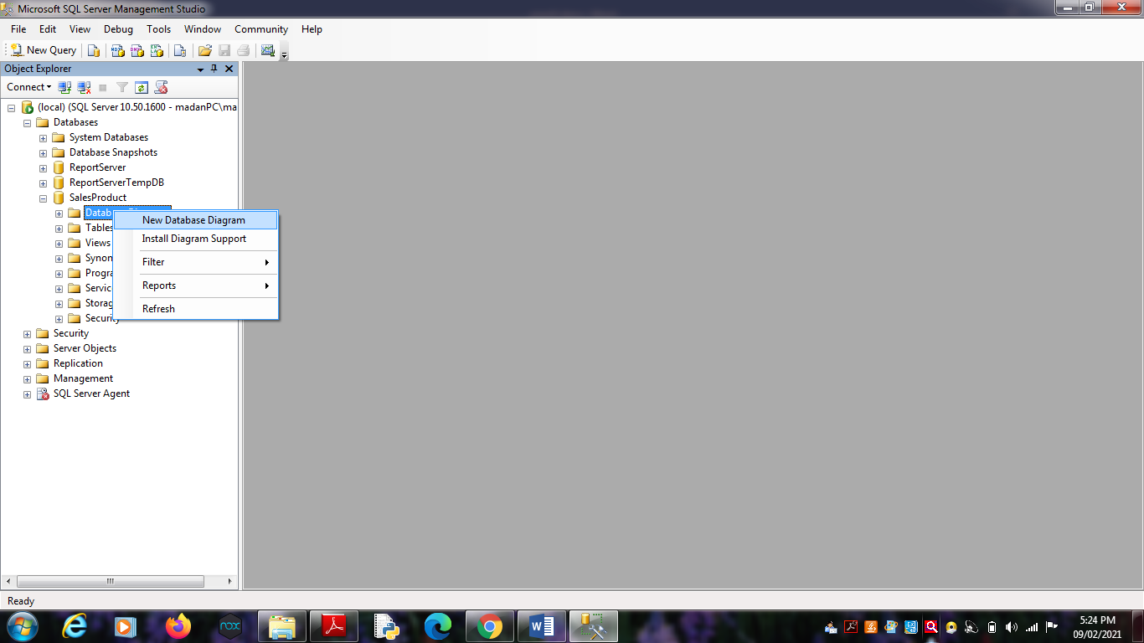 3. Create fact and Dimension Tables. (Right click on surface, choose

New Table to add tables on Database Diagrams.)

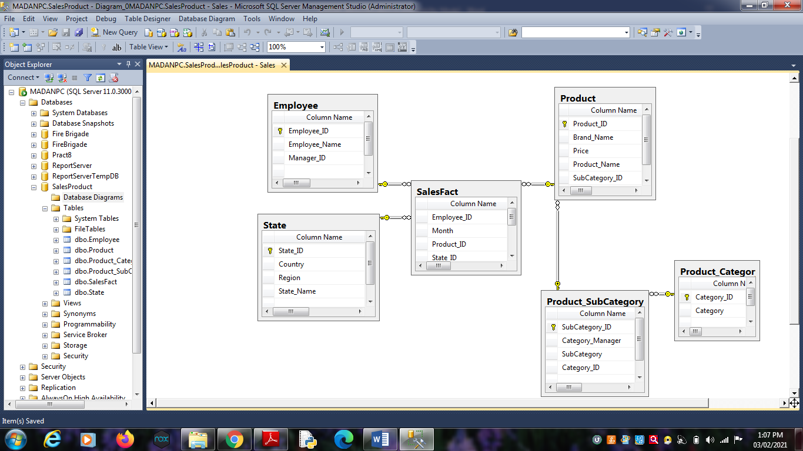

4. Establish relationship between fact and dimension tables.

5. Save Database Diagrams with name as “Sales”. (After saving

Database Diagrams fact and dimension tables are automatically

placed in Table tab.)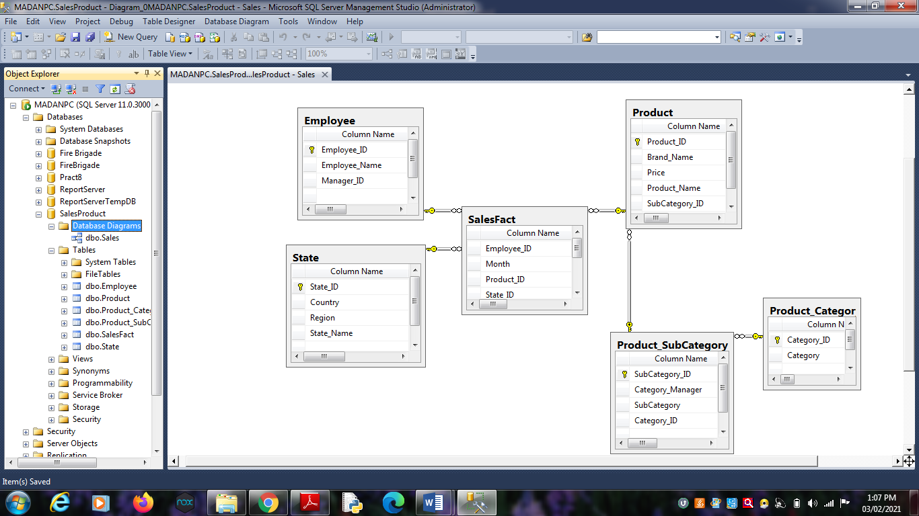

**Practical No 2**

**Aim:** Create Data Source using SSAS(SQL Server Analysis Services.)

**Solution:**

Open Application -> Microsoft SQL Server 2008 R2 -> SQL Server

Business Intelligence Development Studio

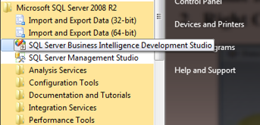

1. Select File -> New Project -> Choose Analysis Service Project ->

Name it as “SalesProduct_BIPrj” and click on OK.

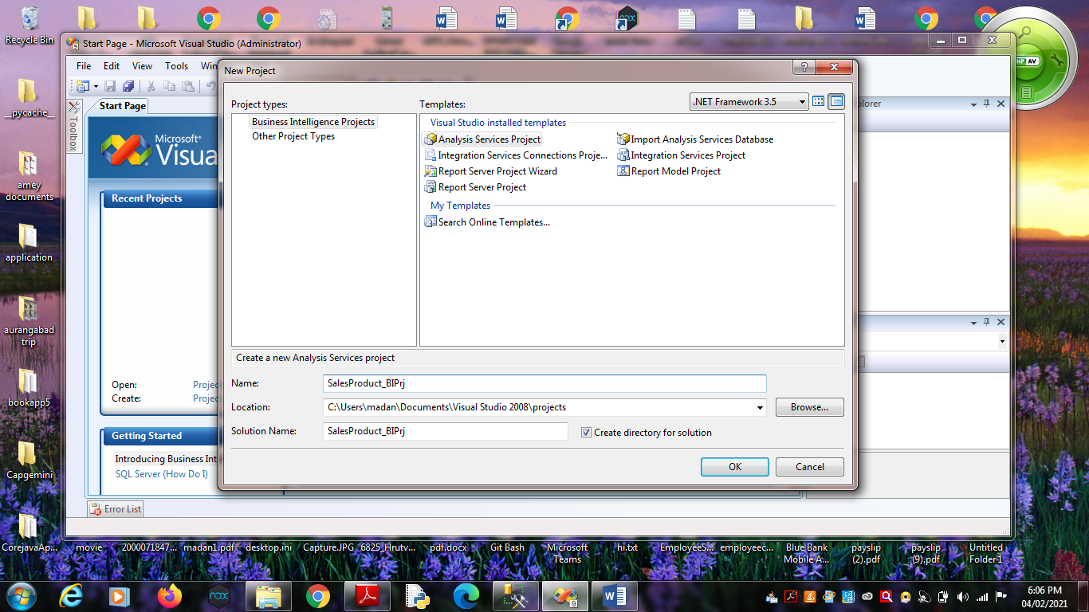

2. Right Click on Data Sources -> New Data Source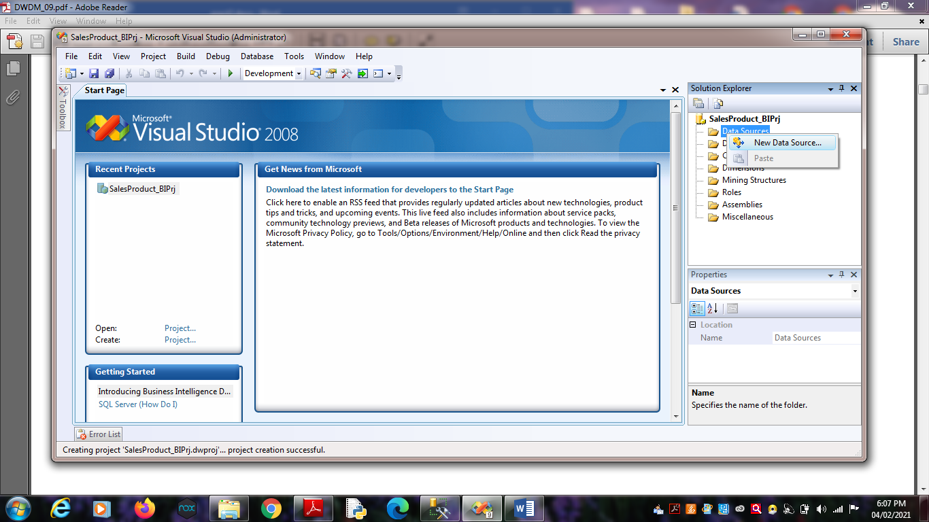

Click on Next.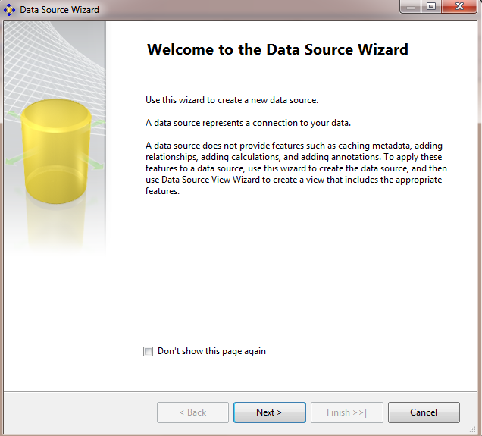

3. Choose Provider as “Microsoft OLEDB Provider for SQL Server” ,

Server Name as “.”, Select database name as

“SalesProduct”.(Created in SQL Server Management studio).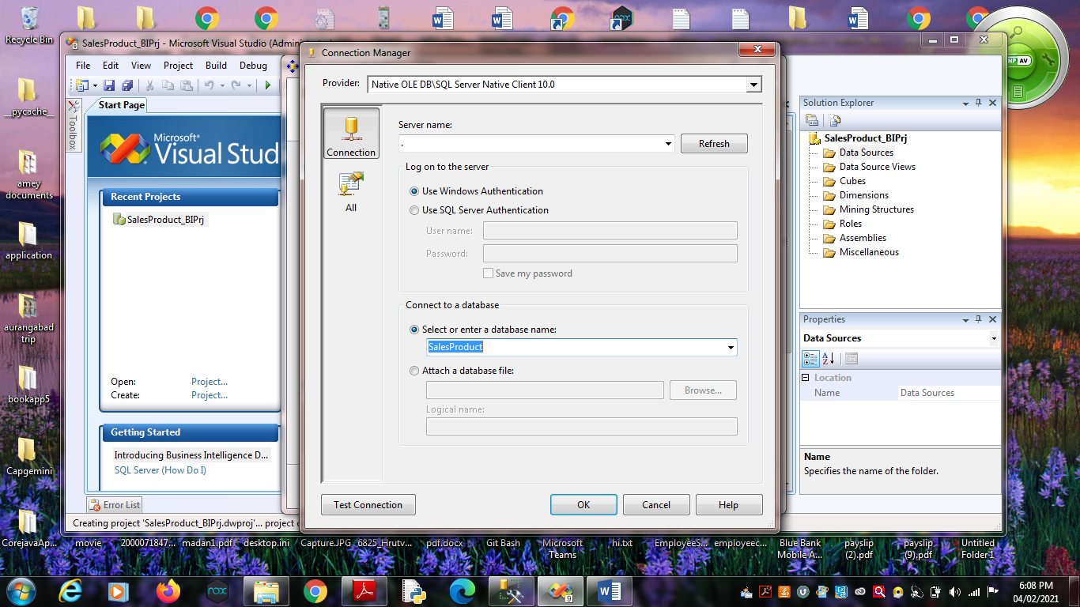

Click on Next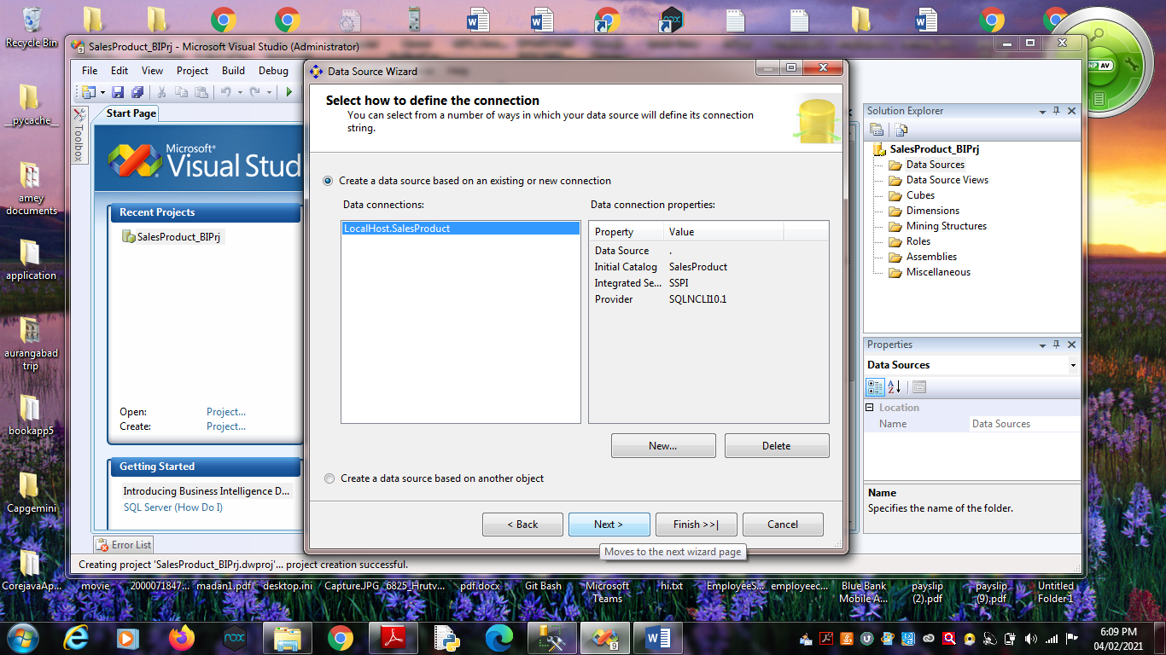5. Choose “Inherit” option.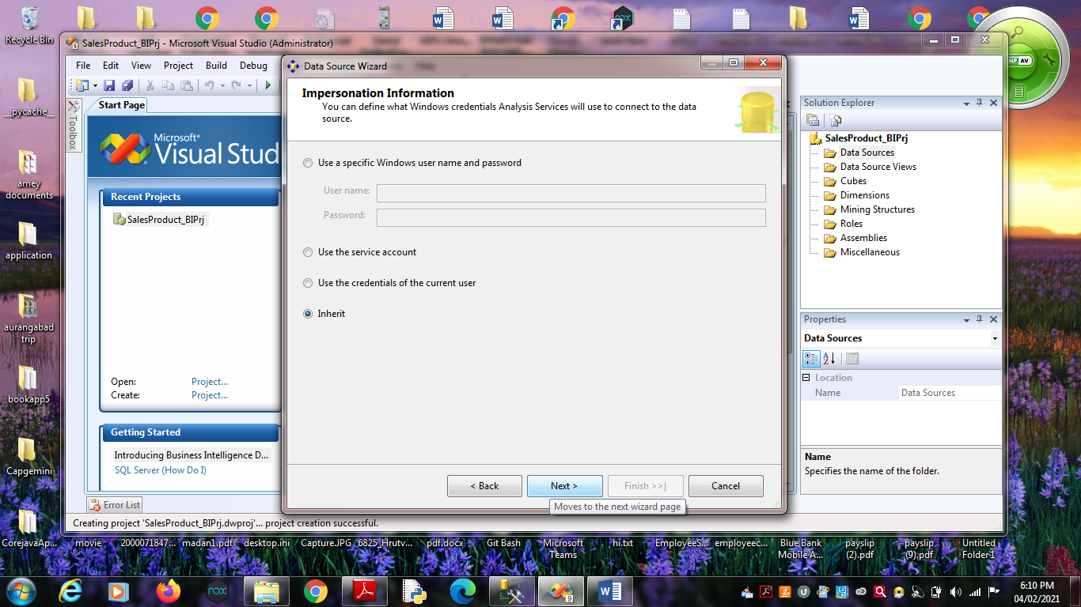 Click on Next.

6. Click on Finish.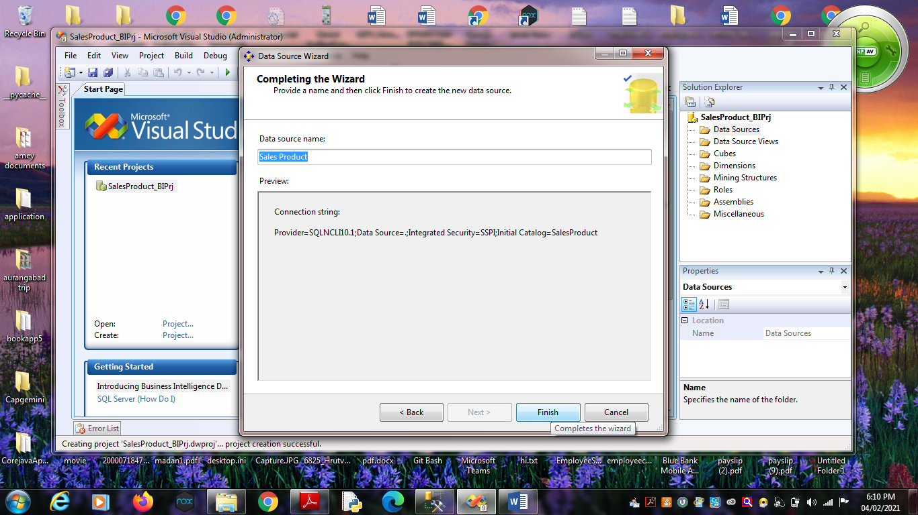

Name Data Source as “Sales Product”.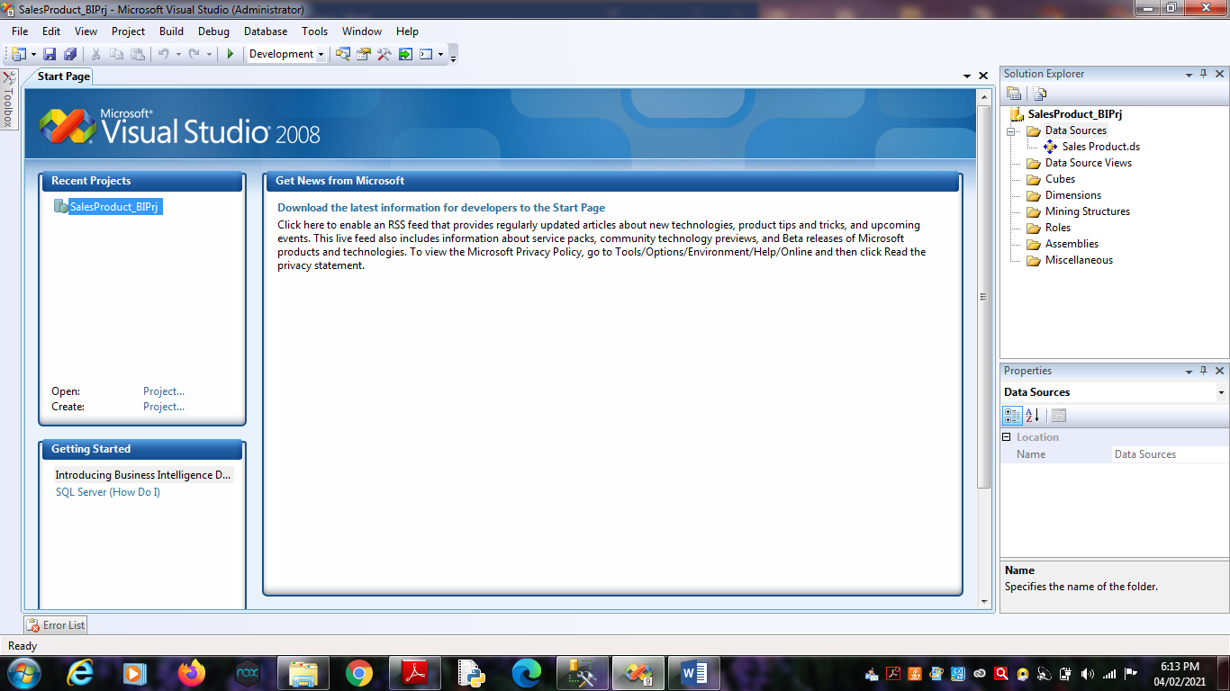

**Practical No 3**

**Aim:** Create Data Source View using SSAS(SQL Server Analysis

Services.)

**Solution:**

1. Right click on Data Source View -> New Data Source View

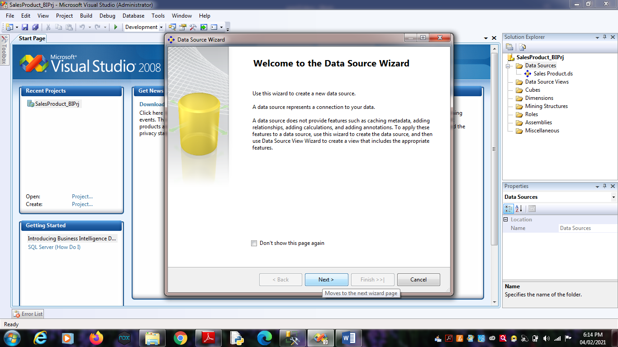Click on Next.

2. Click on Next.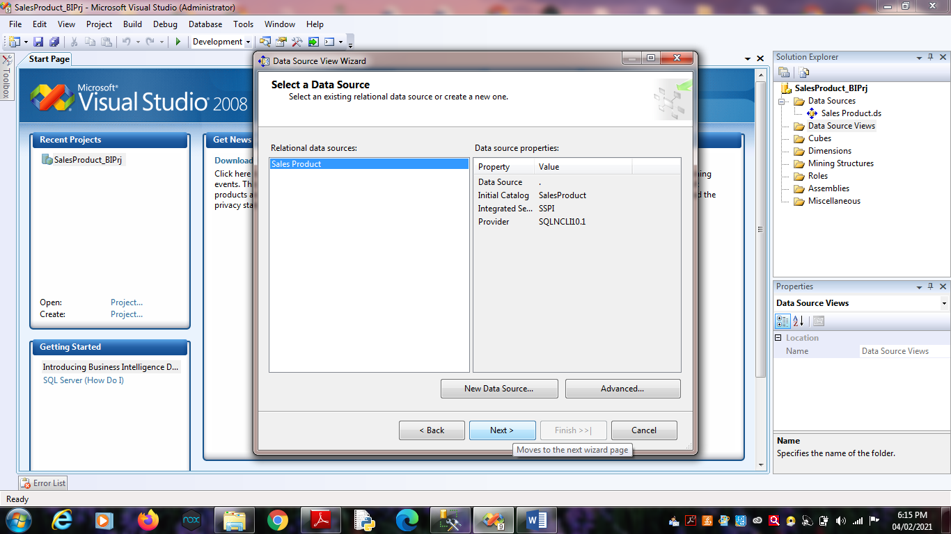

3. Select Tables and Views.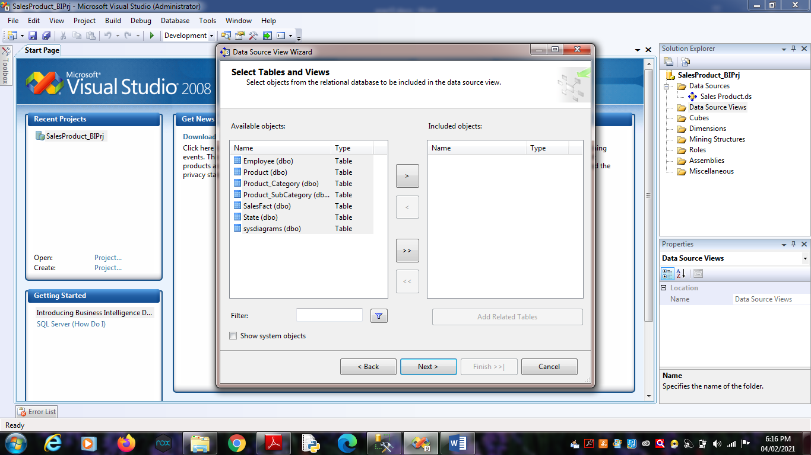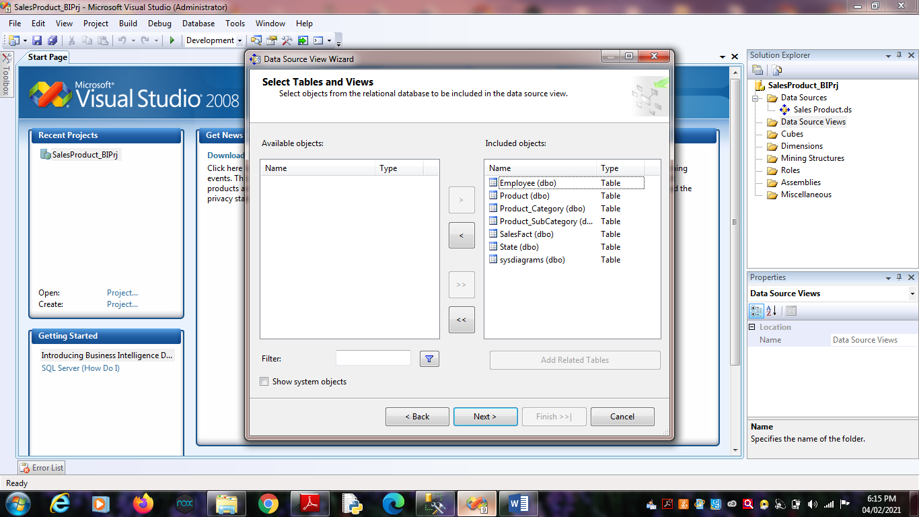 Click on Finish.

4. Finally, we will get the Data Source View like :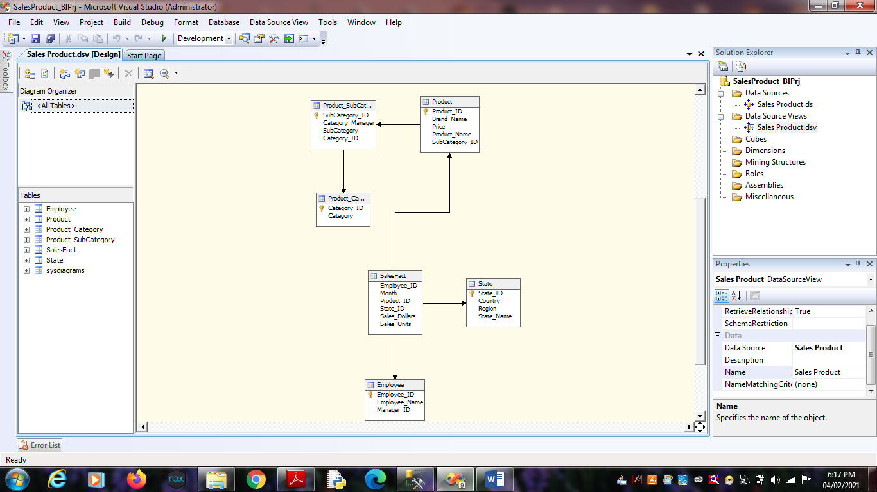

**Practical No 4**

**Aim**: Create cube using SSAS(SQL Server Analysis Services.) and process

the cube.

**Solution:**

1. Right click on Cubes -> New Cube.

Click on

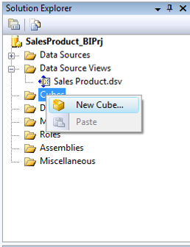

Click on Next.

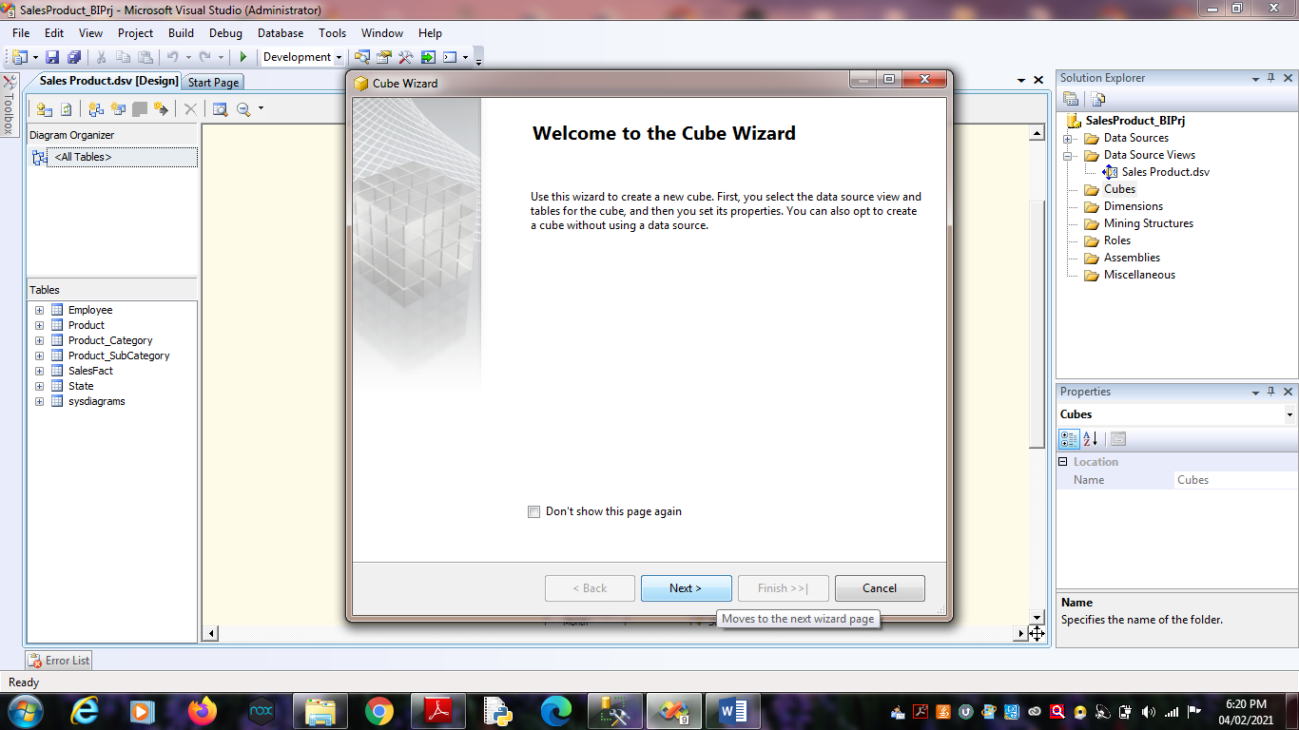

2. Select First option “Use existing tables”. Click on Next.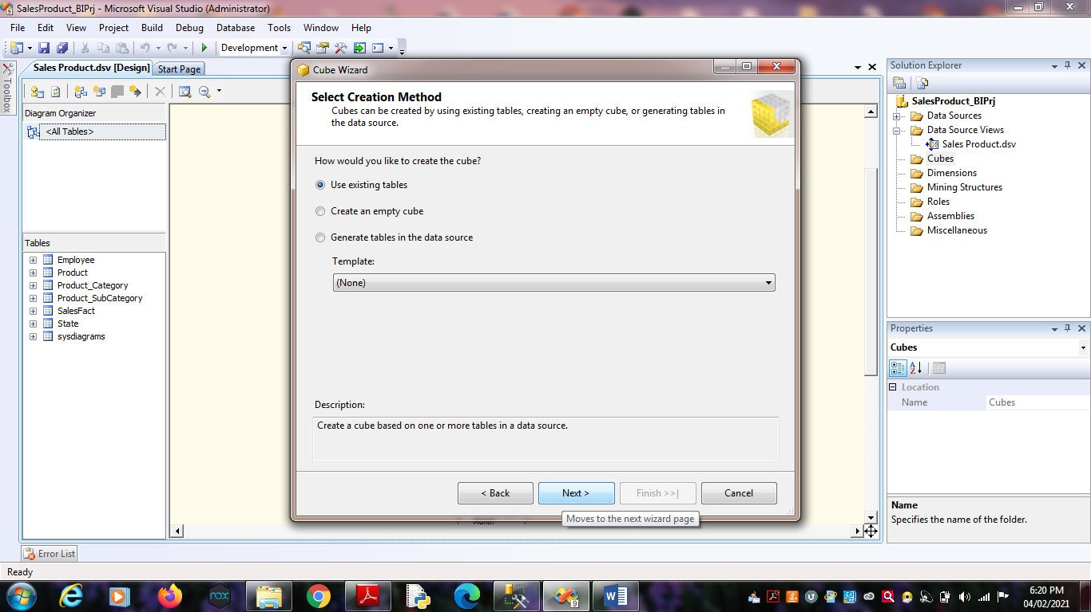

3. Select Data Source View as “Sales Product” and Select all the tables.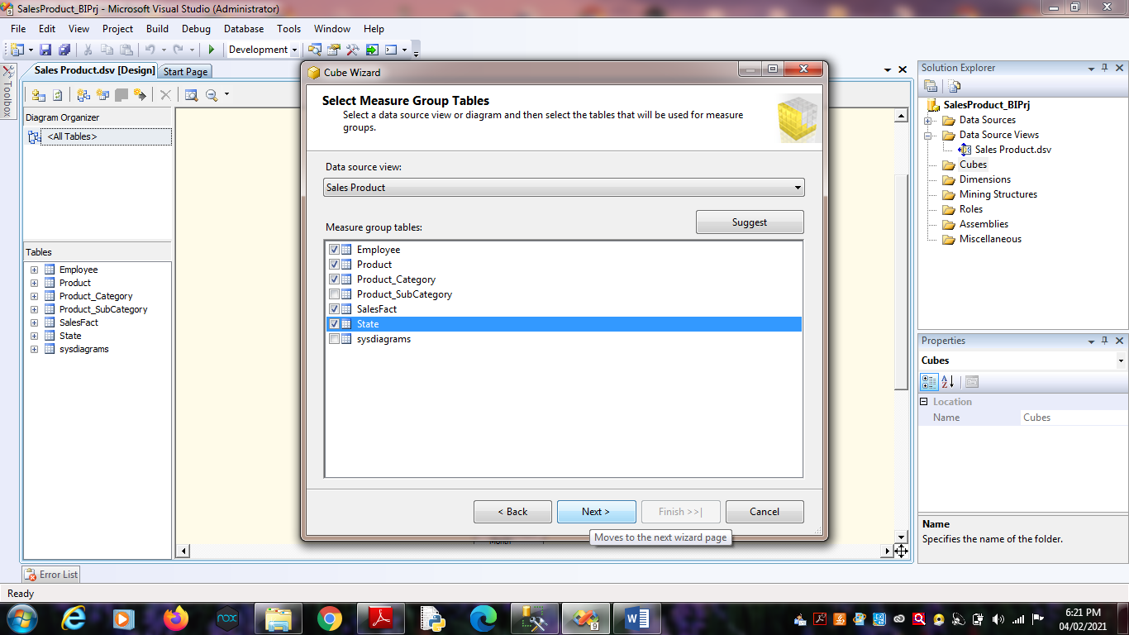

Click on Next.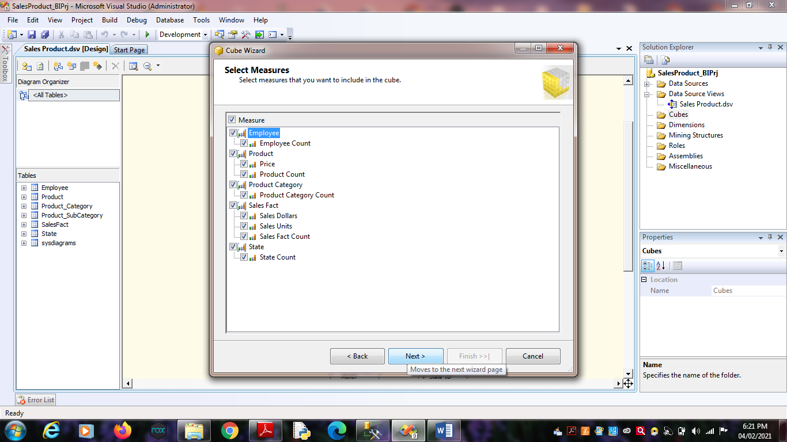 Click on Next.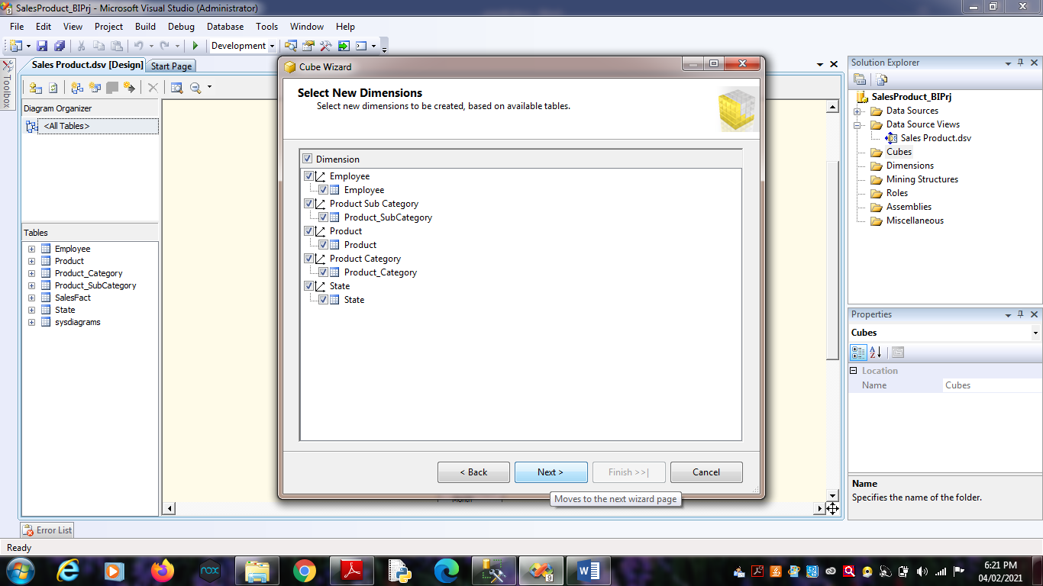 Click on Next.

4. Name Cube as “SalesCube”.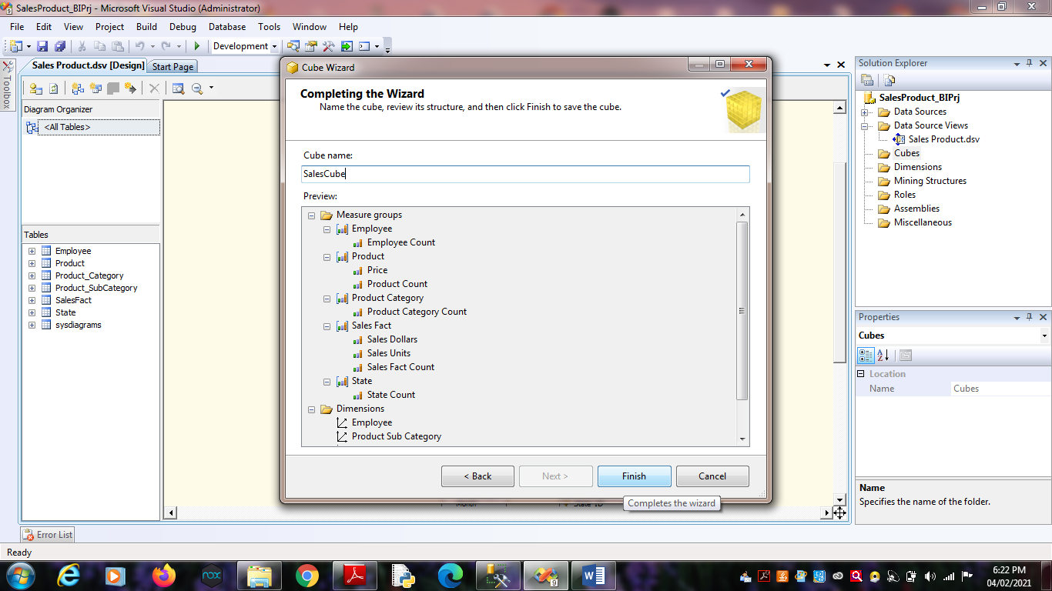

Click on Finish.

5. Finally, we will get the Cube View as well Dimensions View like :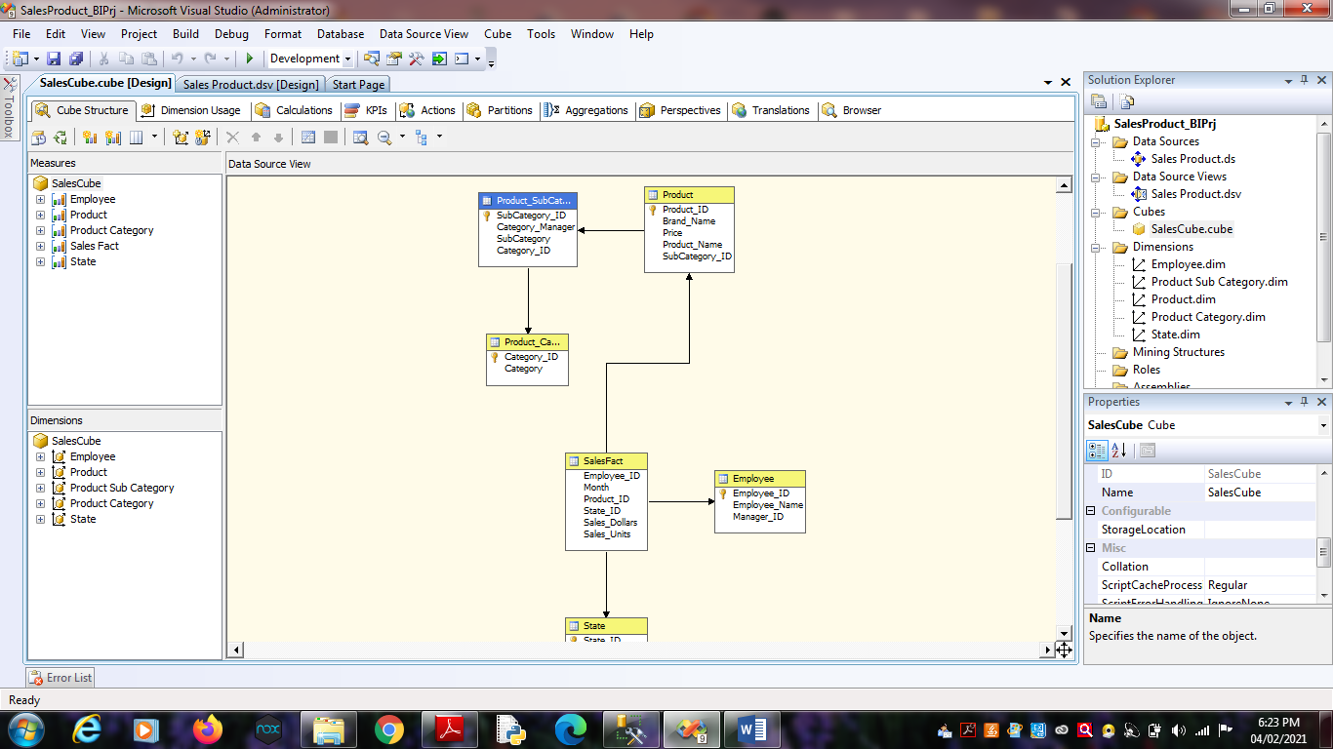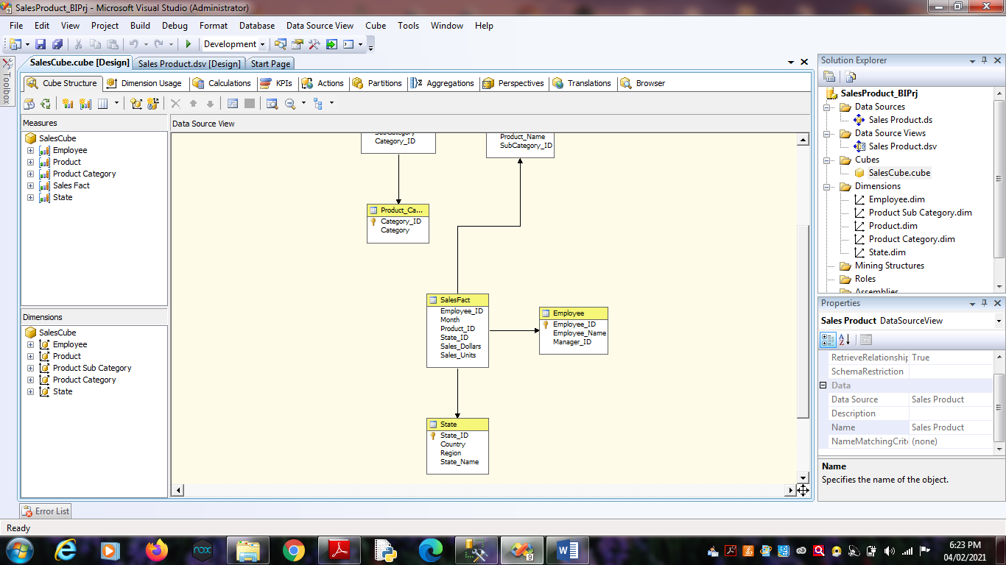

6. Finally, Process cube by Right click on SalesCube -> Process .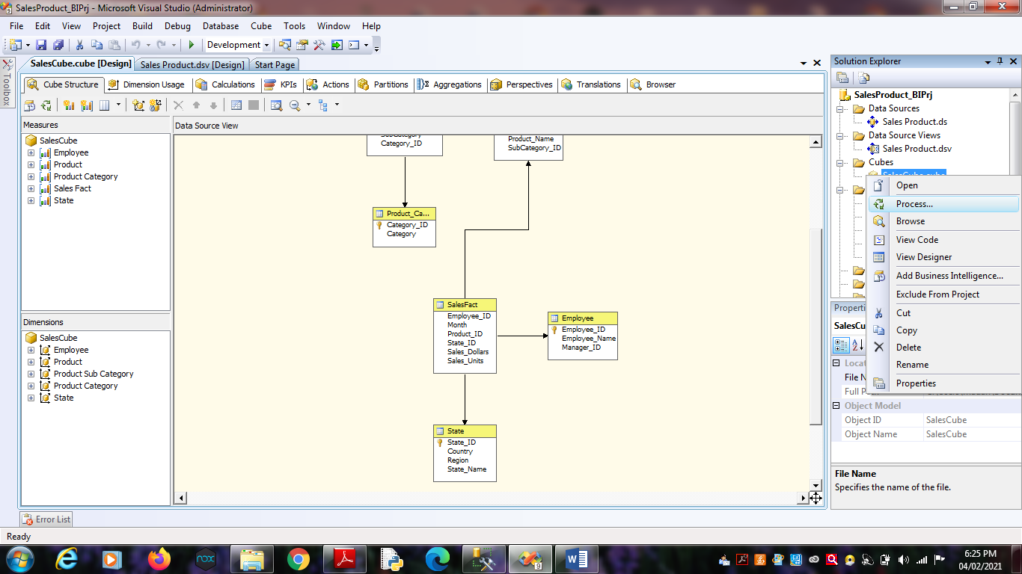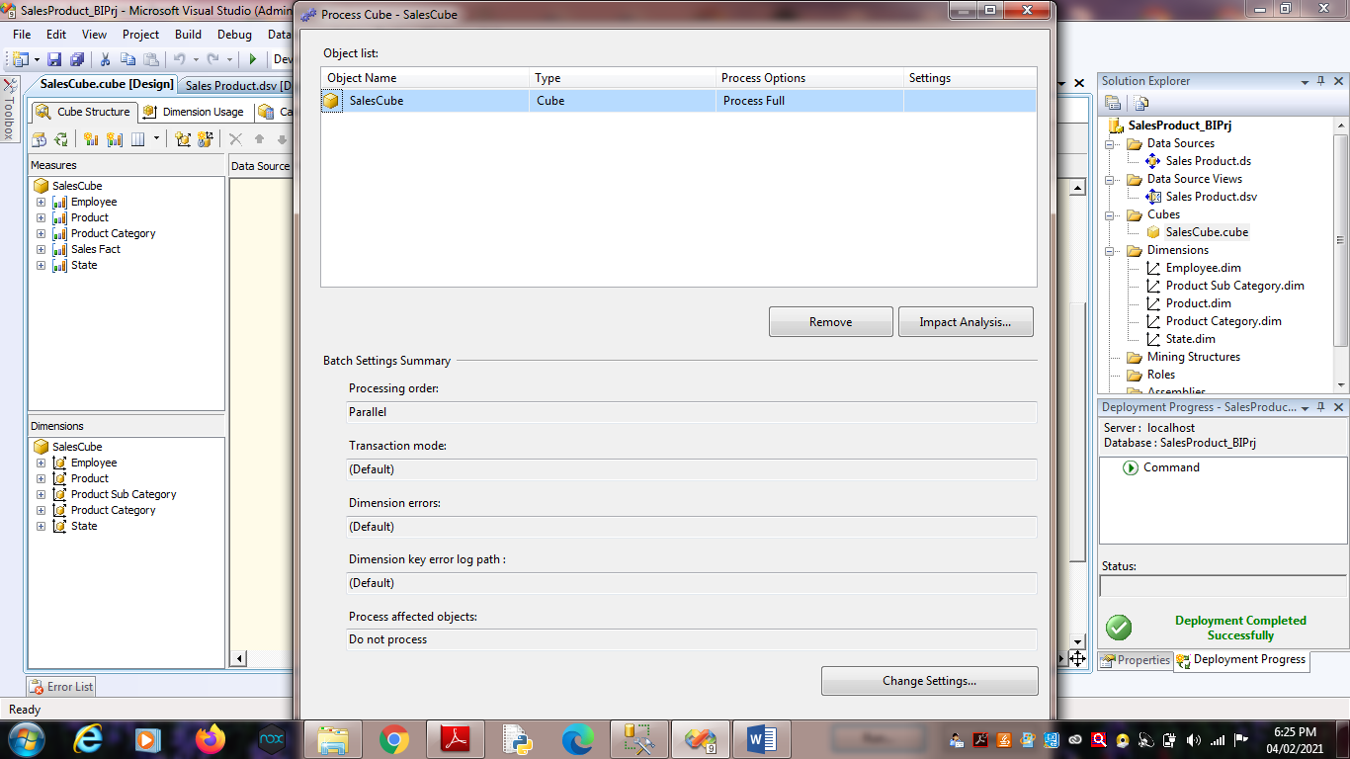

7. Click on Run.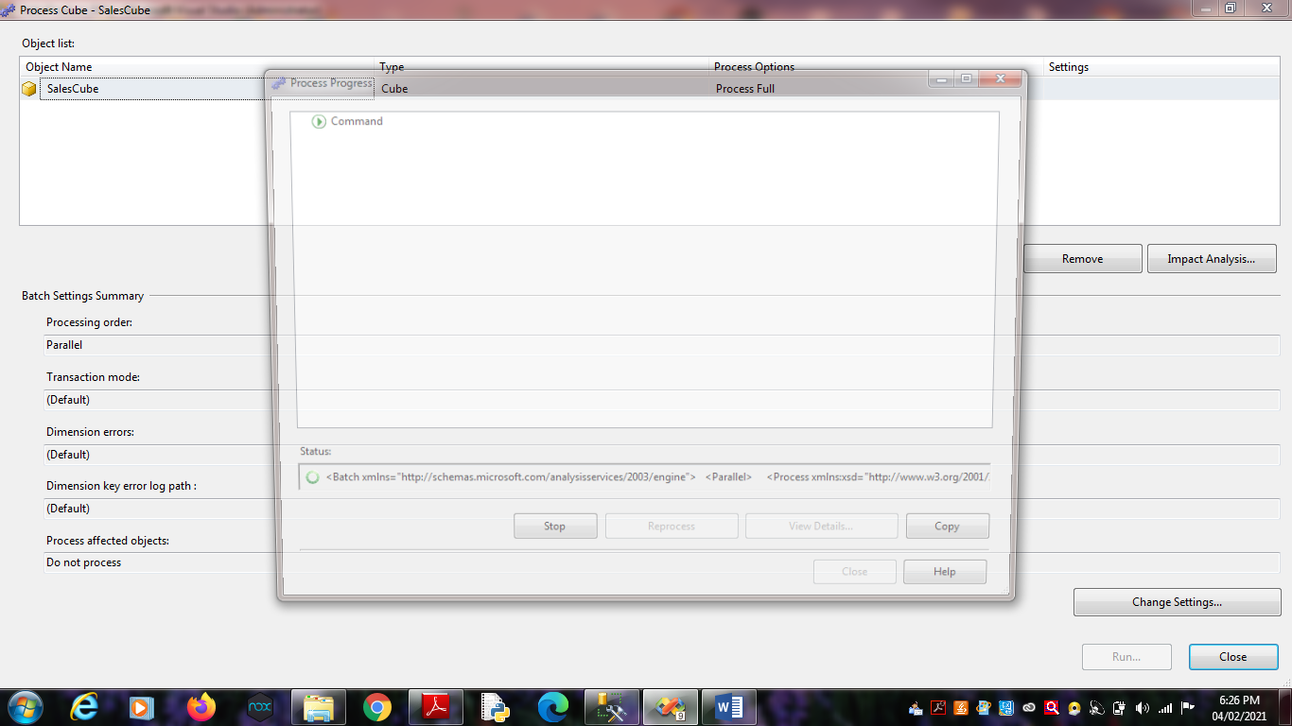

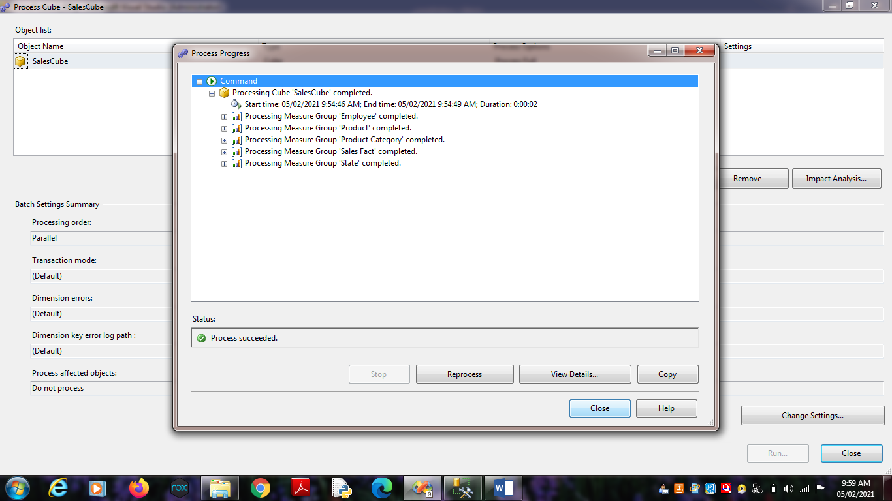

**Practical No 5**

**Aim:** View cube data in multidimensional Format.

**Solution:**

1. Double Click on “SalesCube”. Go to the “Browser” Tab.

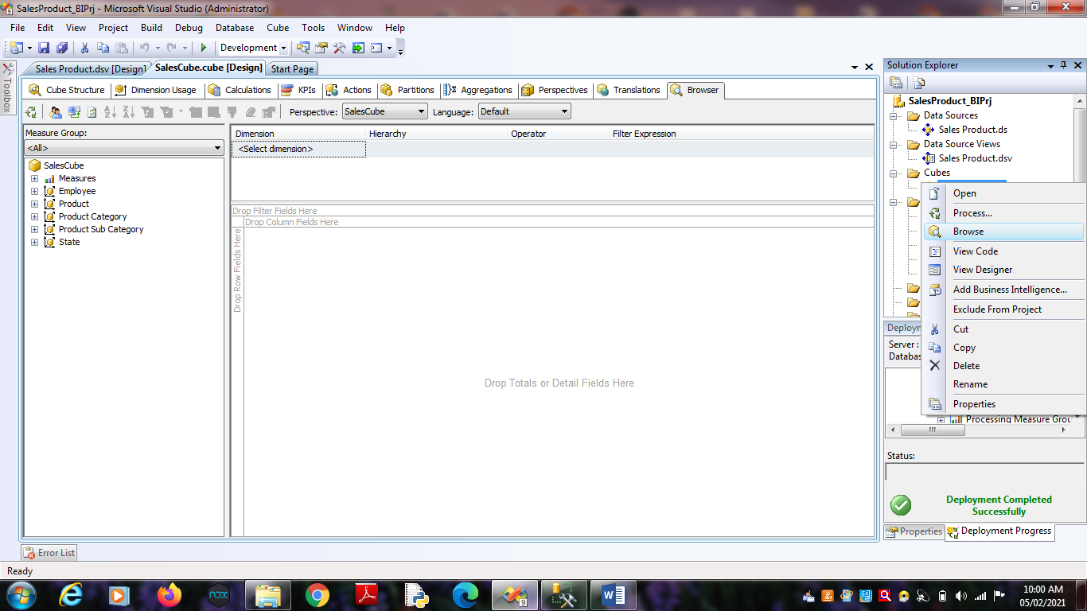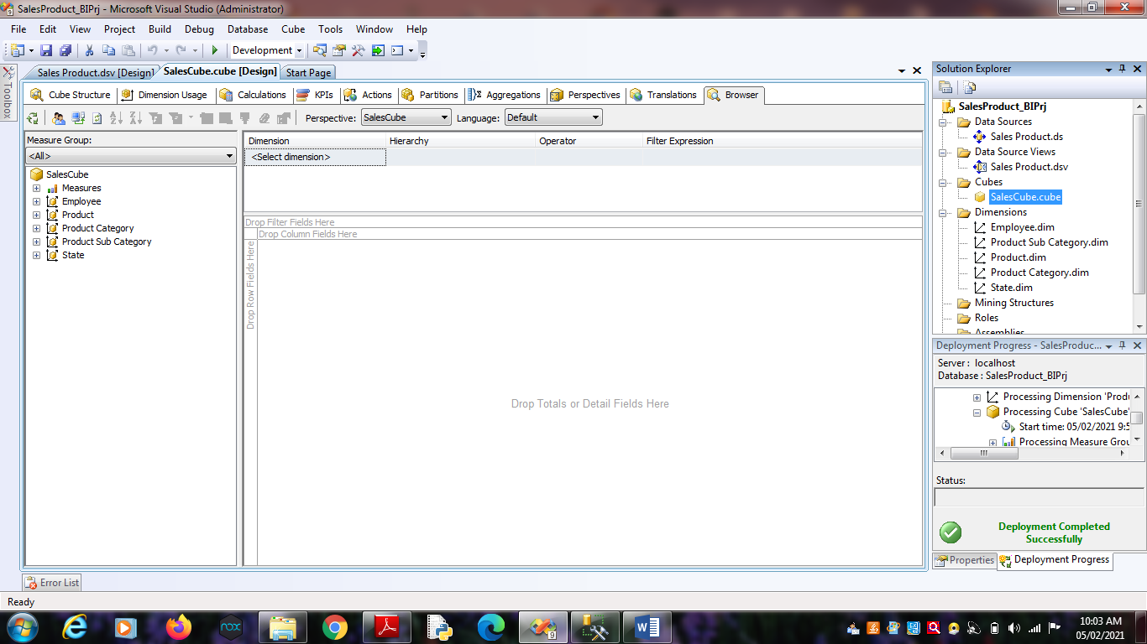2. Go to the “State Dimension”. Right Click on ‘State_ID’ -> Add to

Row Area.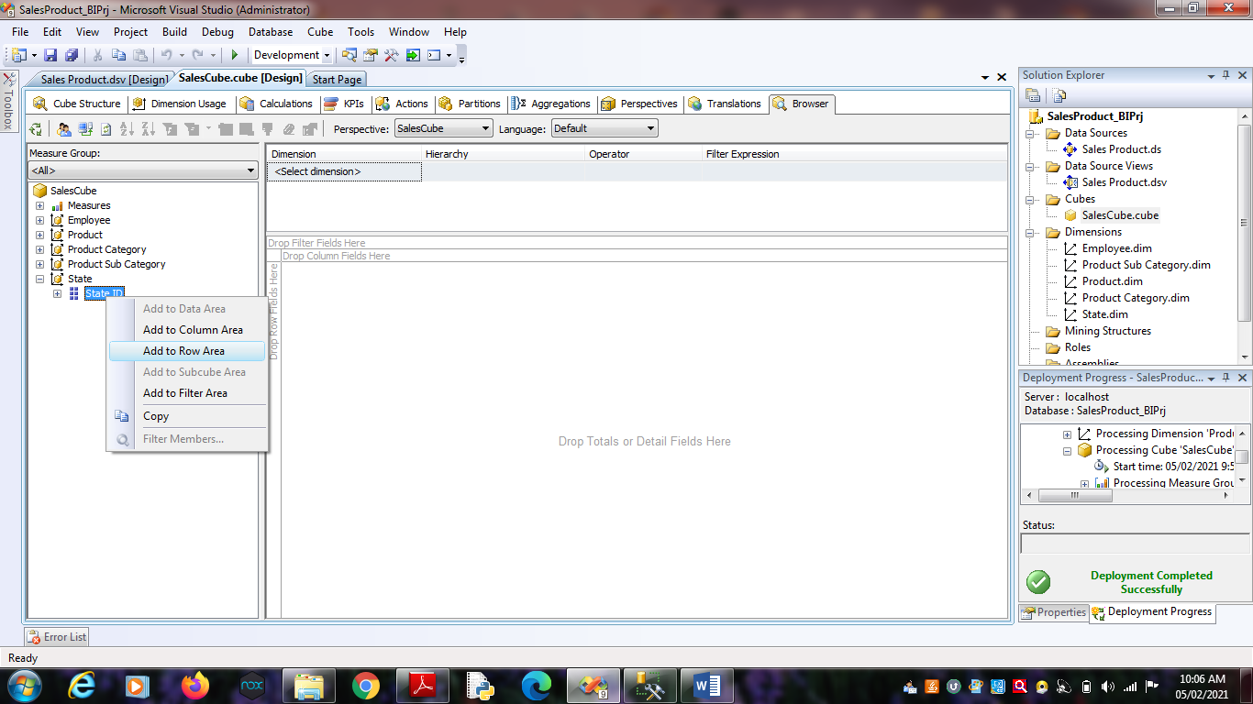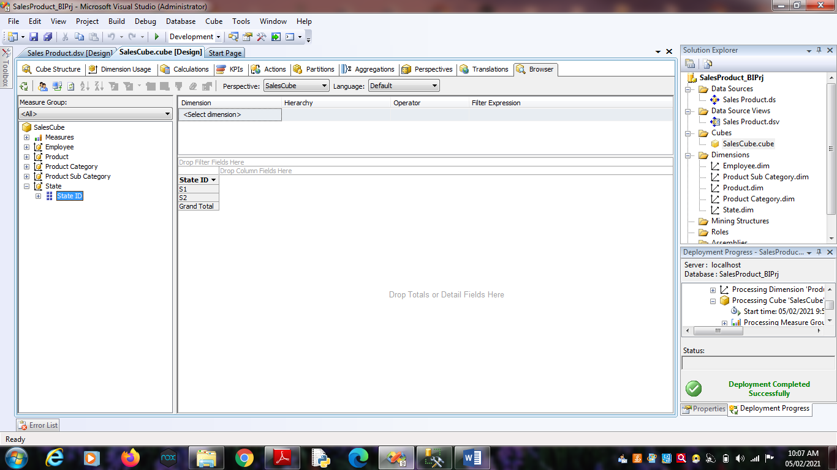 3. Go to the “Product Dimension”. Right Click on ‘Product_ID’ -> Add

to Column Area.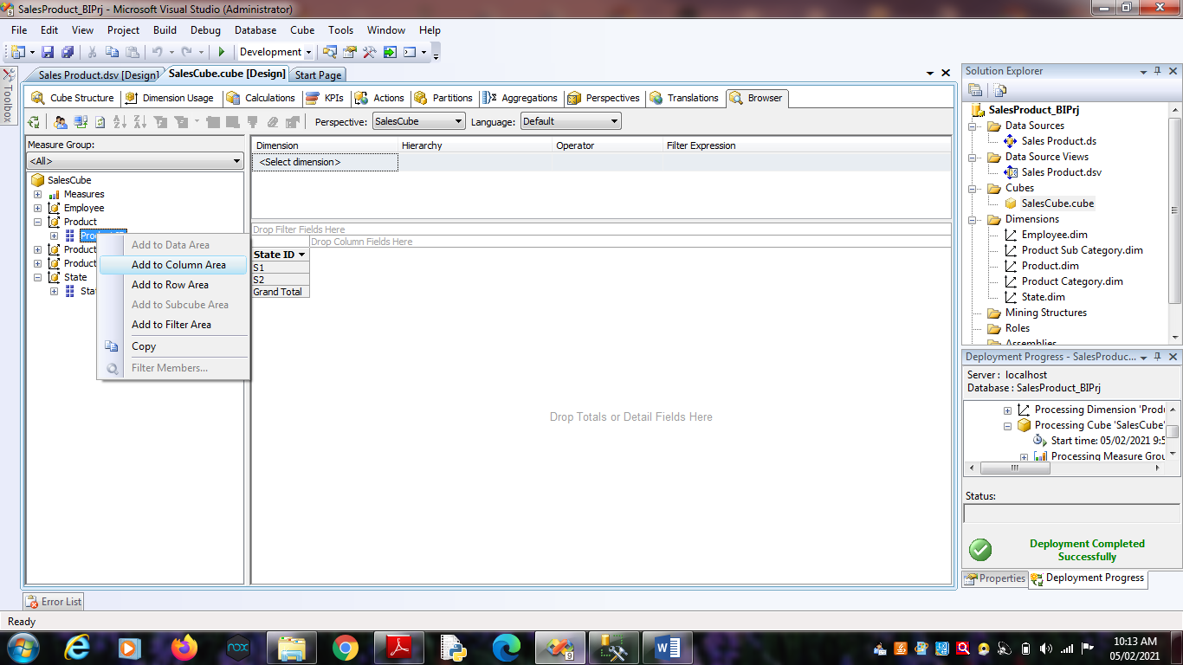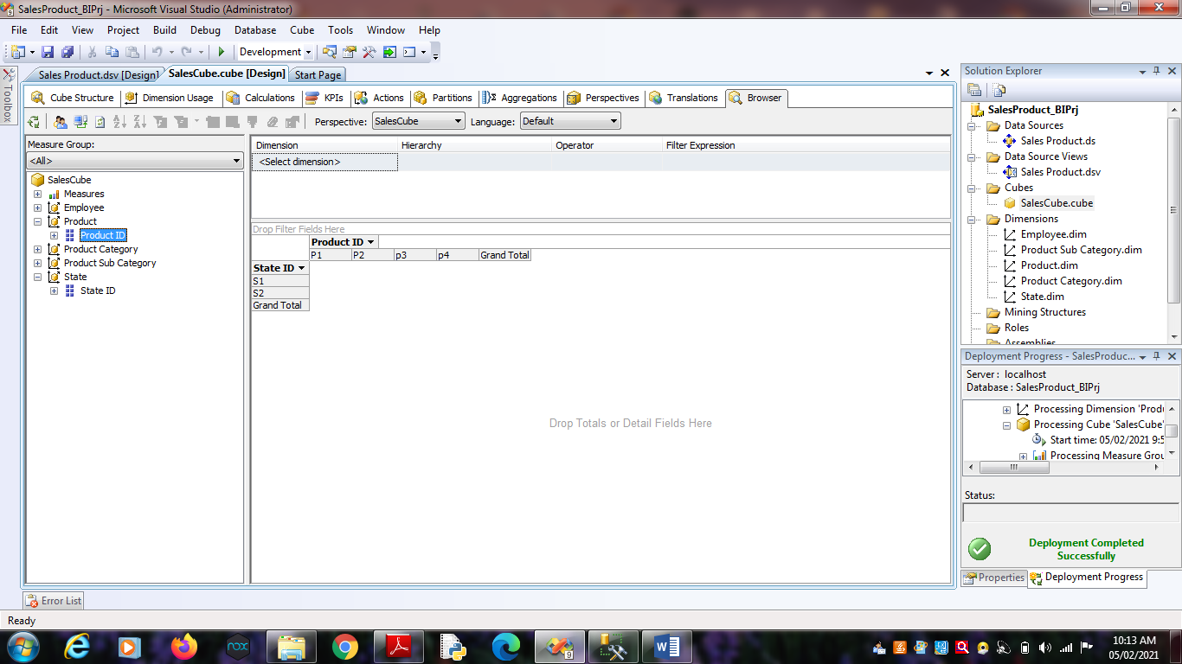 4. Go to ‘Measures’. Select ‘SalesFact’ -> Right Click on “Sales

Dollars” as well “Sales Units” -> Add to Data area.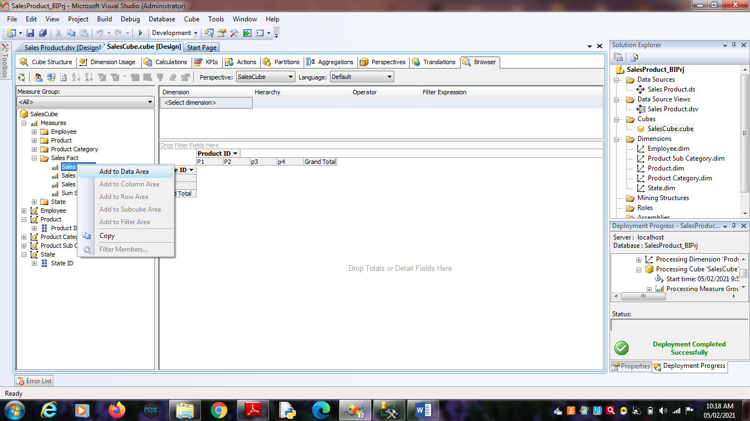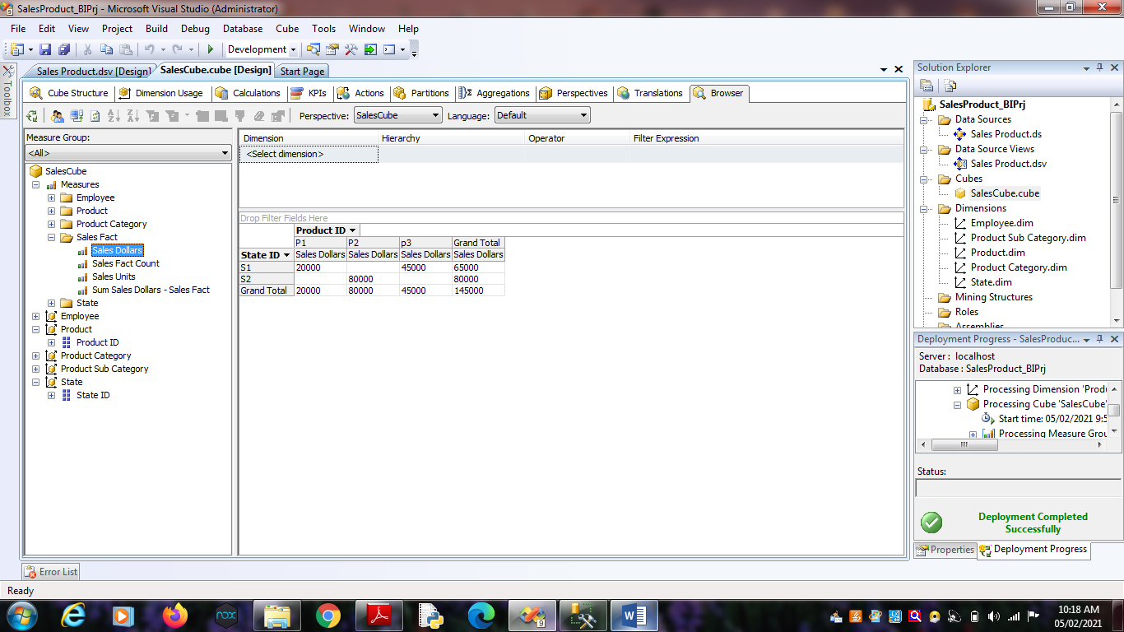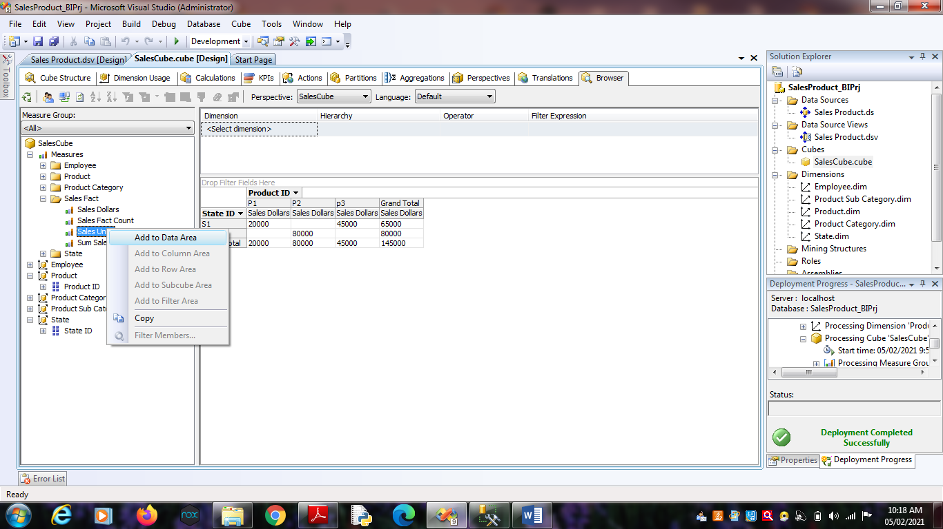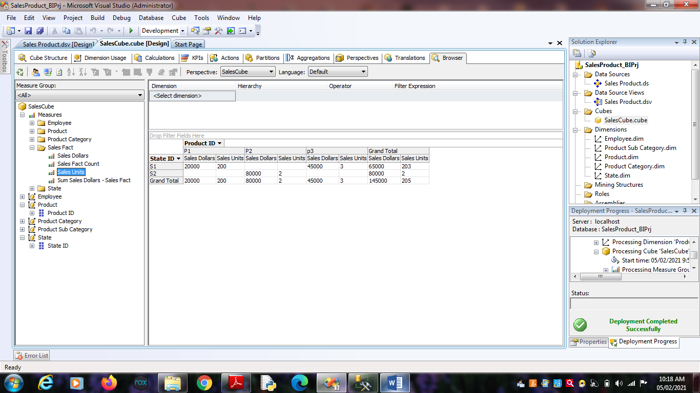 5. Go to the “Employee Dimension”. Right Click on ‘Employee_ID’ ->

Add to Row Area.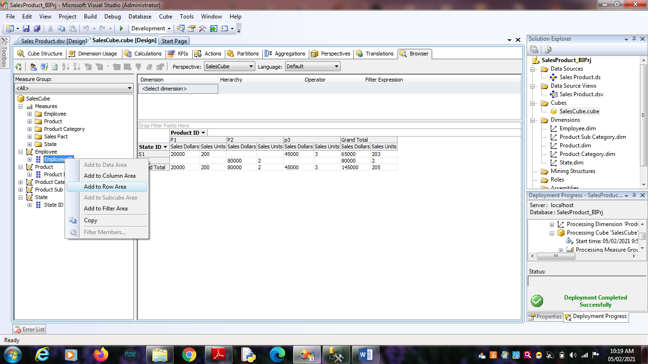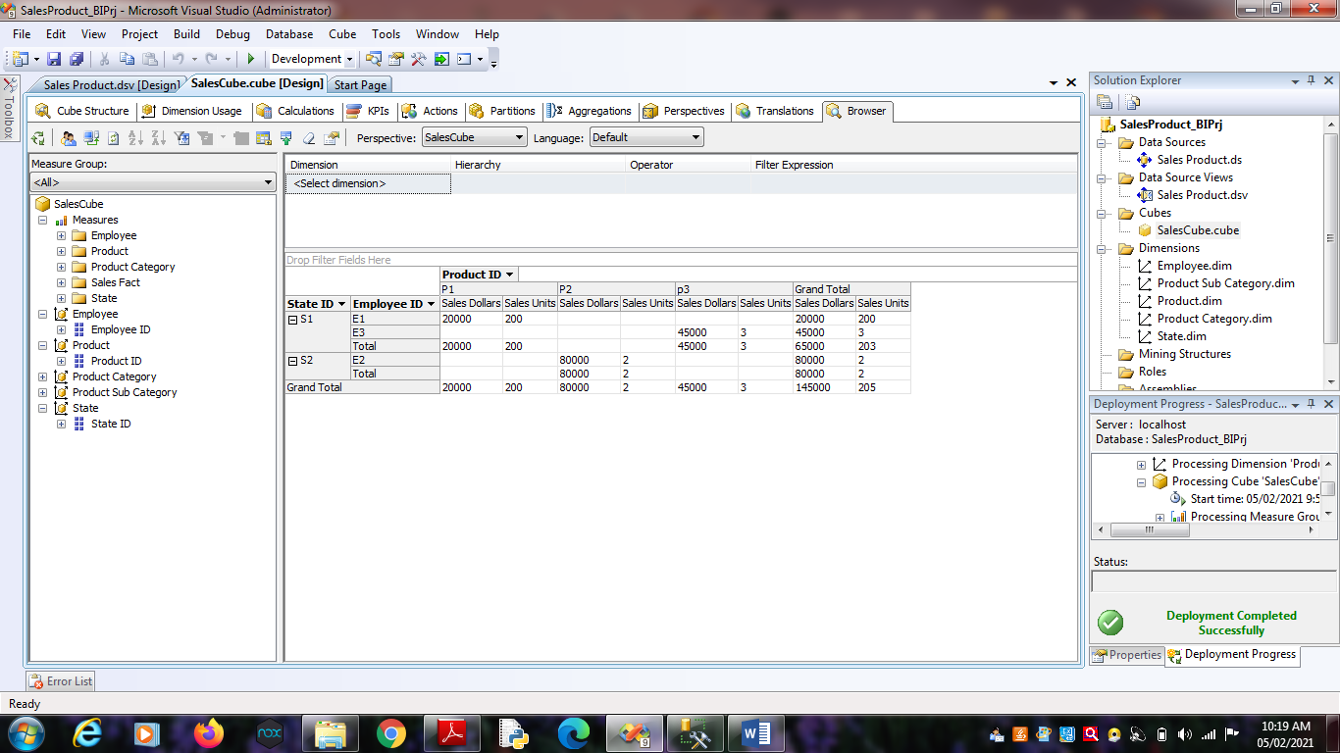

**Practical No 6**

**Aim :** Working with measures in the cube.

**Solution :**

1. Double click on ‘SalesCube’. Go to cube structure.

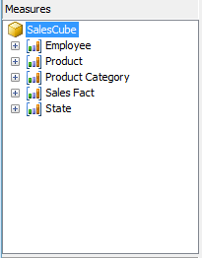

2. Right click on SalesCube -> New Measure.

Select Usage = “Sum” , Source table = “SalesFact” and Source

Column = “Sales_Dollars”.

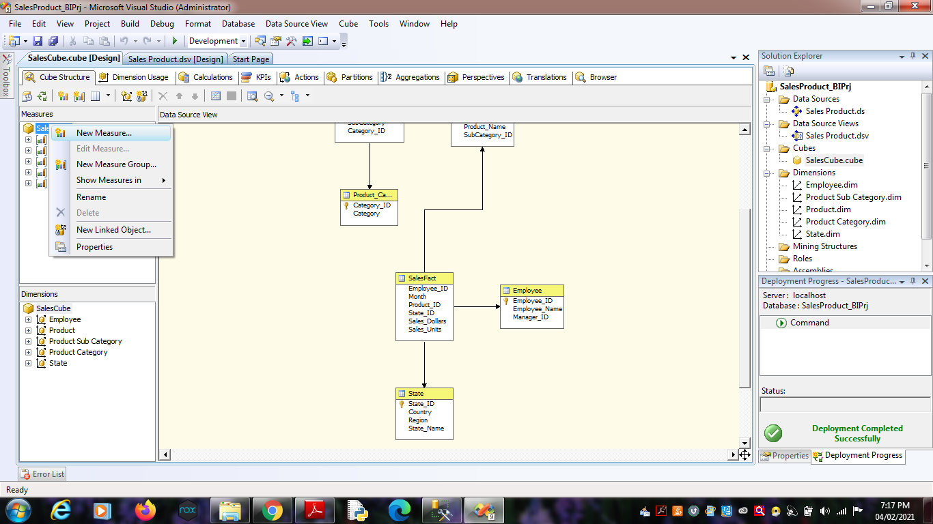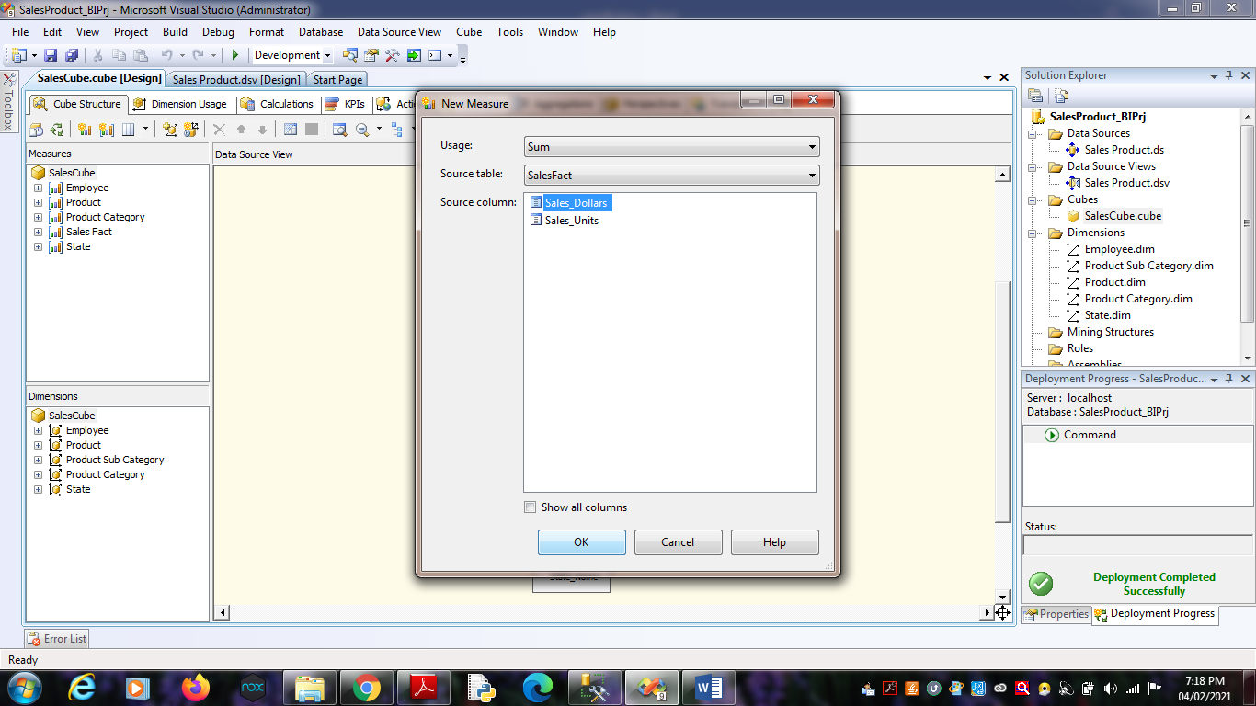Click on OK.

4. Process Cube and Go to Browser and Reconnect it. Right Click on

“Sum Sales Dollars” -> Add to Data Area.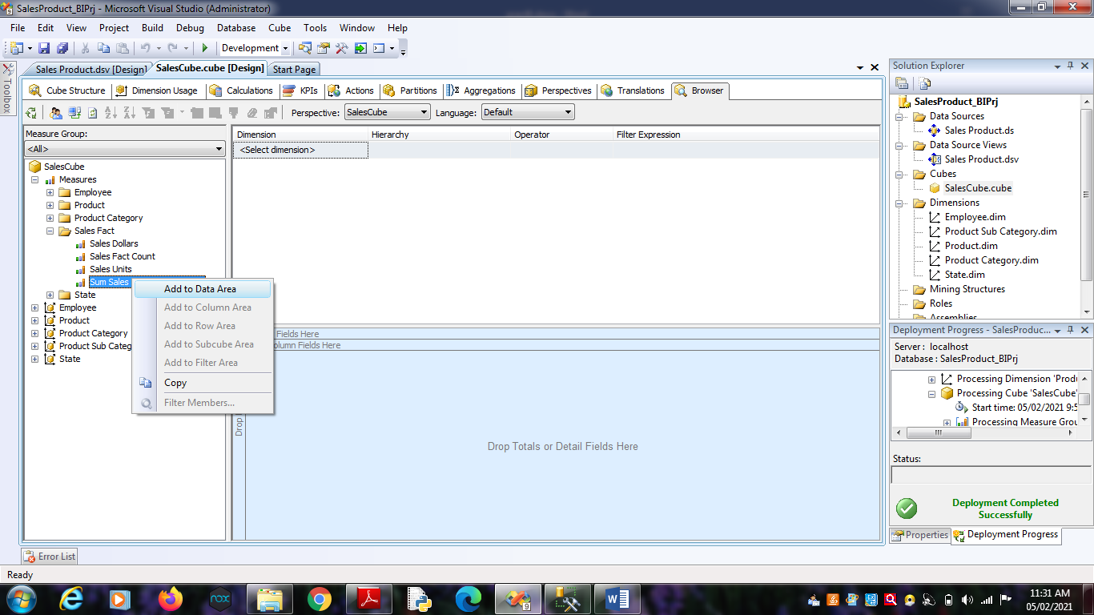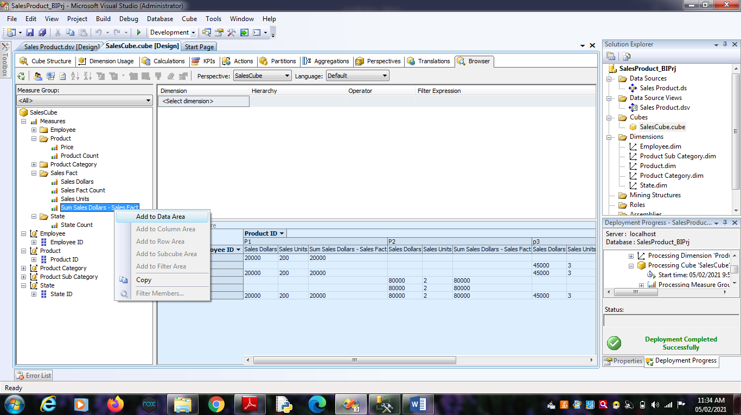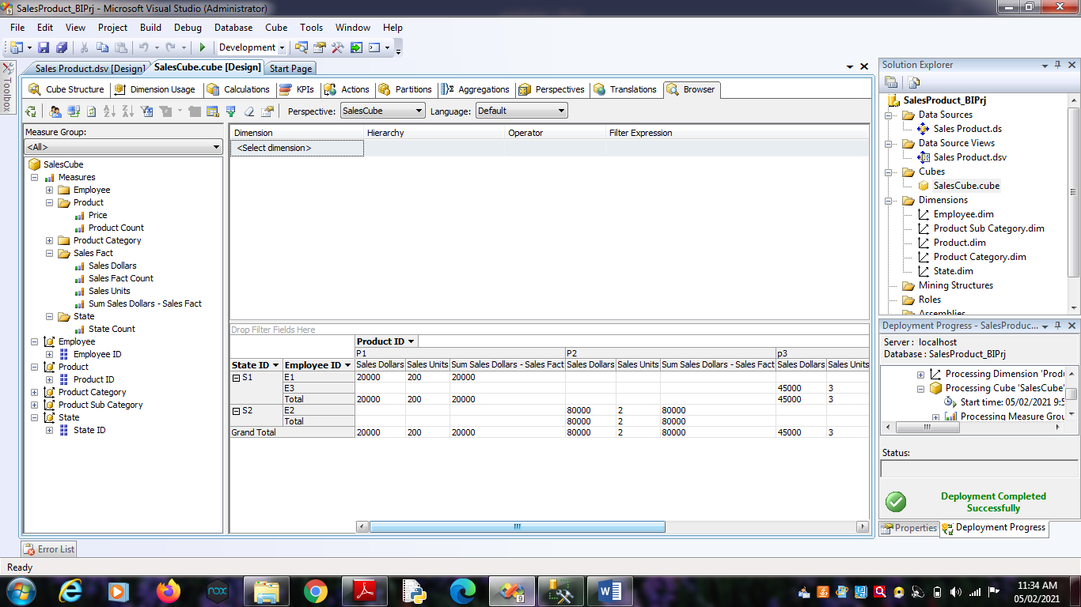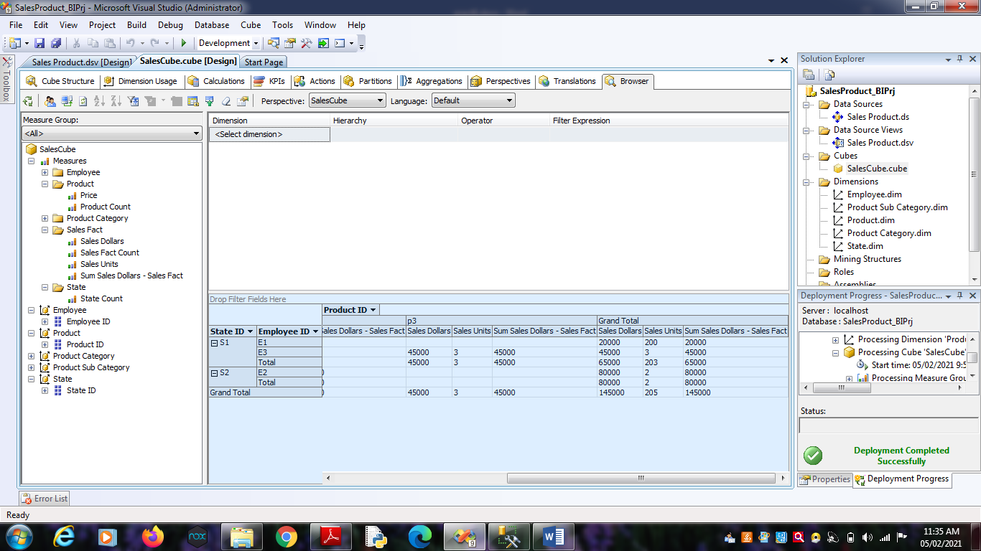

**Practical No 7**

**Aim:** Creating an Excel Pivot Table and Pivot Chart by using the OLAP cube data.

**Solution:**

1. Open MS-Excel. Click on Data Menu.

2. Go to From Other Sources.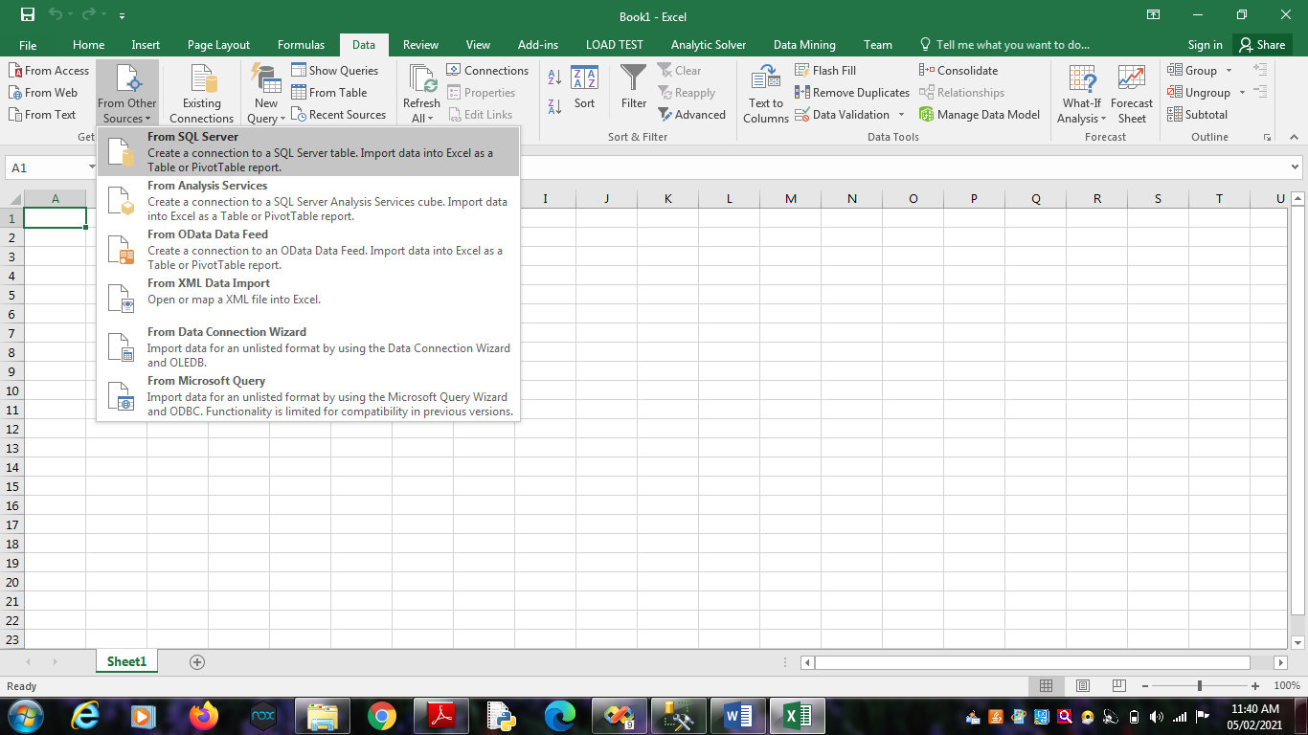

2.1. From SQL Server -> Type Server name as “.”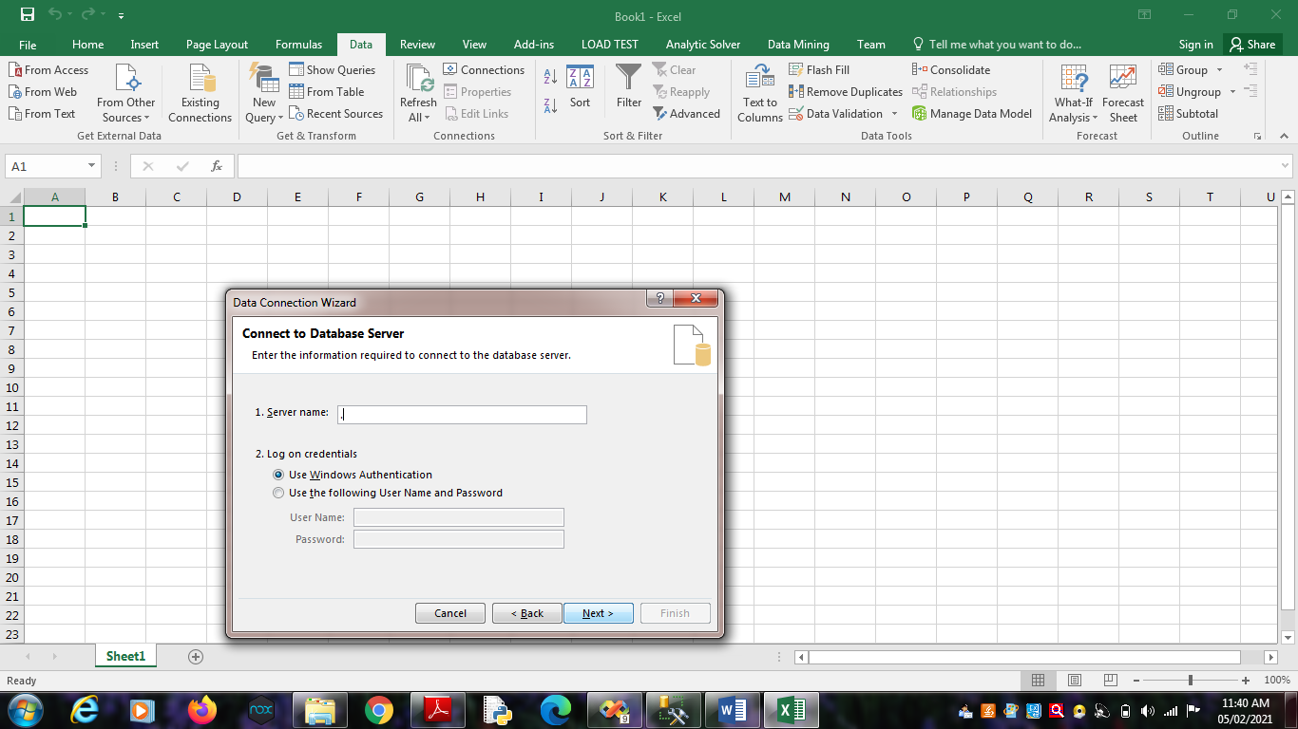

Click on Next.

Choose SQL Database -> “SalesProduct”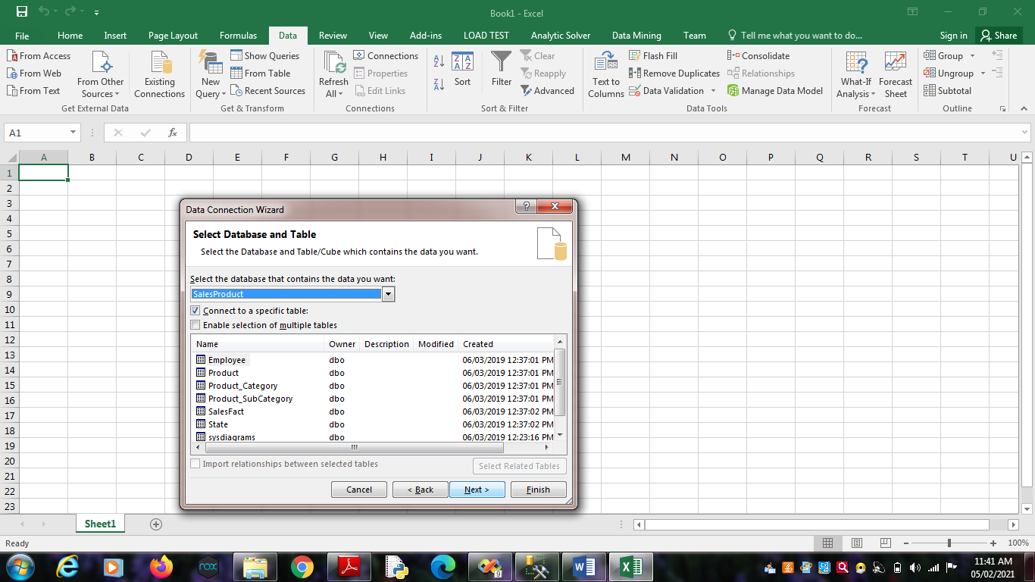

Click on Finish.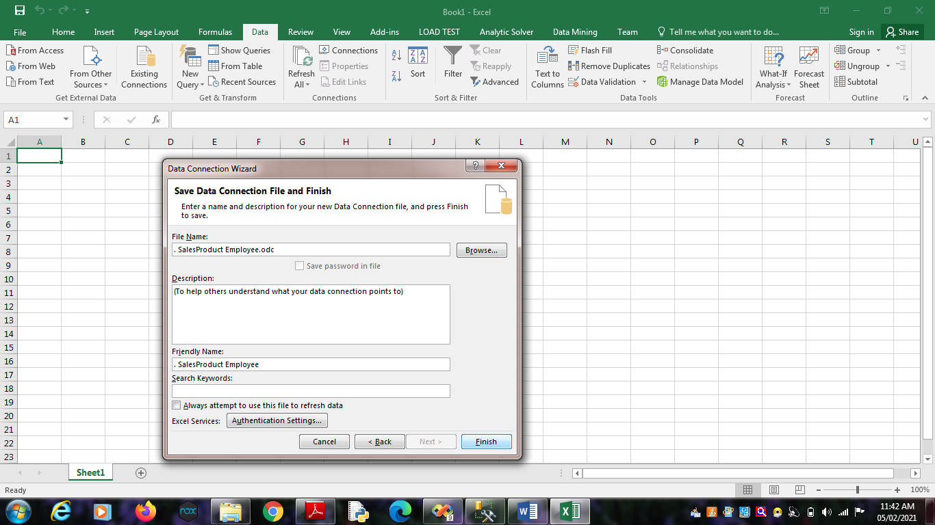

Click on OK.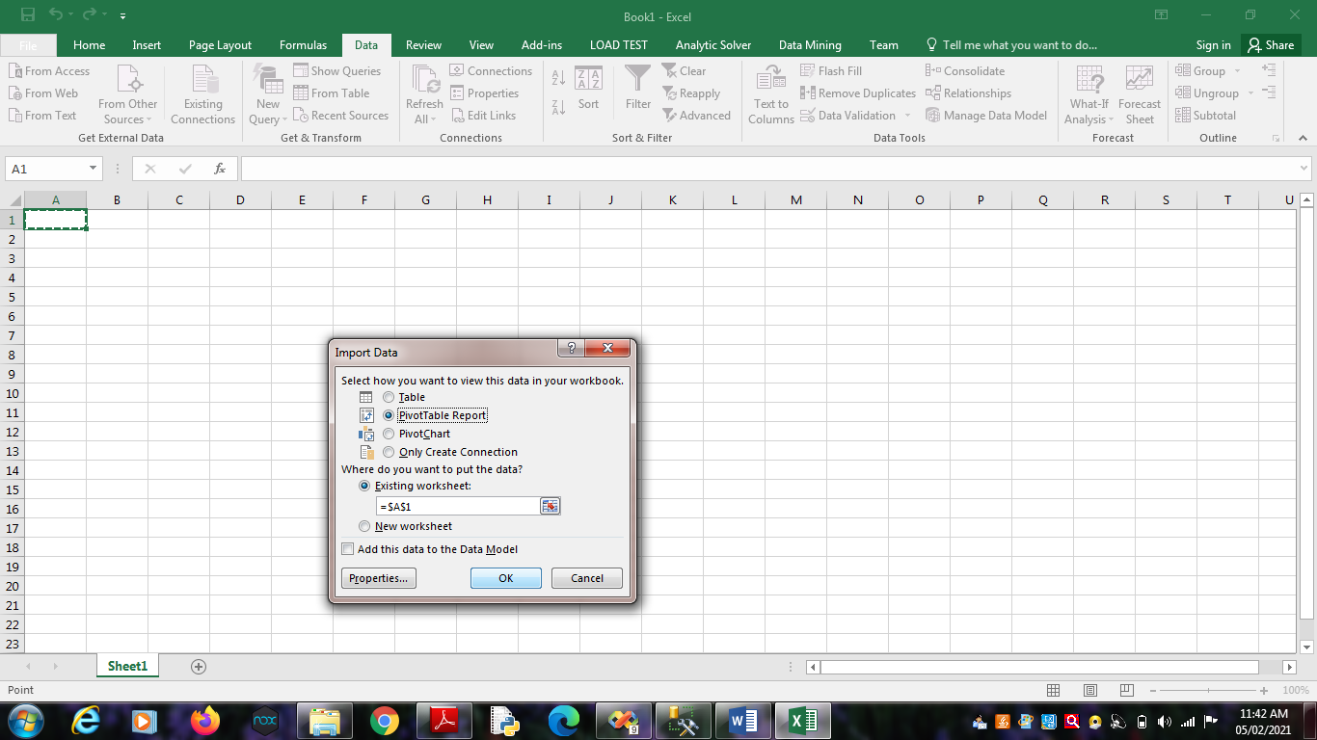

2.2. From Analysis Services -> Type Server name as “.”

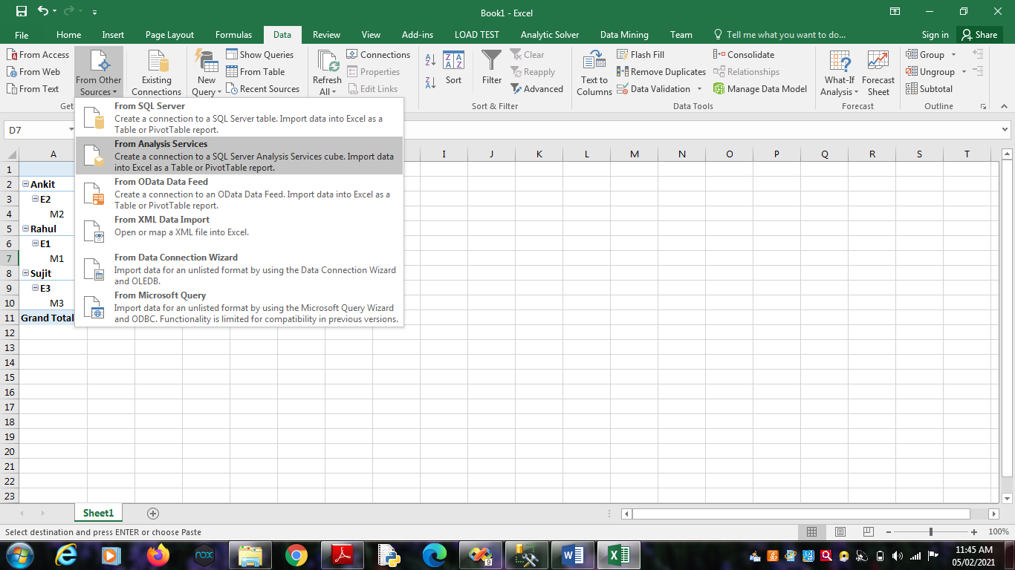

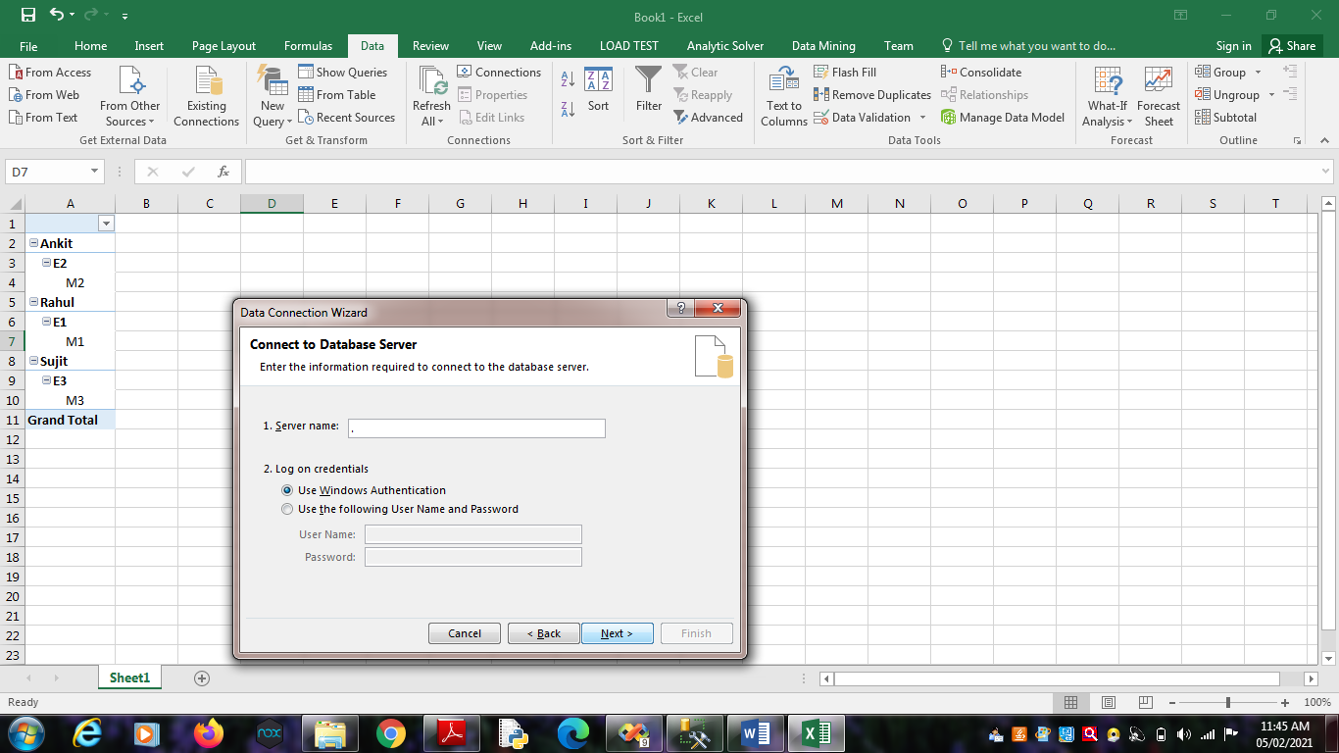

Click on Next.

Choose Analysis Database as “SalesProduct_BIPrj”. Click on

Next.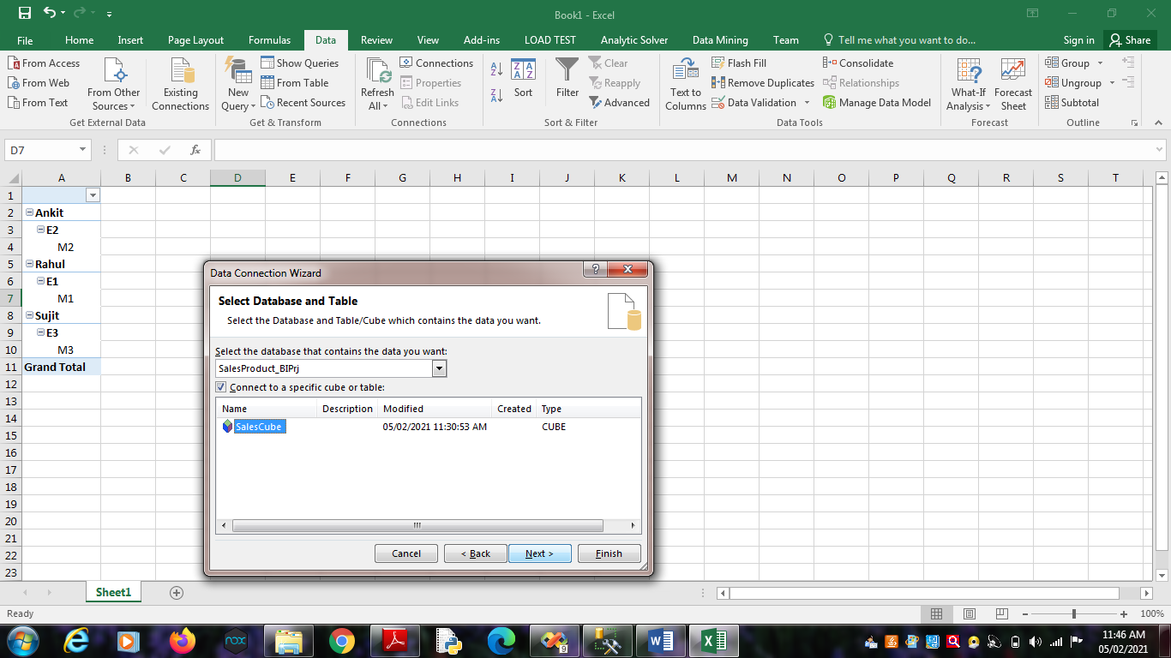

Click on OK.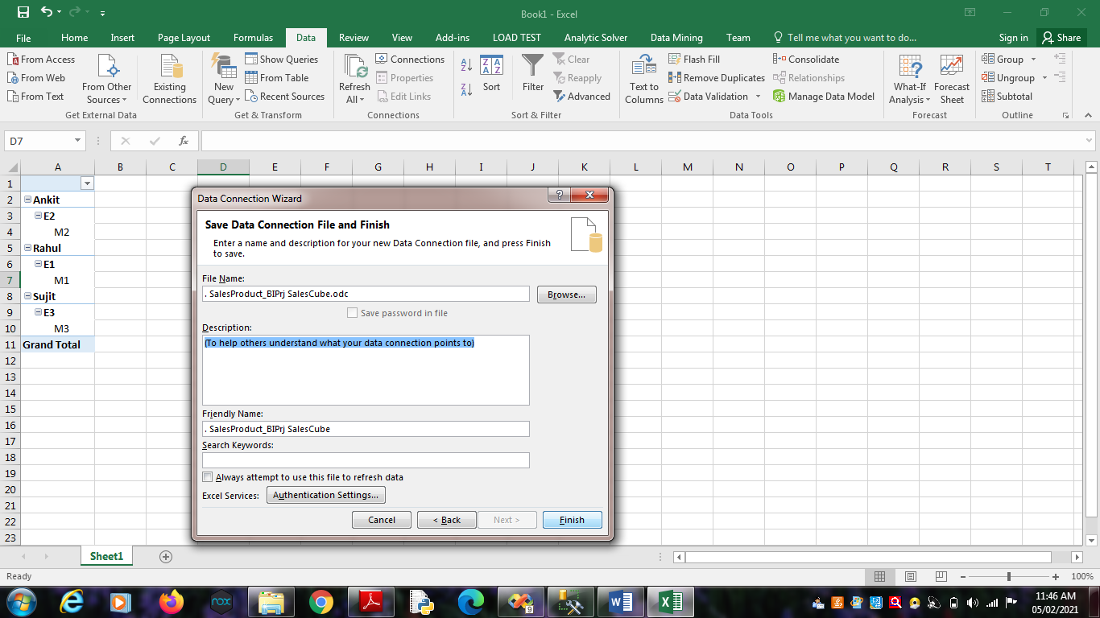

Click on Finish.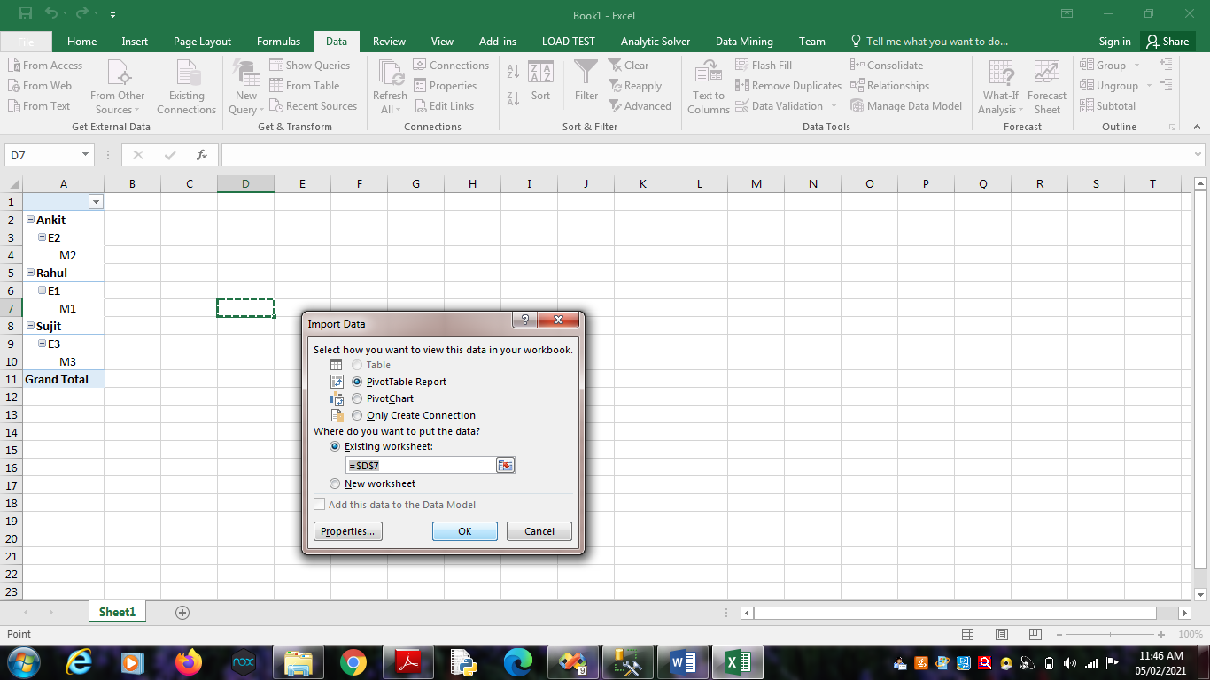

Click on OK.

3. Select State_ID, Product_ID,Employee_ID and Measures as

Sales_Dollars, Sales_Units and Sum Sales Dollars.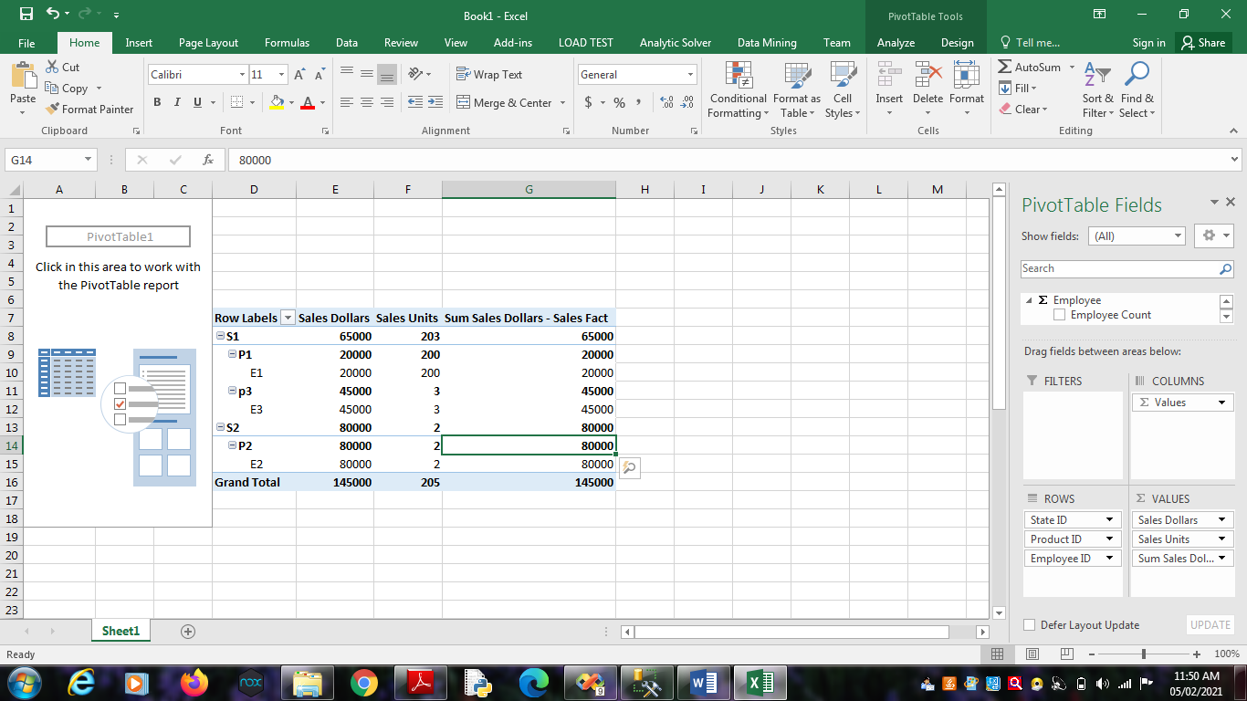

4. Select Result Area. Go to Insert Menu. Select Pie Chart option.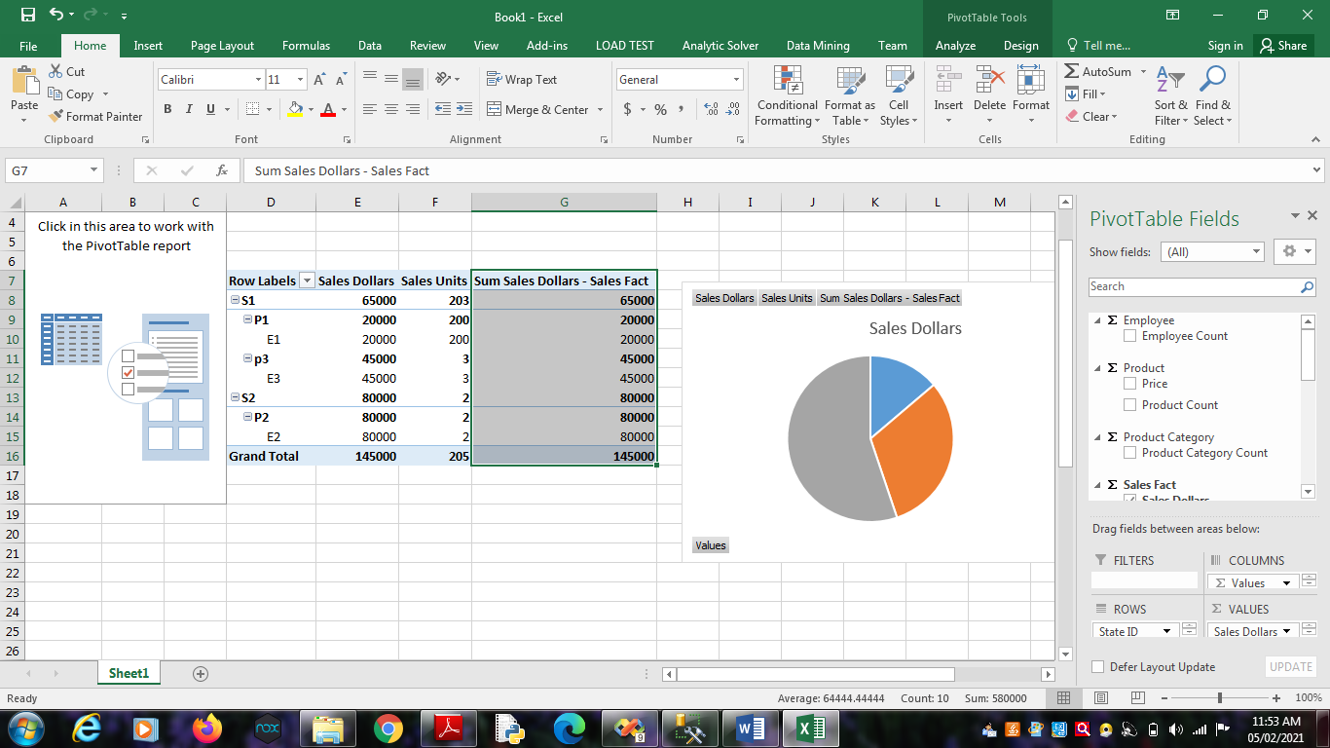

5. Select Result Area. Go to Insert Menu. Select Column option.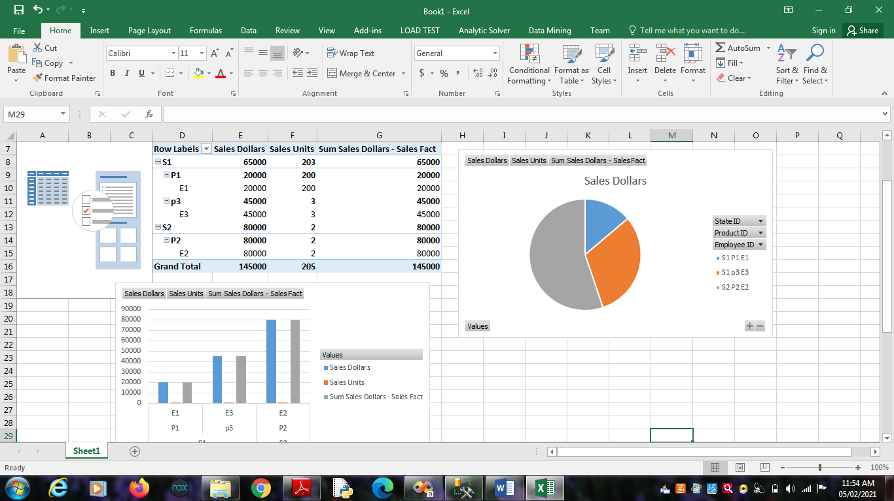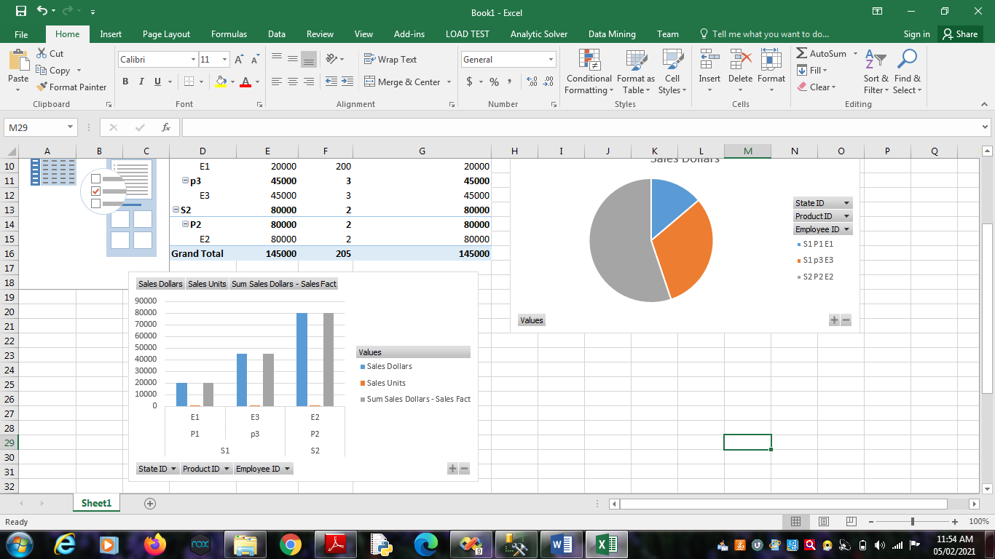

**Practical No 8**

**Aim**: Firing Queries on Tables.

**Solution:**

Open Application -> Microsoft SQL Server 2008 R2 -> SQL Server

Management Studio

1. Select Connect Tab -> Database Engine -> Select Server Name(local)



2. Expand ‘Database’ -> Expand ‘SalesProduct’ -> Expand Tables.

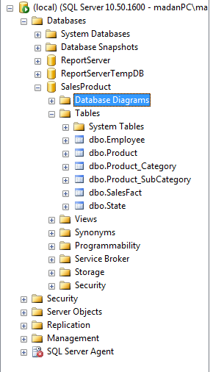

3. Fire following queries :

3.1. SELECT [Employee_ID],[Employee_Name] ,[Manager_ID]

FROM [SalesProduct].[dbo].[Employee]

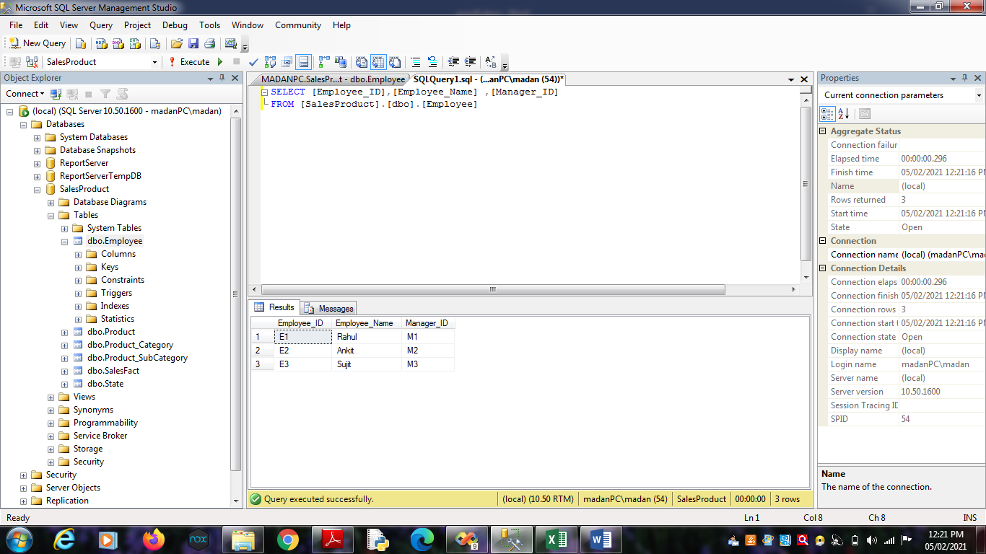

3.2 SELECT [Product_ID],[Brand_Name],[Price],[Product_Name]

,[SubCategory_ID] FROM [SalesProduct].[dbo].[Product]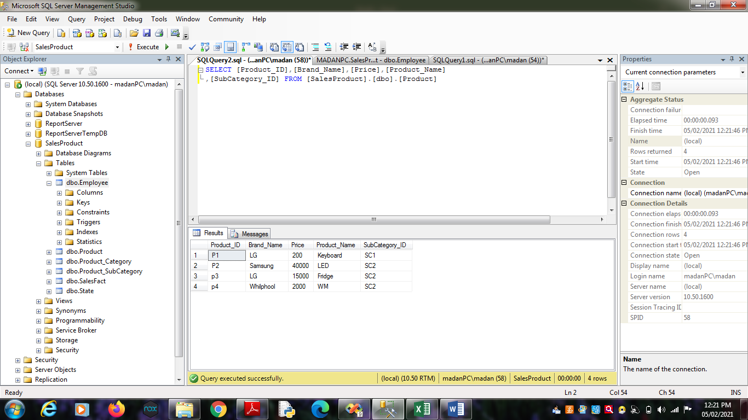

3.3. SELECT [State_ID],[Country],[Region],[State_Name]

FROM [SalesProduct].[dbo].[State]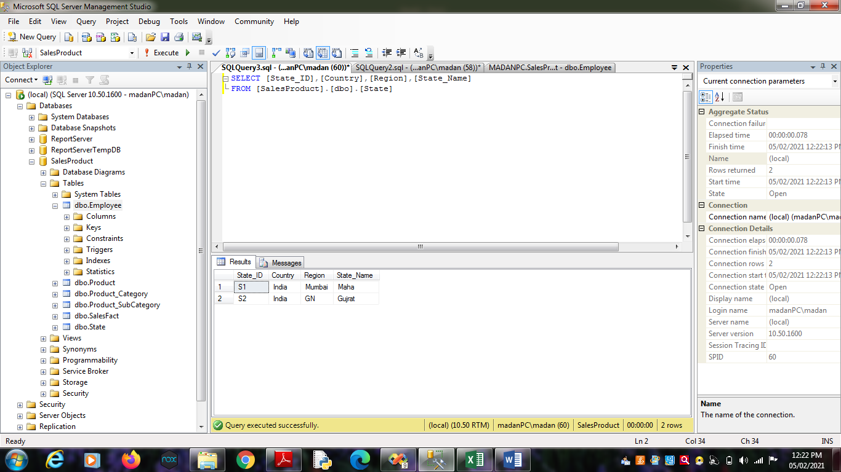

3.4. SELECT

[SubCategory_ID],[Category_Manager],[SubCategory],[Category_ID]

FROM [SalesProduct].[dbo].[Product_SubCategory]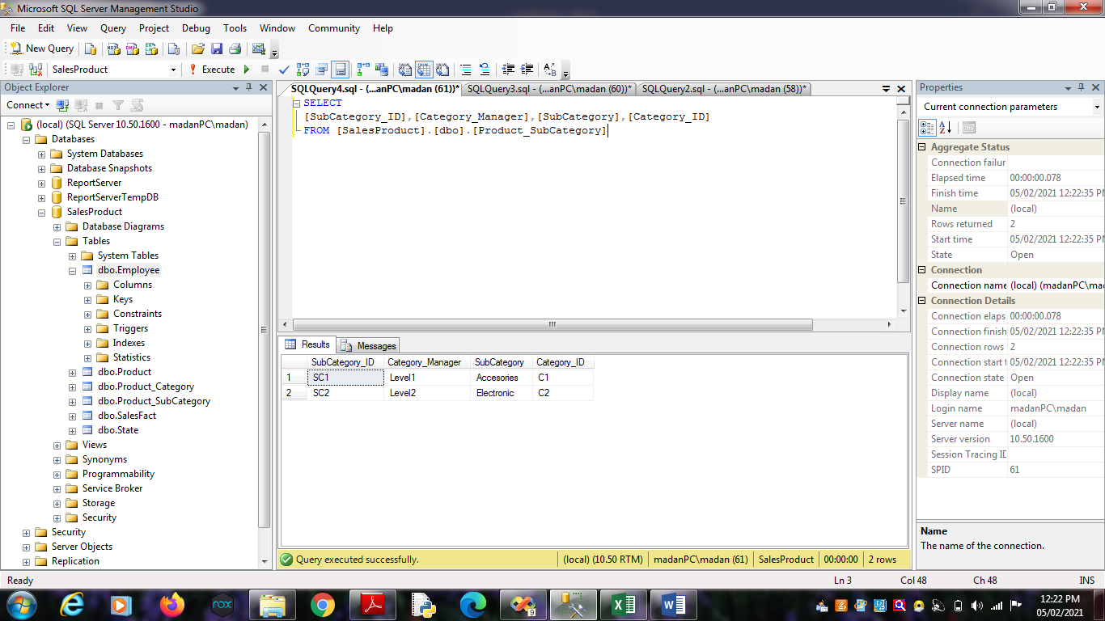

3.5. SELECT [Category_ID],[Category]

FROM [SalesProduct].[dbo].[Product_Category]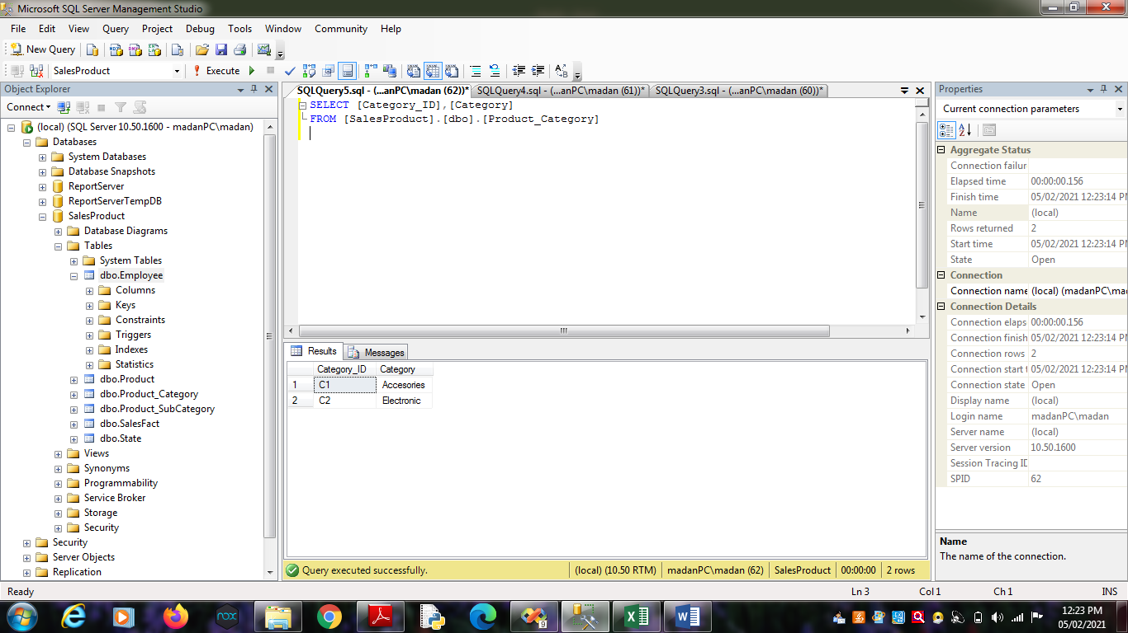

3.6. SELECT [Employee_ID],[Month],[Product_ID],[State_ID],[Sales_Dollars]

,[Sales_Units] FROM [SalesProduct].[dbo].[SalesFact]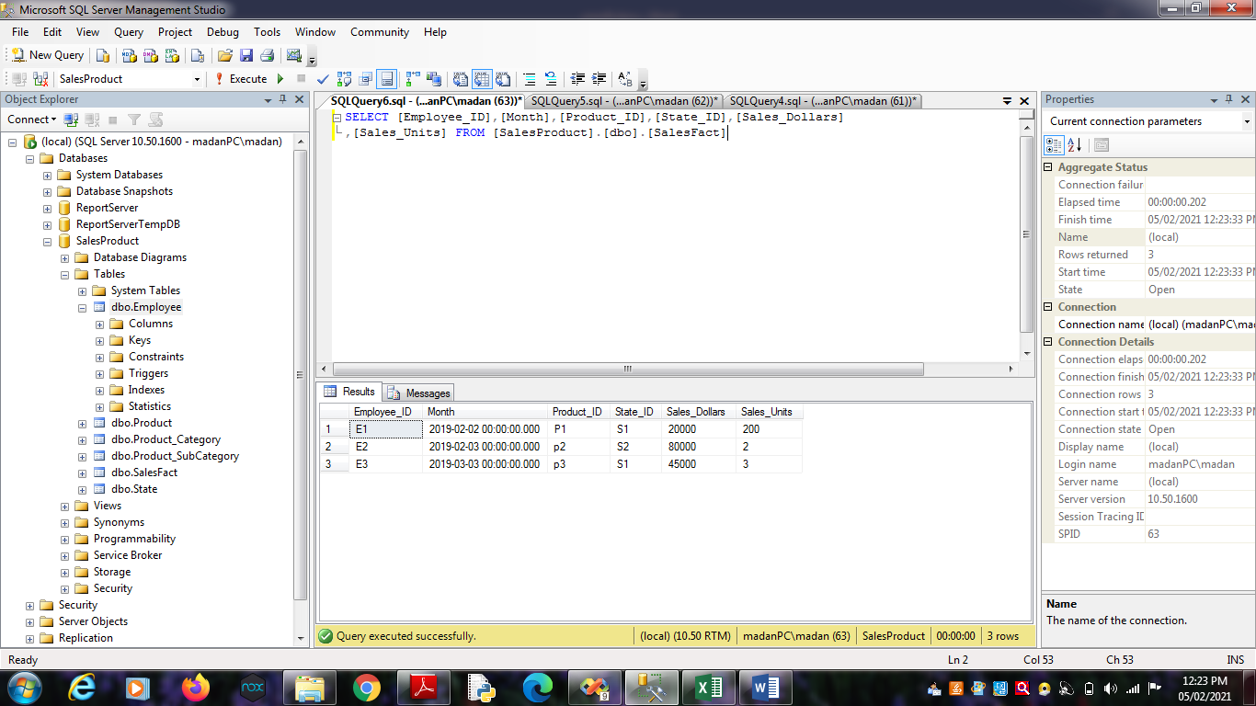

3.7. select [Employee_ID],[Sales_Dollars],[Sales_Units],

[SalesProduct].[dbo].[Product].[Product_ID],[Product_Name]

FROM [SalesProduct].[dbo].[SalesFact],[SalesProduct].[dbo].[Product]

where[SalesProduct].[dbo].[SalesFact].[Product_ID] =

[SalesProduct].[dbo].[Product].[Product_ID];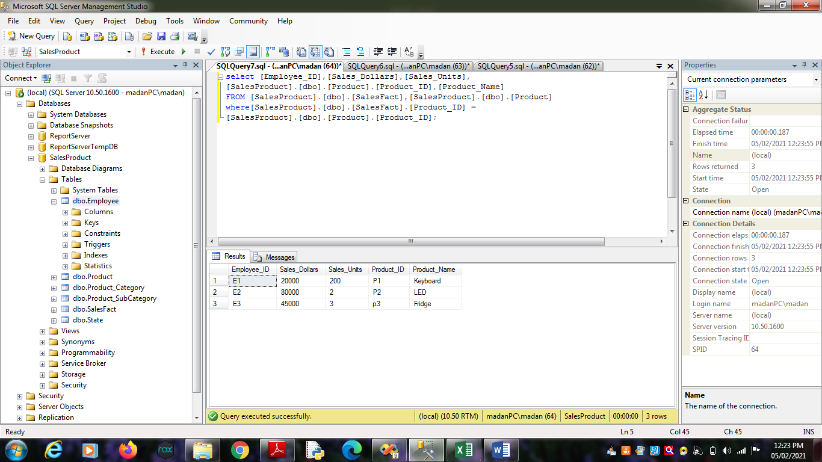

3.8. select [Employee_ID],[Sales_Dollars],[Sales_Units],

[SalesProduct].[dbo].[State].[State_ID],[State_Name]

FROM [SalesProduct].[dbo].[SalesFact],[SalesProduct].[dbo].[State]

where[SalesProduct].[dbo].[SalesFact].[State_ID] =

[SalesProduct].[dbo].[State].[State_ID];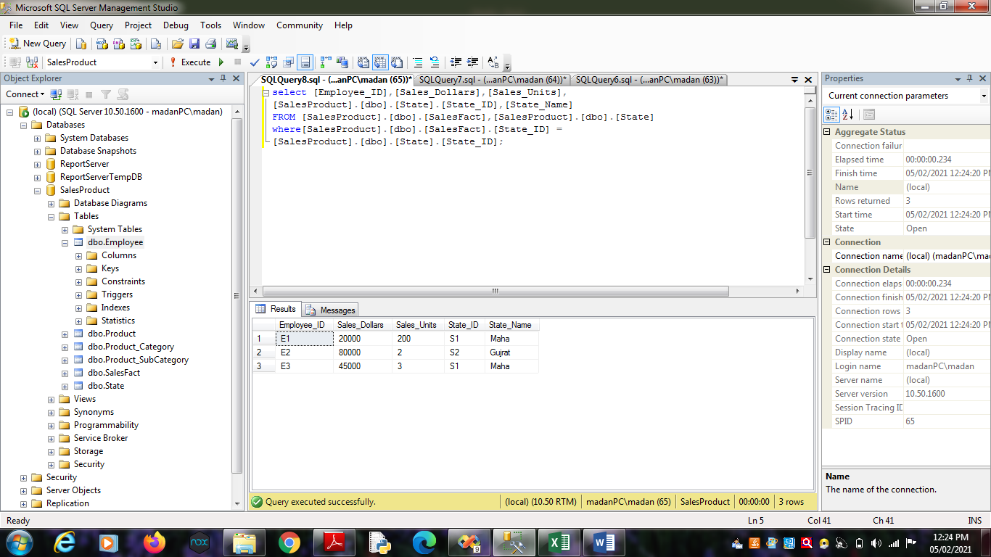

3.9. select [SalesProduct].[dbo].[Employee].[Employee_ID],[Employee_Name],

[Sales_Dollars],[Sales_Units]

FROM [SalesProduct].[dbo].[Employee] , [SalesProduct].[dbo].[SalesFact]

where [SalesProduct].[dbo].[Employee].[Employee_ID]=

[SalesProduct].[dbo].[SalesFact].[Employee_ID] ;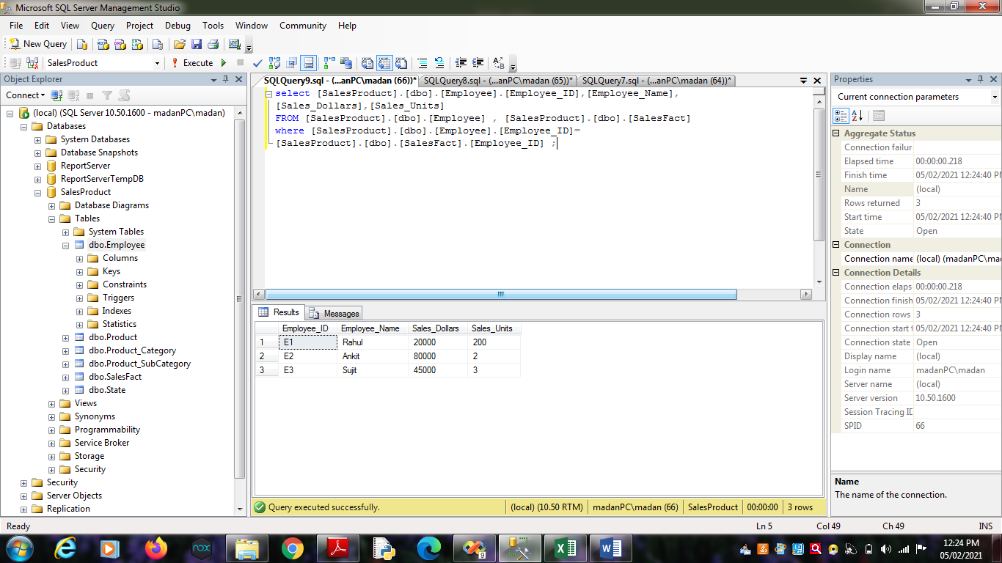

**Practical No - 9**

**Aim**: Data Pre Processing

**Solution:** Only the first tab, ‘Preprocess’, is active at the moment because there is no dataset open.

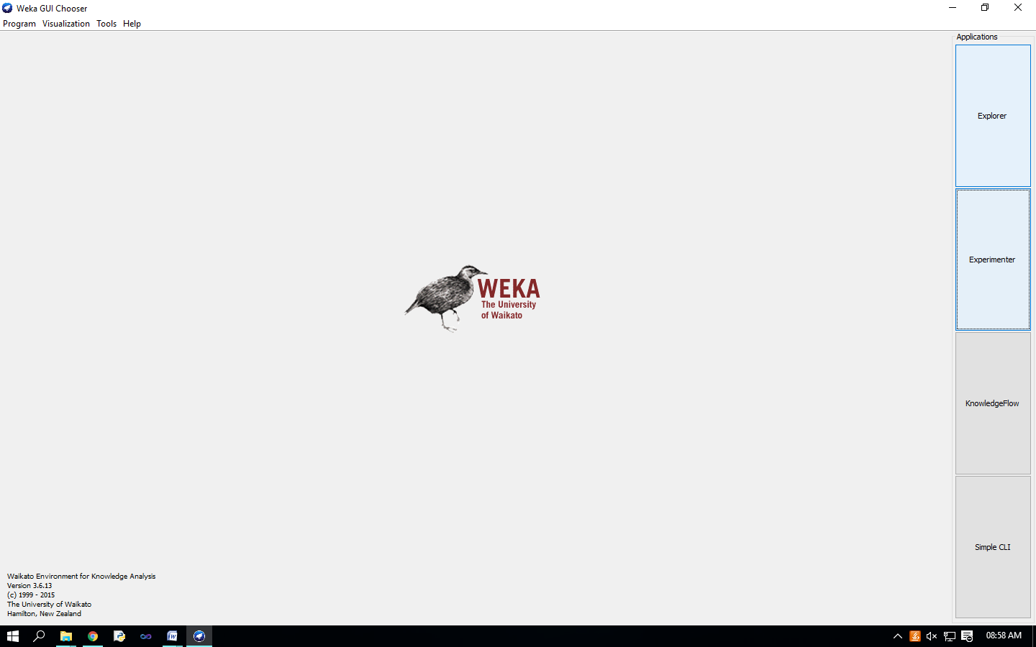

Opening file from a local file system Click on ‘Open file…’ button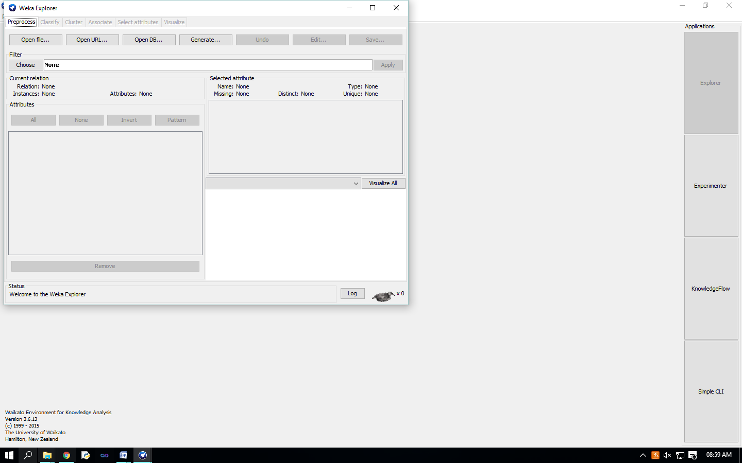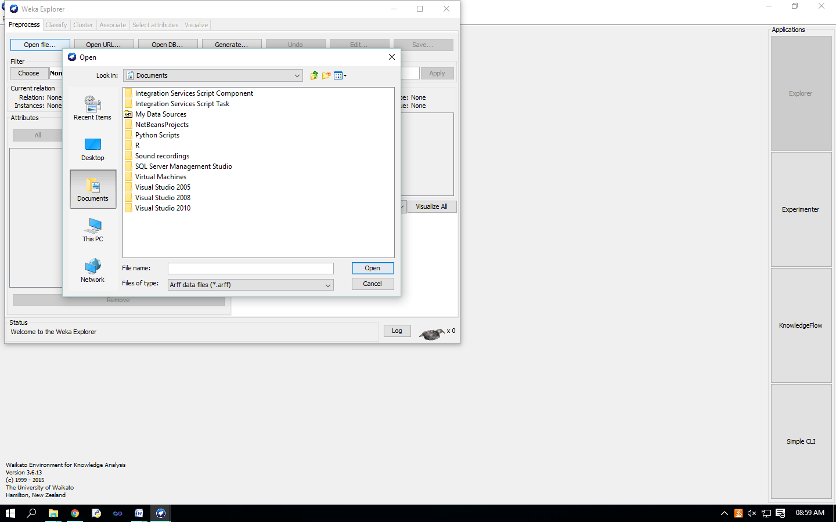

It brings up a dialog box allowing you to browse for the data file on the local file system, choose “weather.arff” file.

C:\Program Files (x86)\Weka-3-6\data

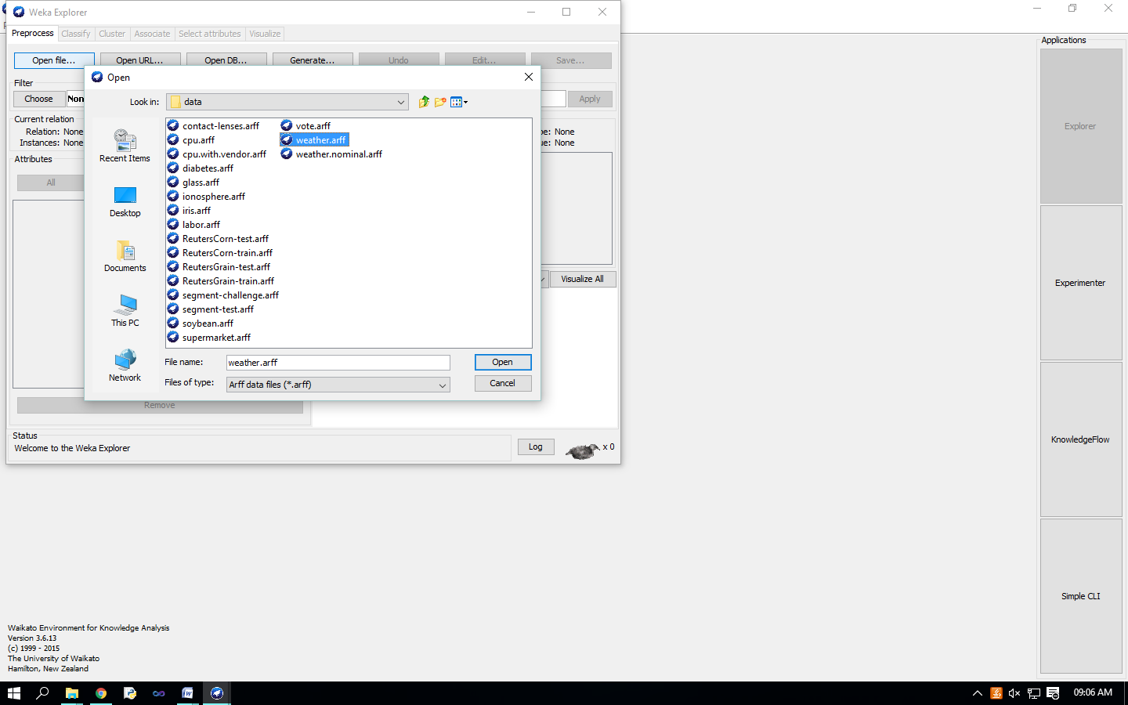

Loading data The most common and easiest way of loading data into WEKA is from ARFF file, using Open File button. 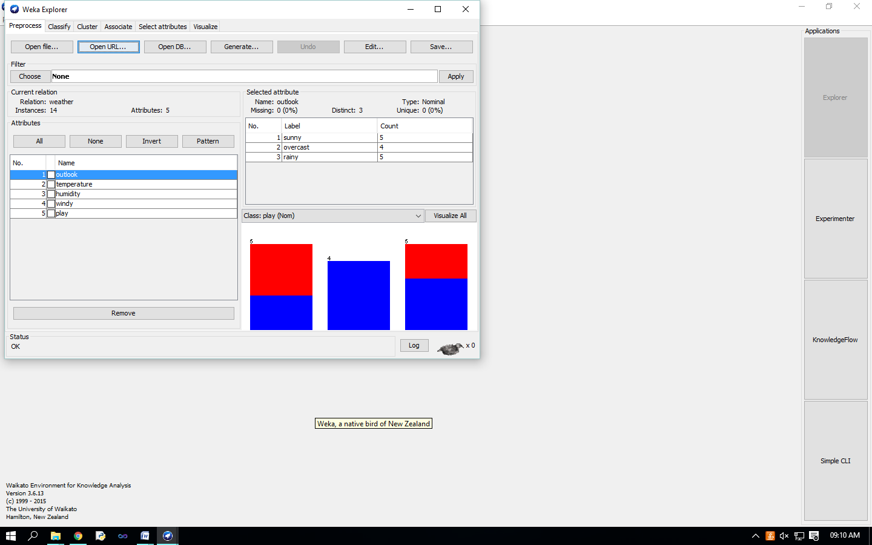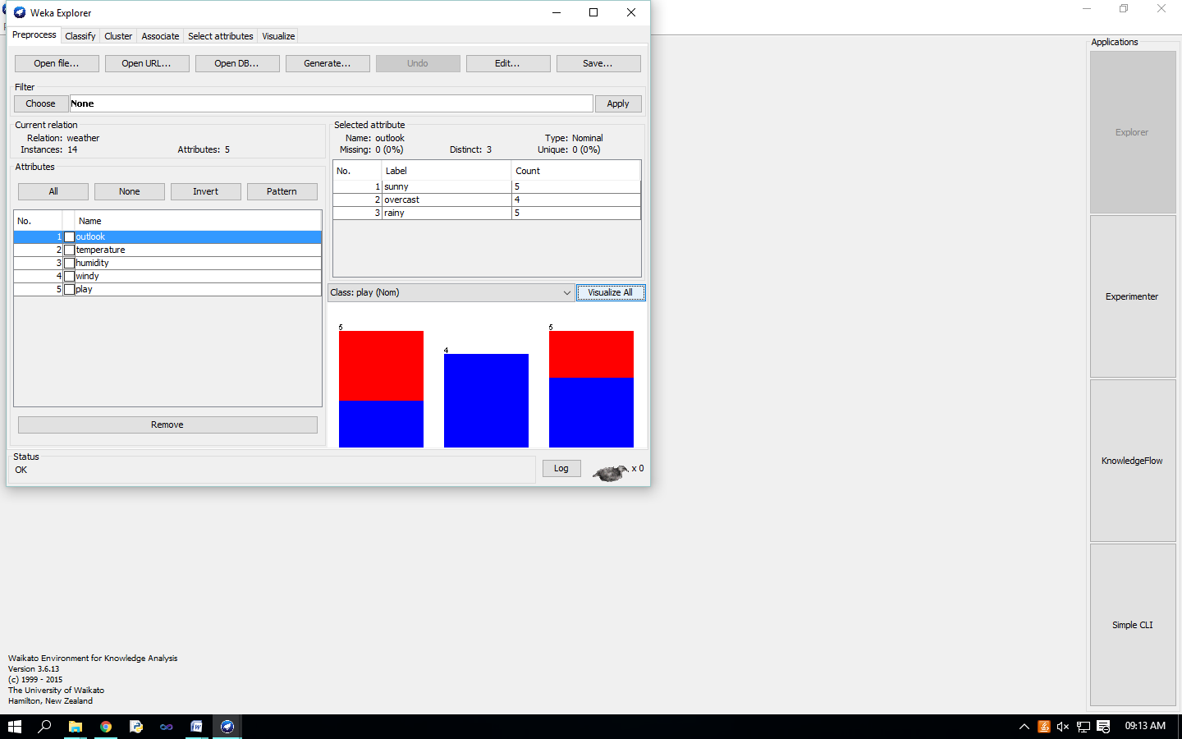

Visualize Attributes: 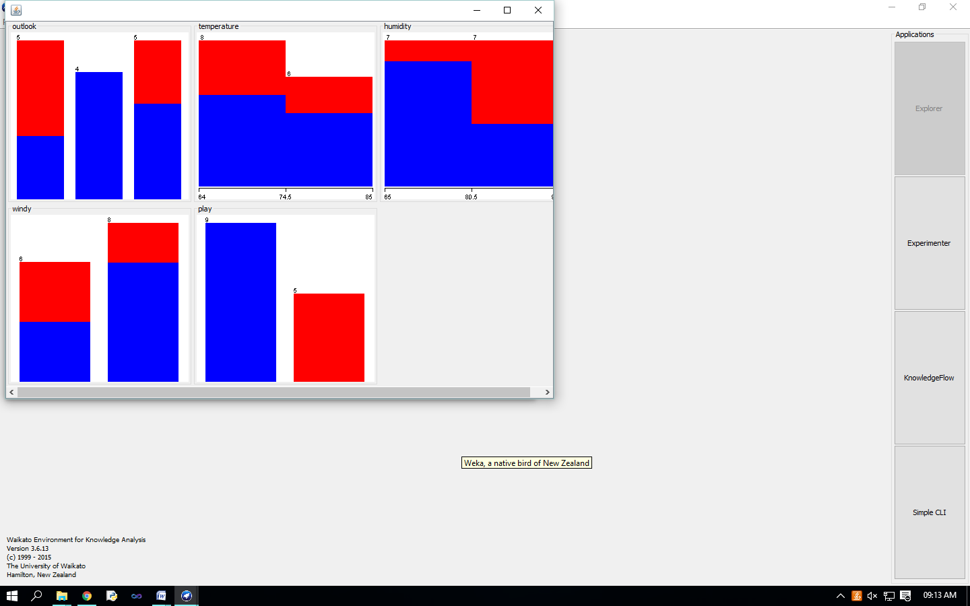

visualize all attributes by clicking on ‘Visualize All’ button.,

**Practical No – 10**

**Aim :** Data discretization.

**Solution :**

In ‘Filters’ window, click on the ‘Choose’ button.

This will show pull-down menu with a list of available filters. Select Supervised 🡪Attribute 🡪

Discretize and click on ‘Apply’ button.

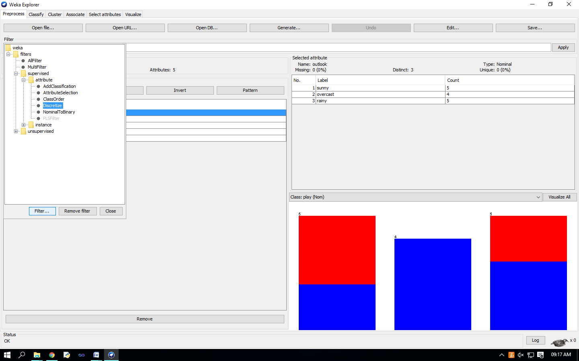 The filter will convert Numeric values into Nominal.

the fields in the window changes to reflect available options.

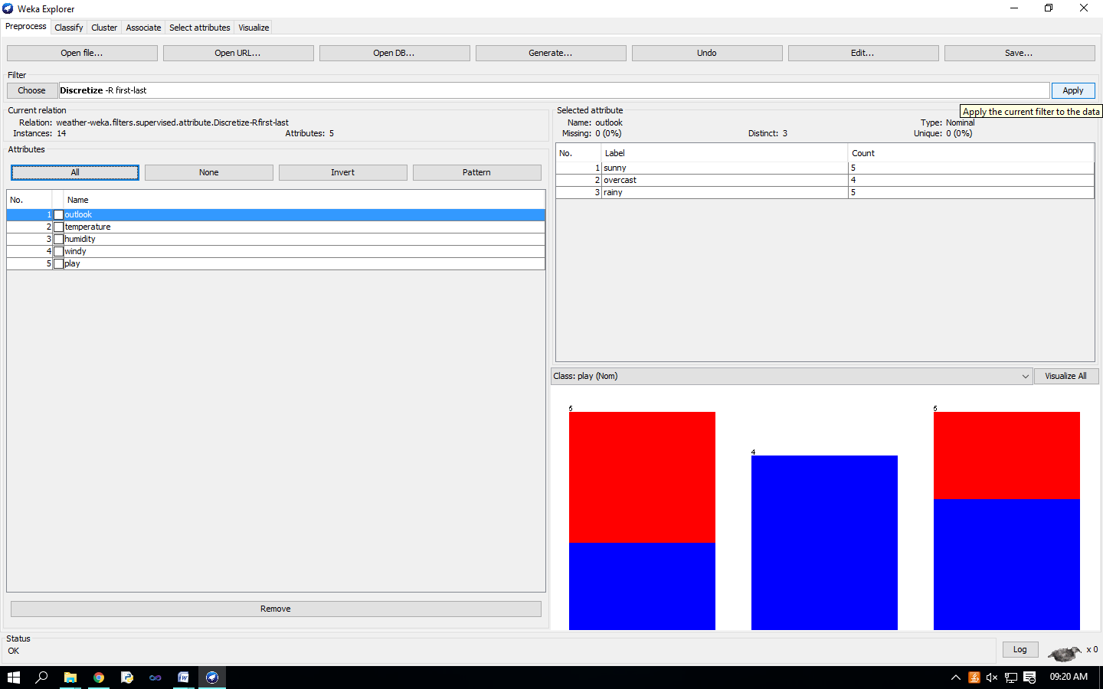

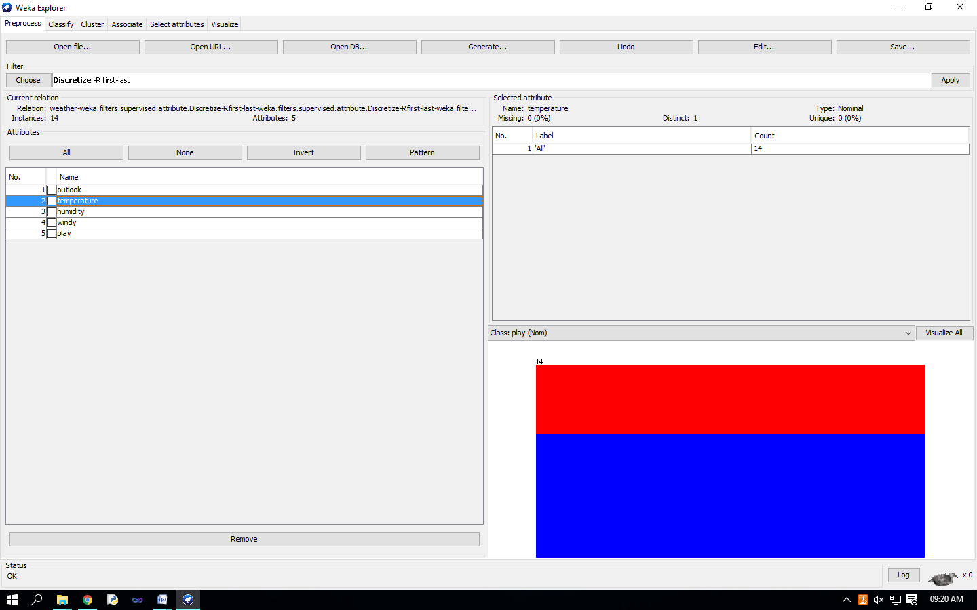

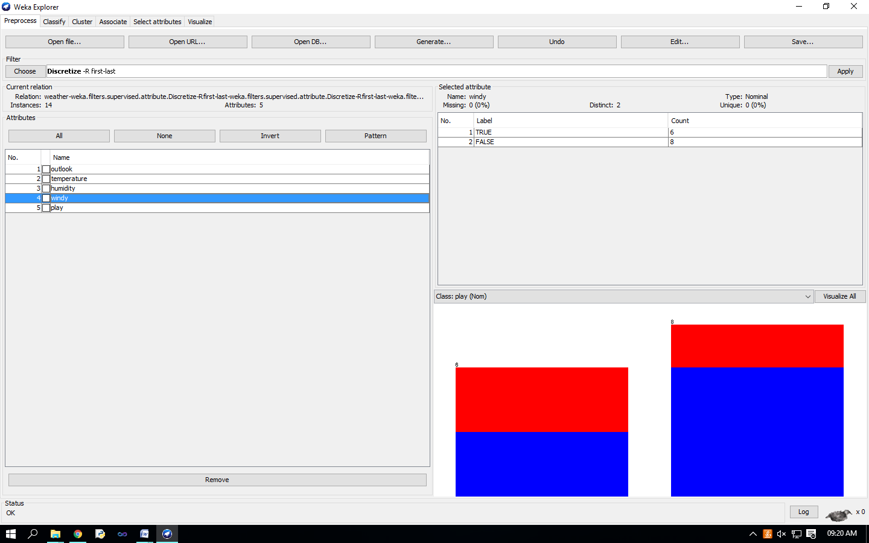

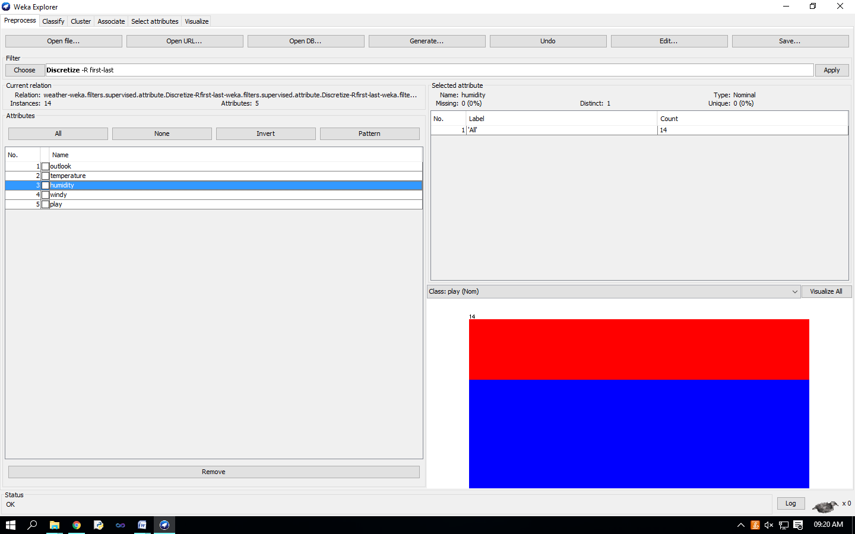

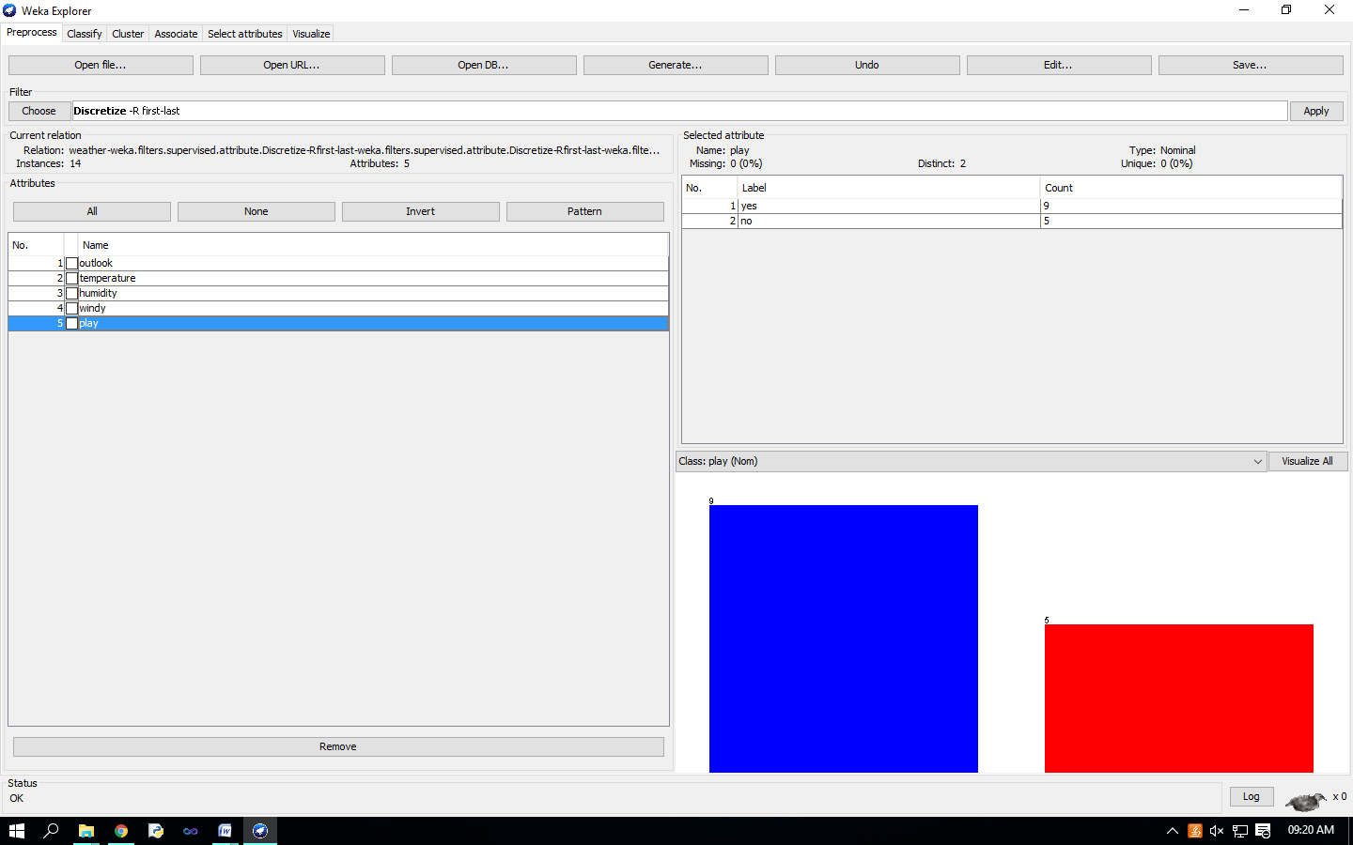

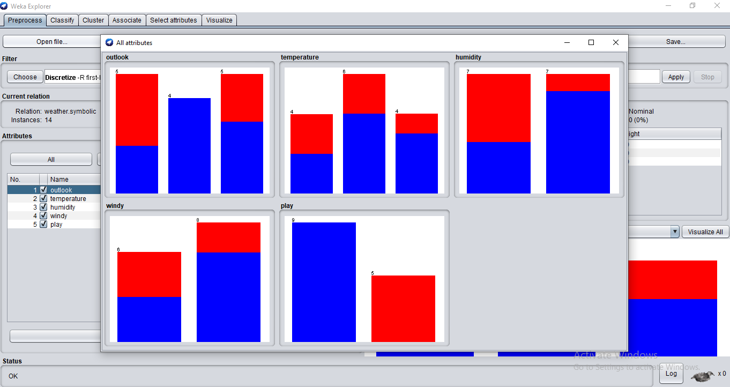

**Practical No - 11**

**Aim** : Classification problems.

**Solution** : Once you have your data set loaded, all the tabs are available to you. Click on the ‘Classify’ tab.

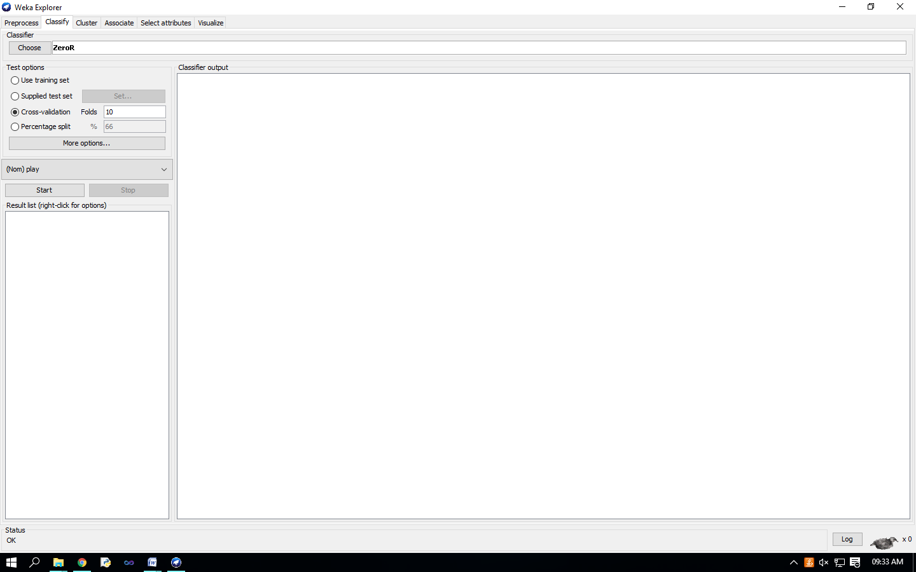

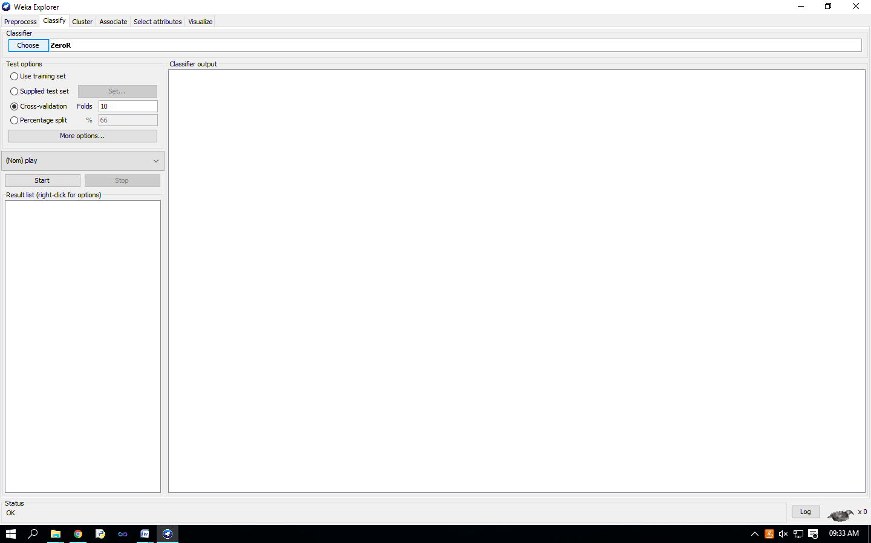

Click on ‘Choose’ button in the ‘Classifier’ box just below the tabs and select C4.5 classifier WEKA Classifiers Trees J48. 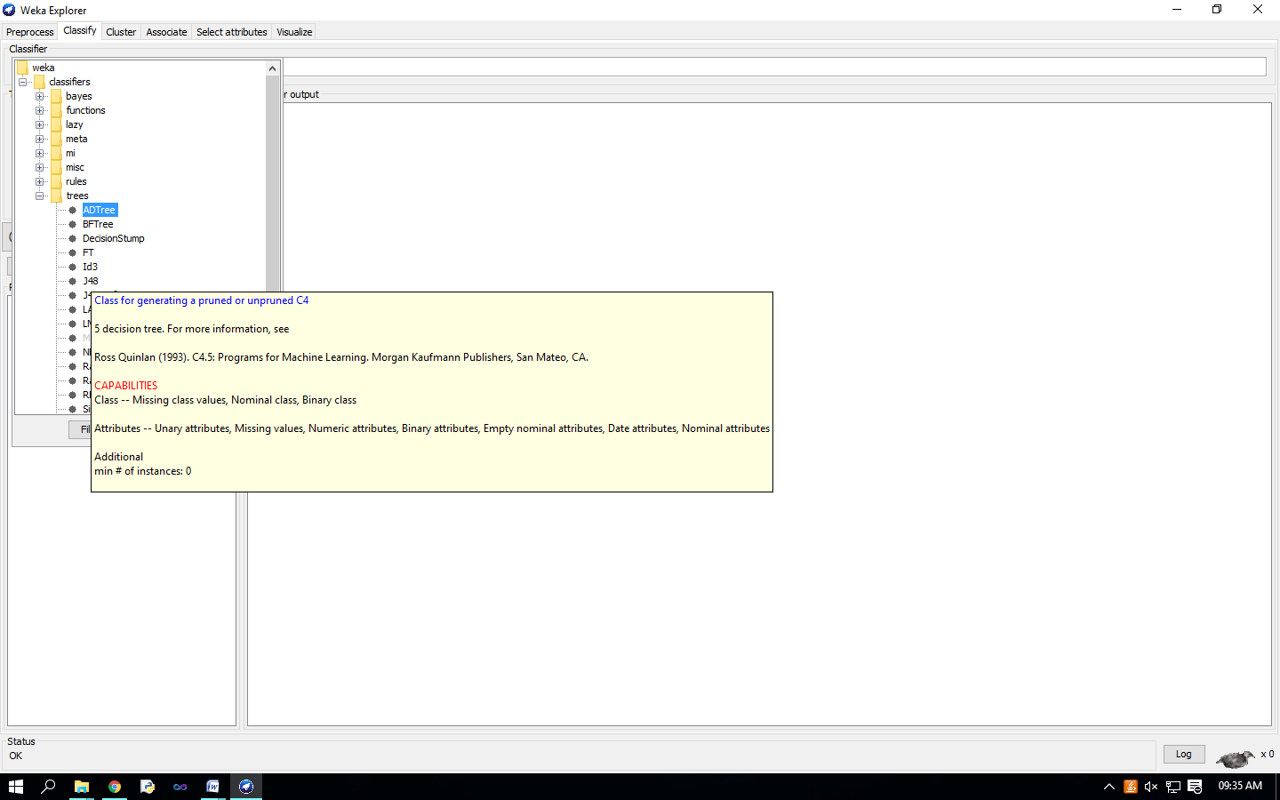

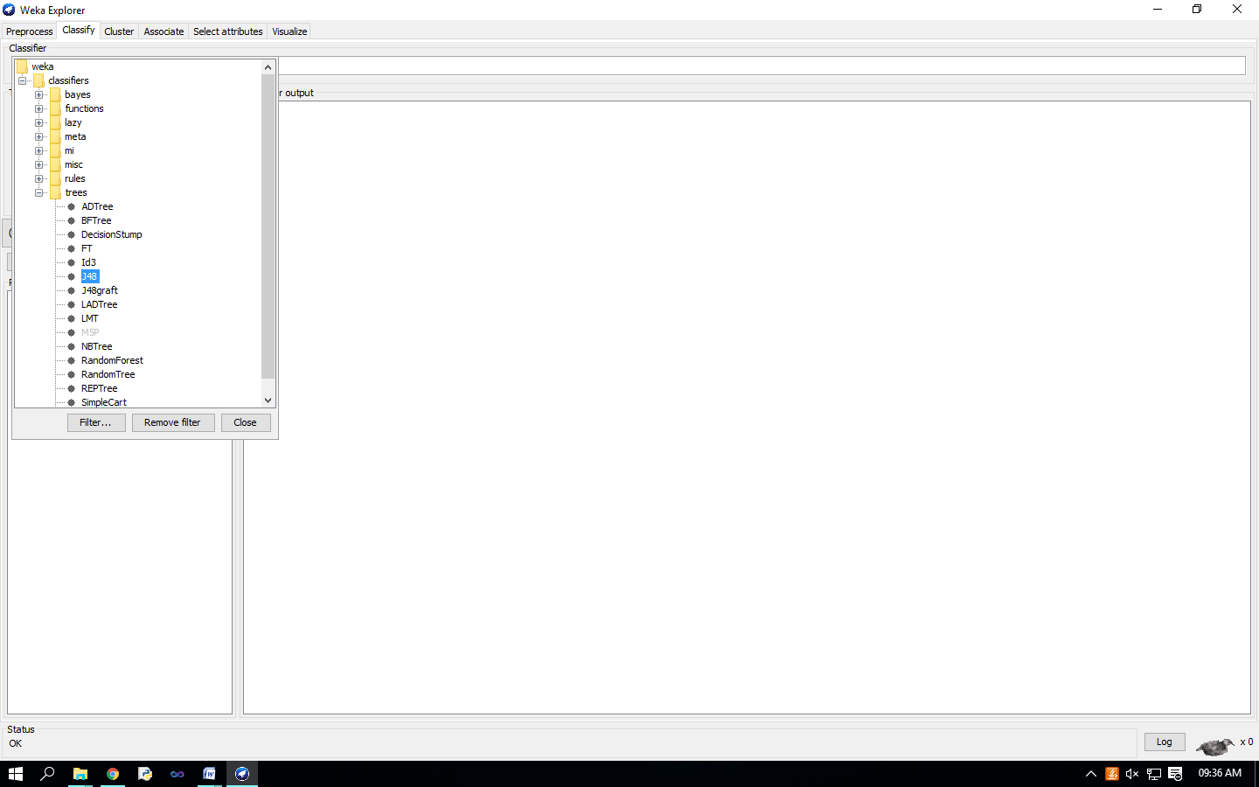

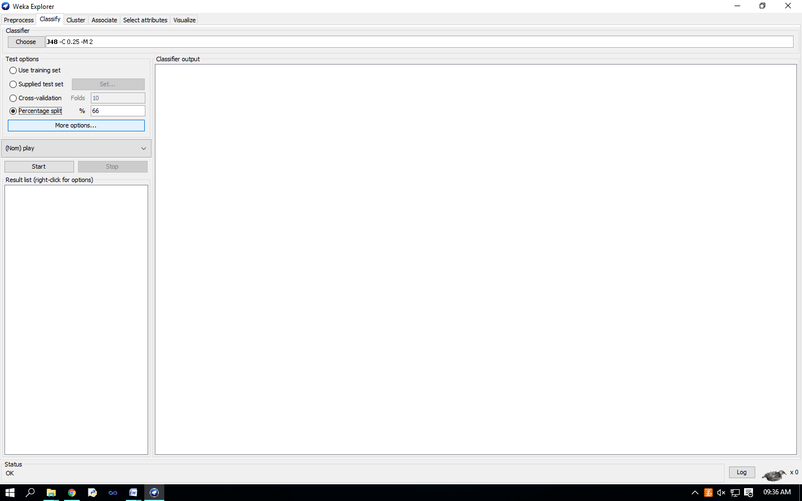

Check ‘Percentage split’ radio-button and keep it as default 66%. Click on ‘More options…’ button. make sure that the Following options are checked : 1. Output model. 2. Output per-class stats. 3. Output confusion matrix 4. Store predictions for visualization. 5. Set ‘Random seed for Xval / % Split’ to 1.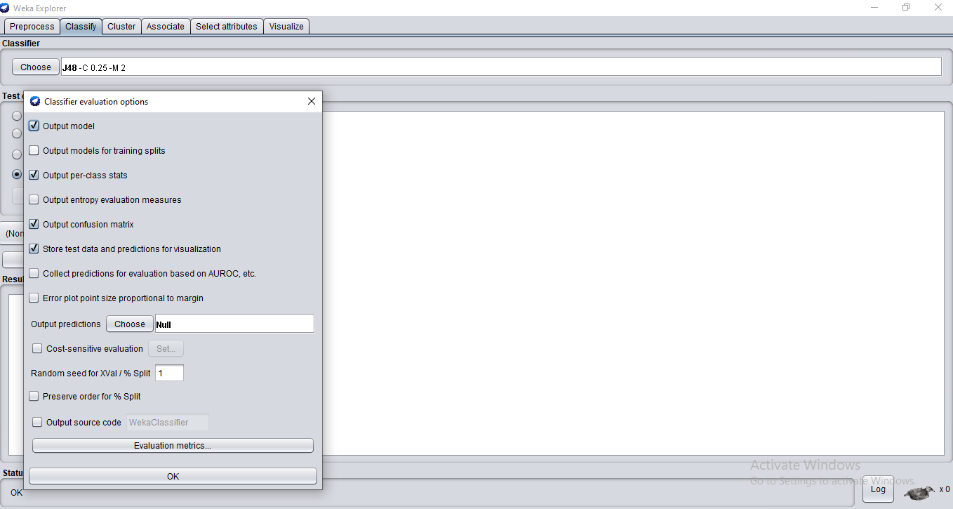

Once the options have been specified, you can run the classification algorithm. Click on ‘Start’ button

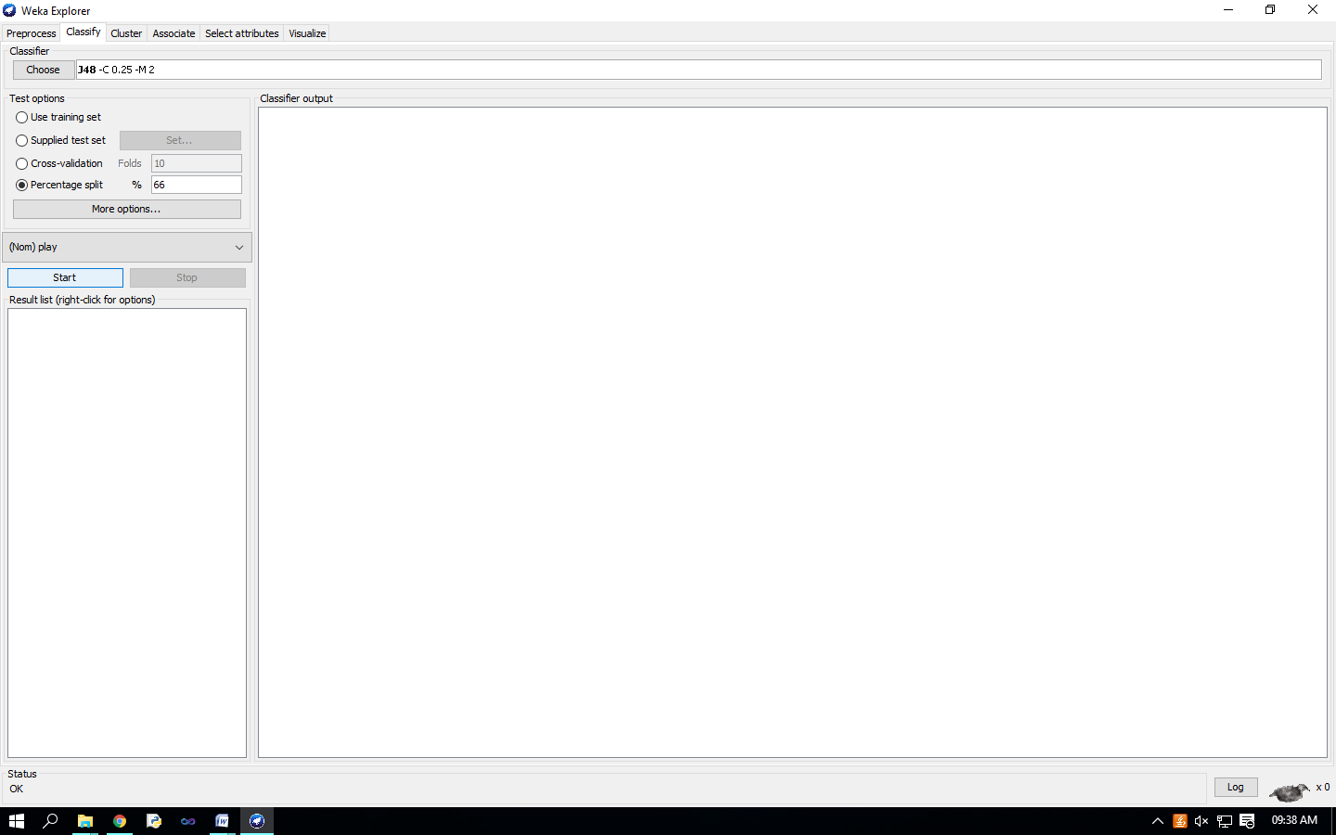

To see a graphical representation of the classification tree. Right-click on the entry in ‘Result list’ for which you would like to visualize a tree. 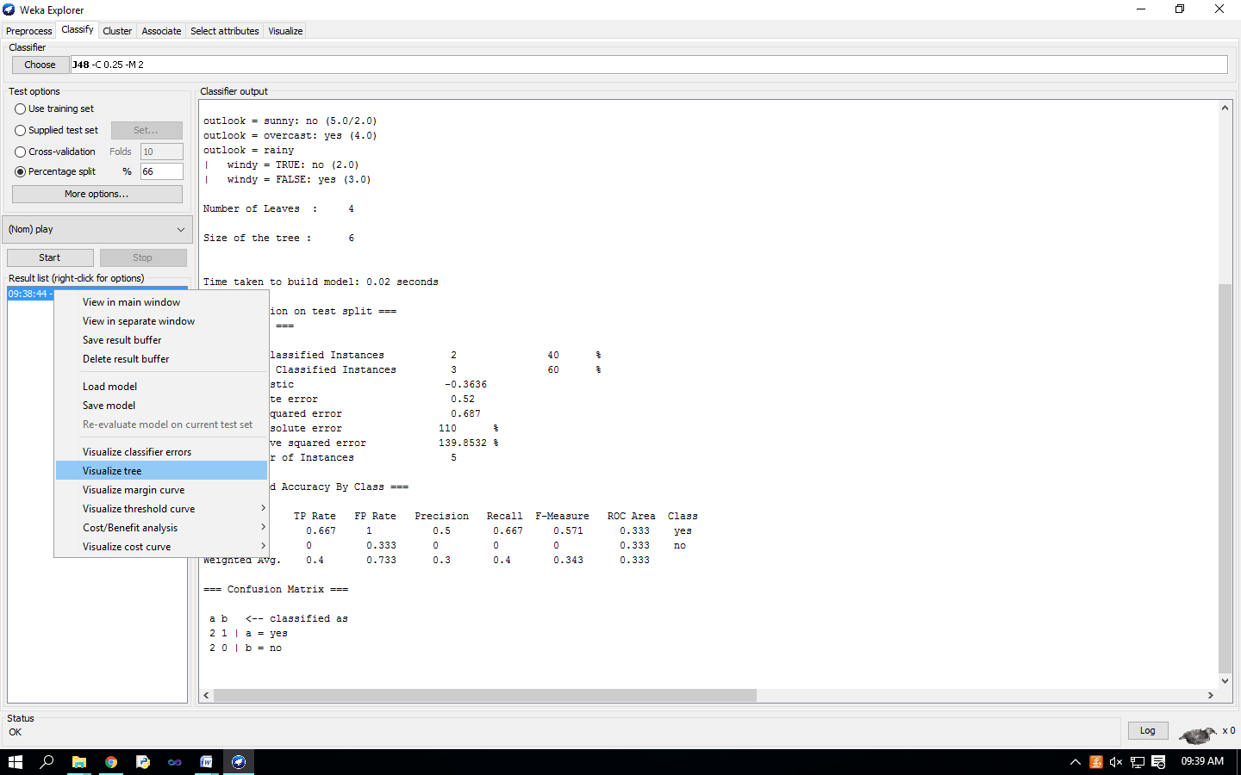Select the item ‘Visualize tree’; a new window comes up to the screen displaying the tree.

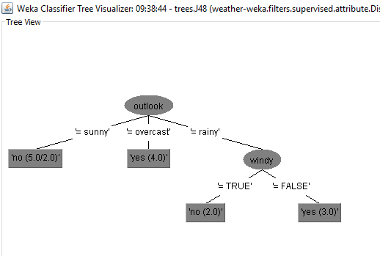

To visualize classification errors. Right-click on the entry in ‘Result list’ again and select ‘Visualize classifier errors’ from the menu: 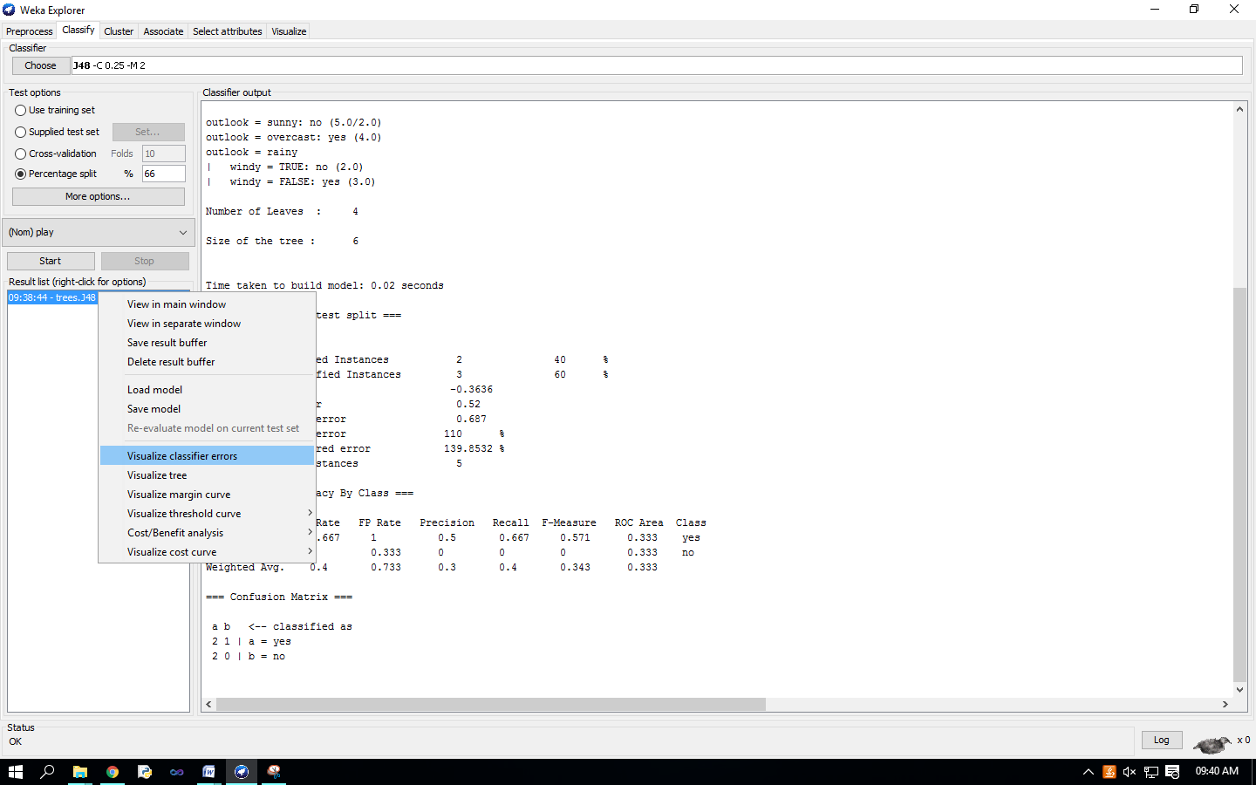Visualize’ window displaying graph appears on the screen. 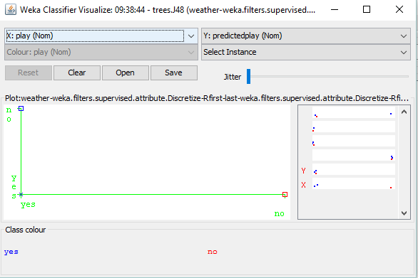

Select outlook(Nom) on X-axis.

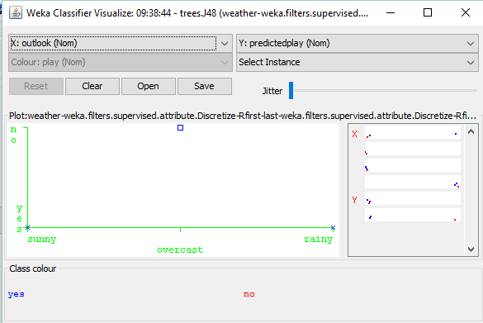

**Practical No - 12**

**Aim** : Clustering Analysis.

**Solution** : we will use customer data [6] that is contained in “customers.arff” file and analyze it with k-means clustering scheme.

We have to create excel file

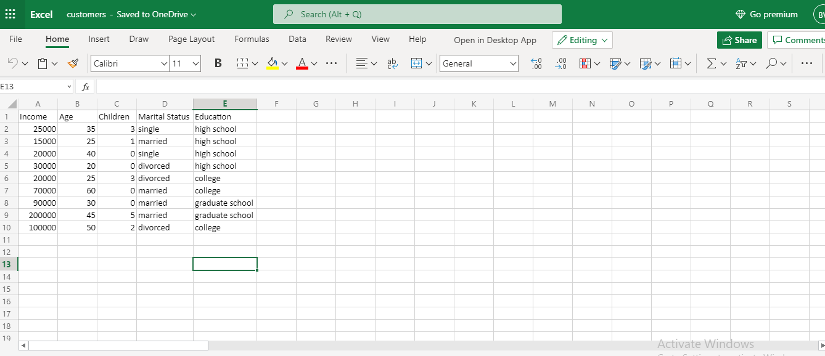

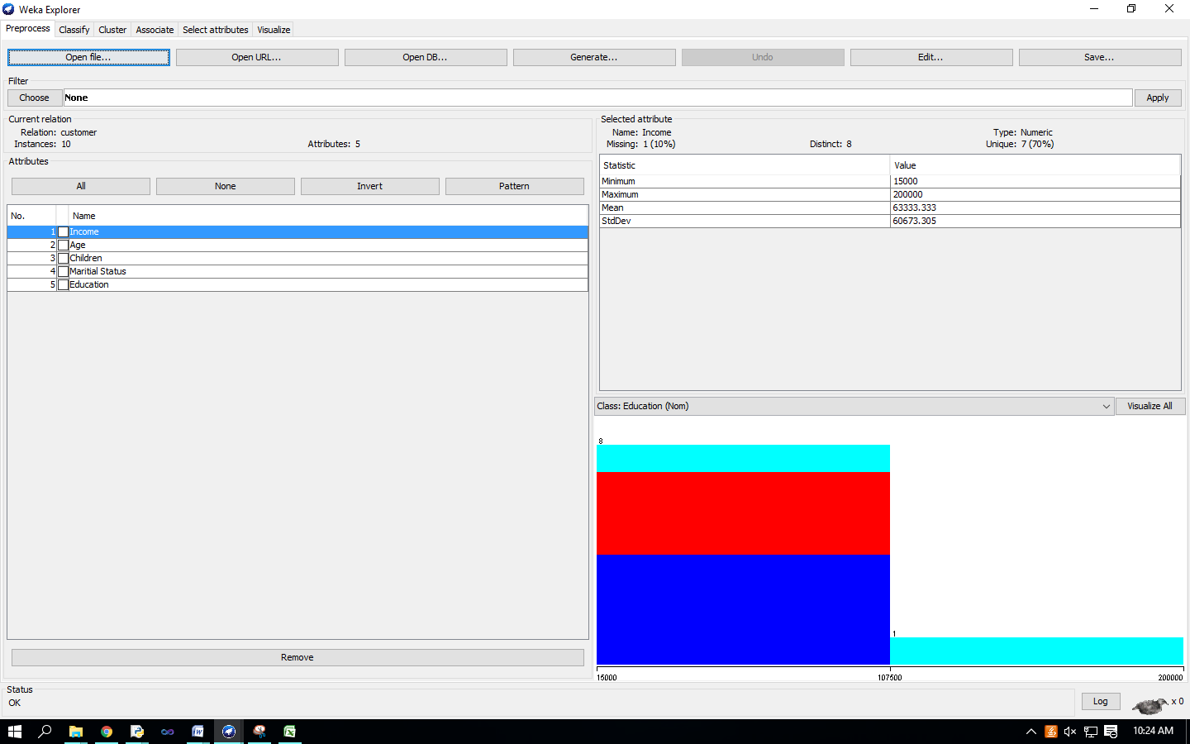

In ‘Preprocess’ window click on ‘Open file…’ button and select “customers.arff” file. Click ‘Cluster’ tab at the top of WEKA Explorer window.

In the ‘Clusterer’ box click on ‘Choose’ button. In pull-down menu select WEKA Clusterers, and select the cluster scheme ‘SimpleKMeans’. Some implementations of K-means only allow numerical values for attributes. right-click on the algorithm “weak.gui.GenericObjectEditor” comes up to the screen. 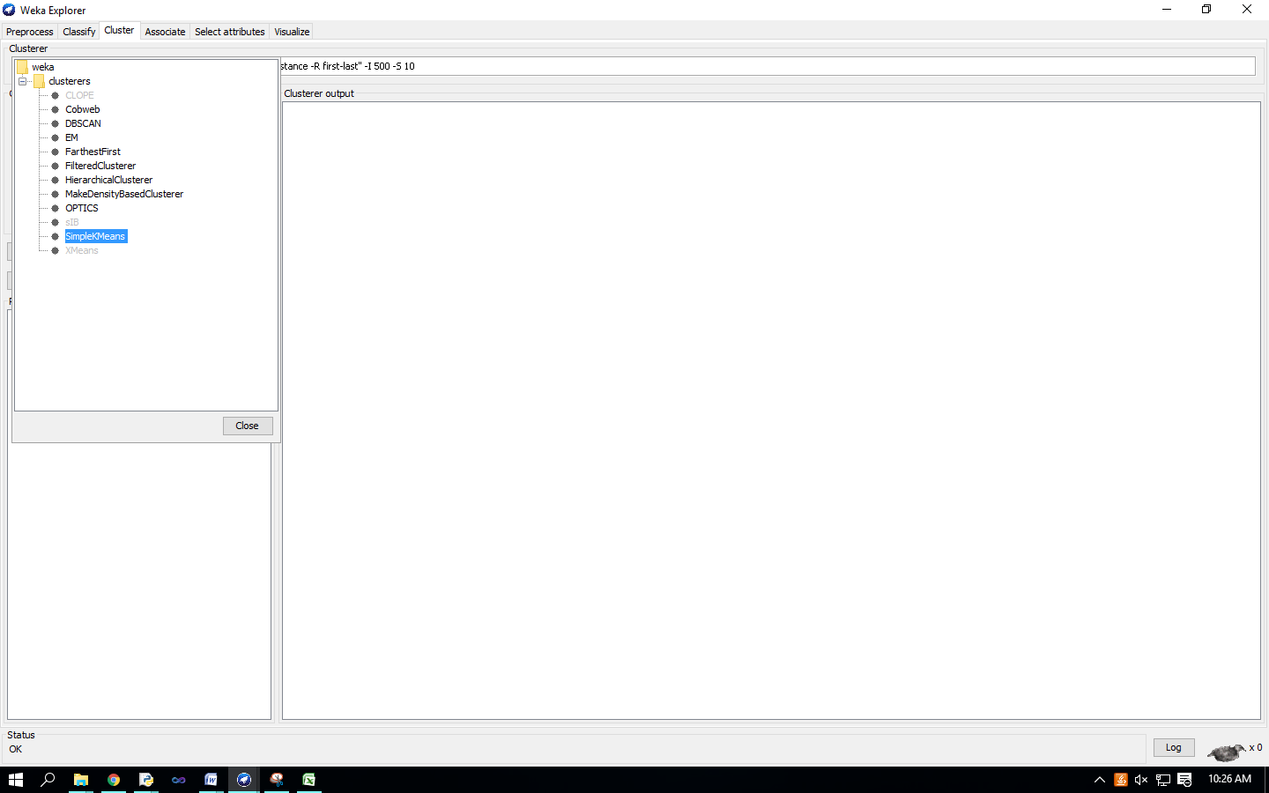

Set the value in “numClusters” box to 5(instead of default 2) because you have five clusters in your .arff file.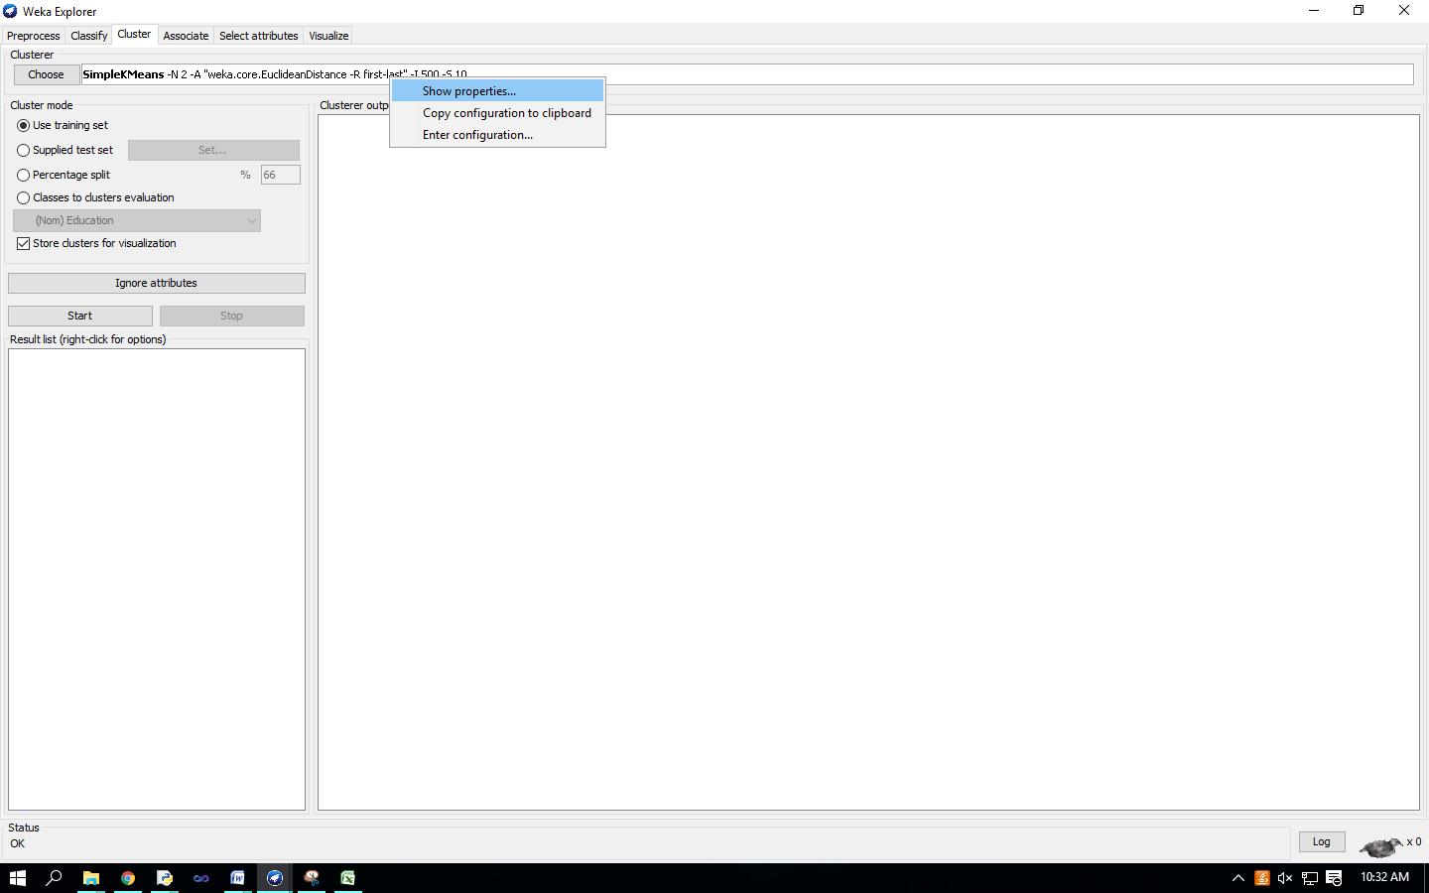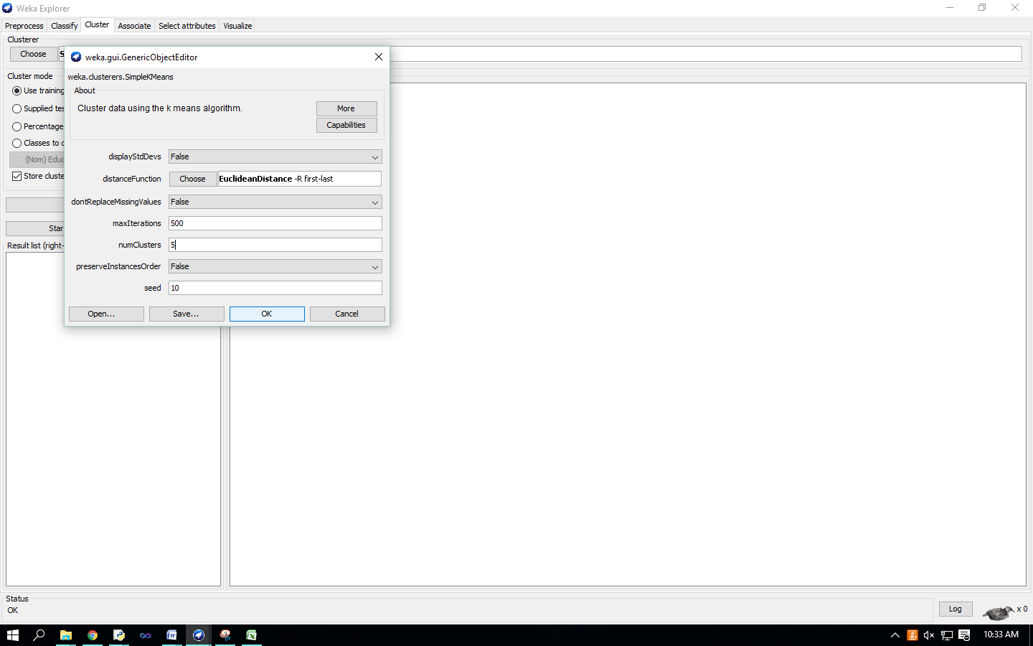

Click on ‘Classes to cluster evaluation’ radio-button in ‘Cluster mode’ box and select ‘marital_status’ in the pull-down box below. 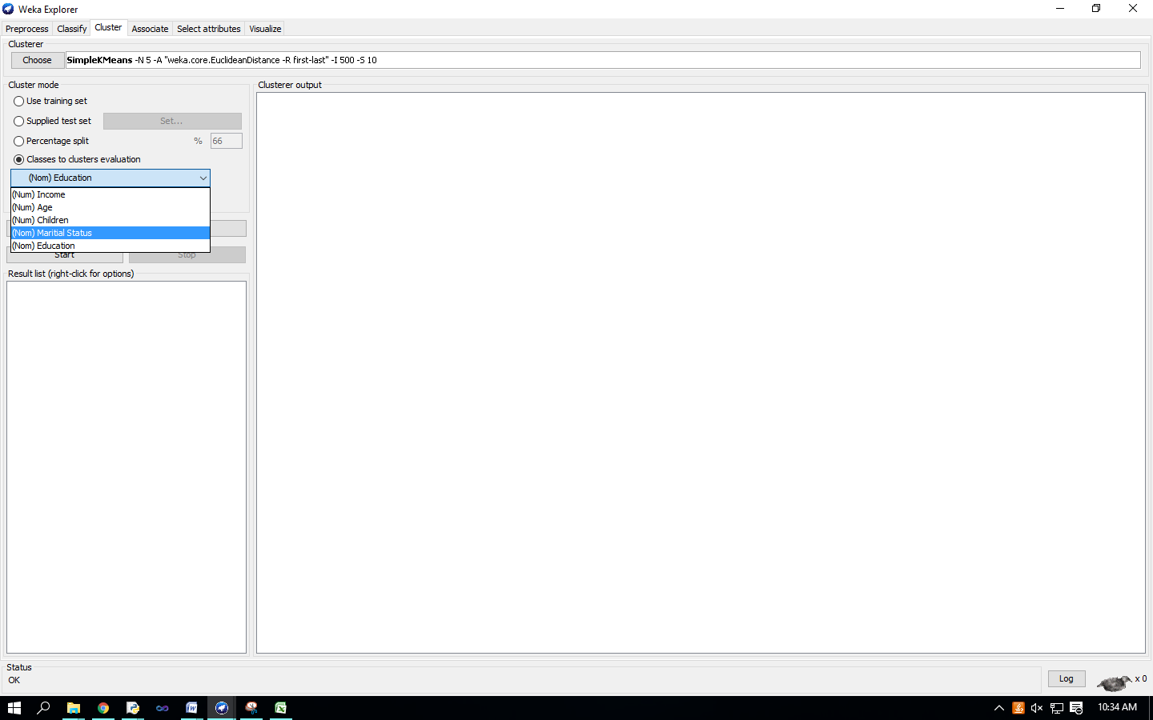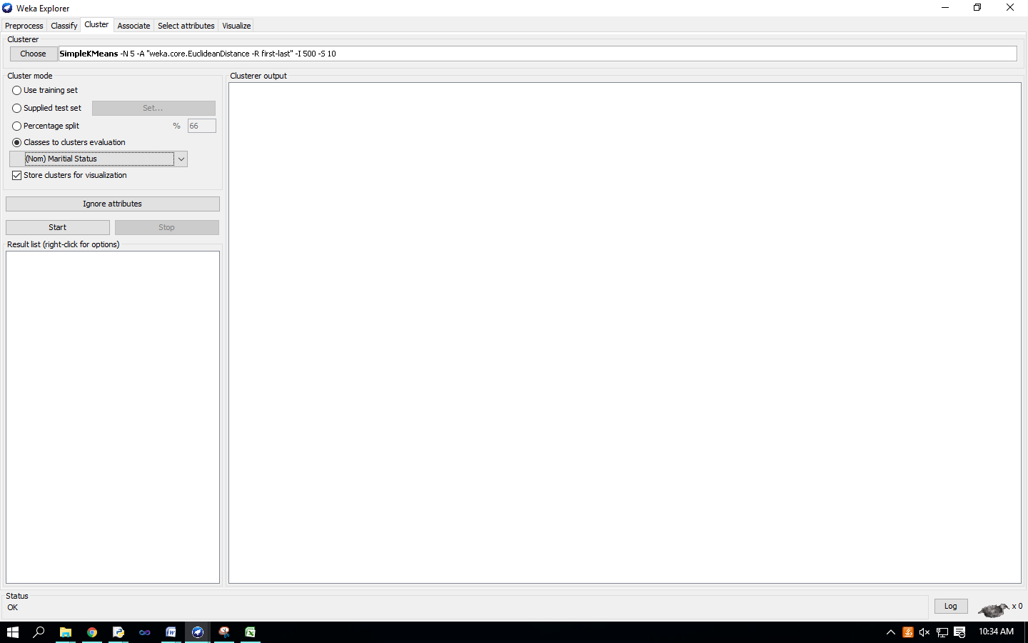

Click on the ‘Start’ button to execute the algorithm. 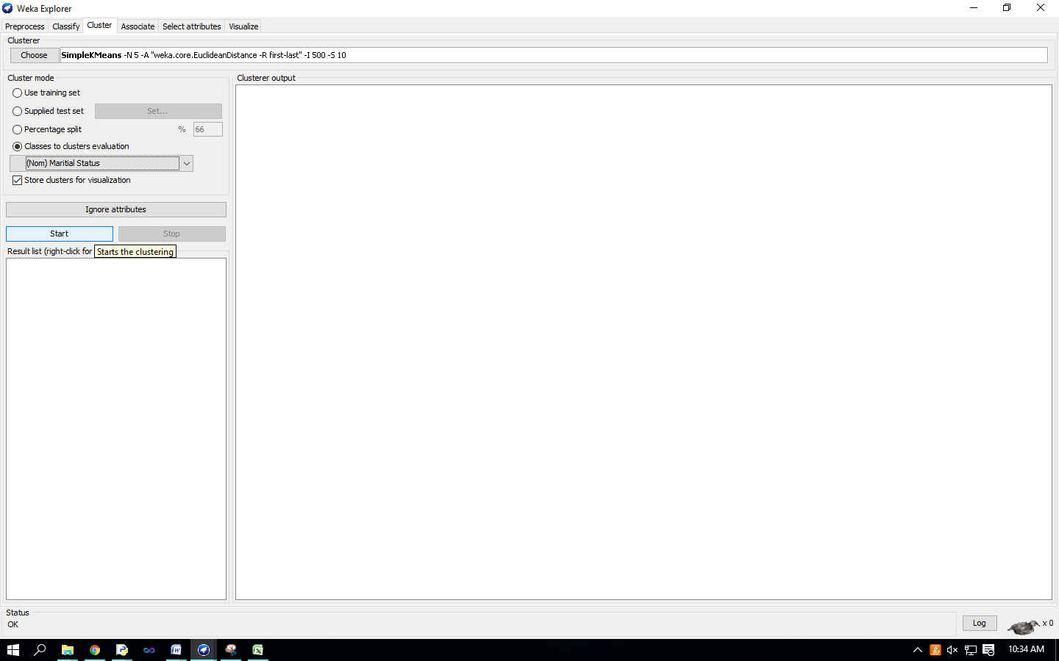

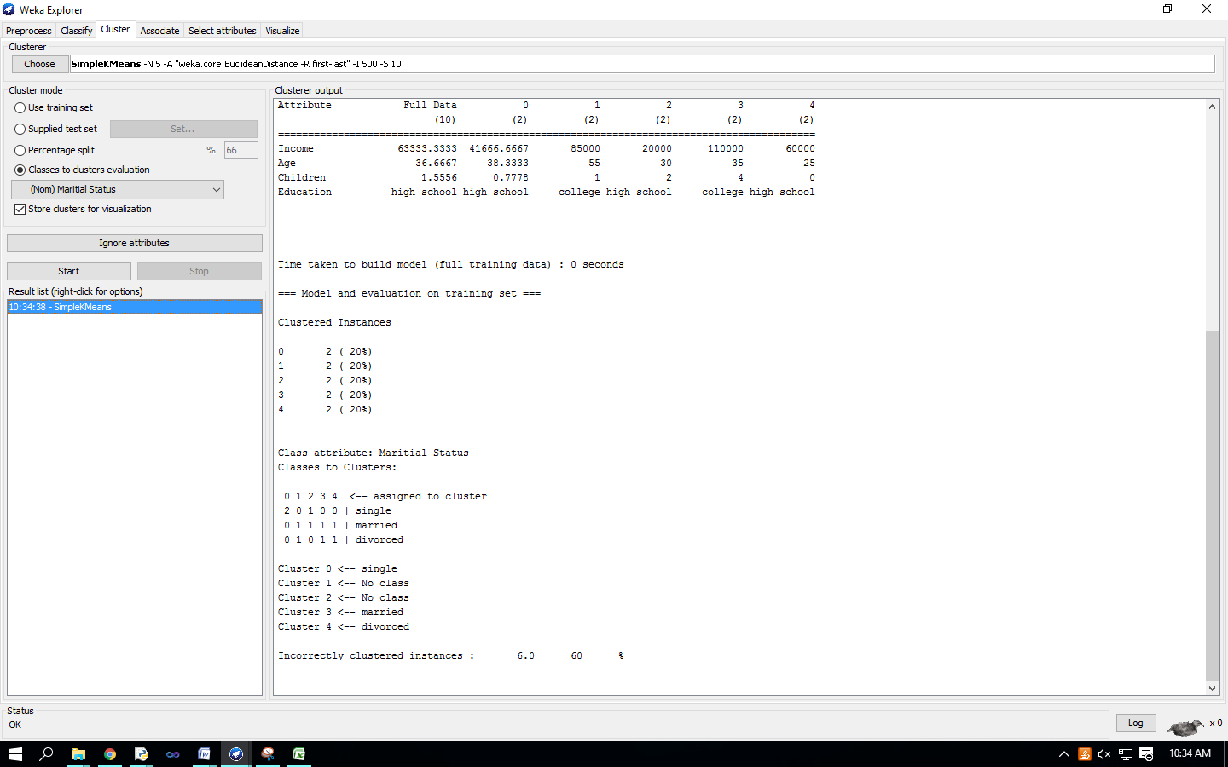

Right-click on the entry in the ‘Result list’ and select ‘Visualize cluster assignments’ in the pull-down window. 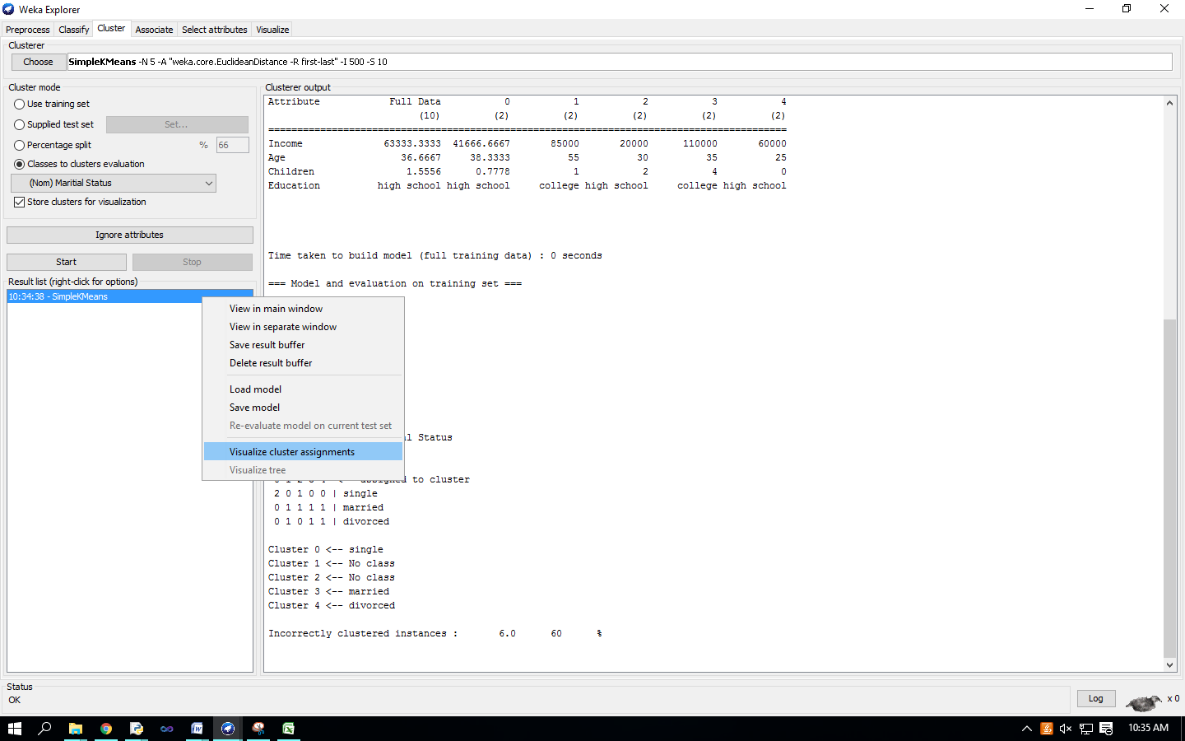‘Weka Clusterer Visualize’ window.

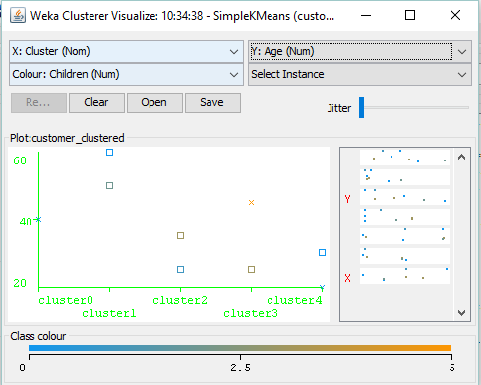

**Practical No-13**

**Aim** : Association Rule Mining.

**Solution** : Choosing Association Scheme Click ‘Associate’ tab at the top of ‘WEKA Explorer’ window. It brings up interface for the Apriori algorithm. 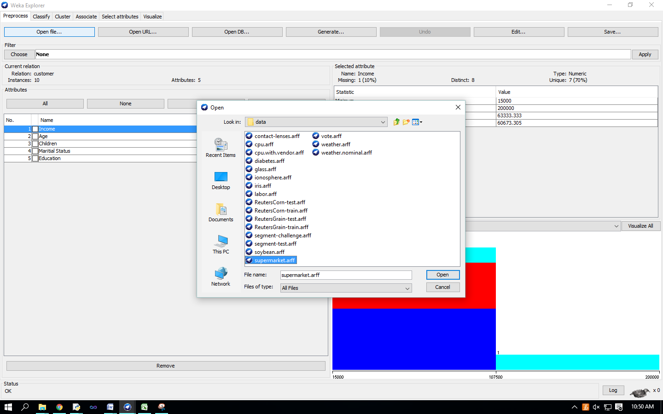

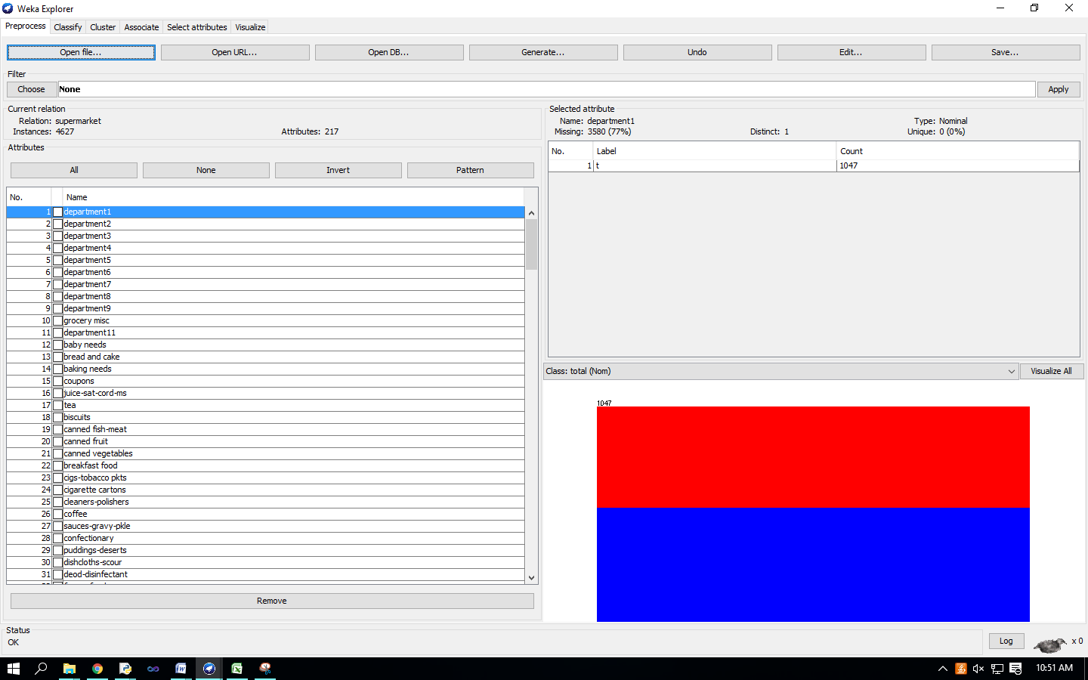Setting Test Options

Check the text field in the ‘Associator’ box at the top of the window

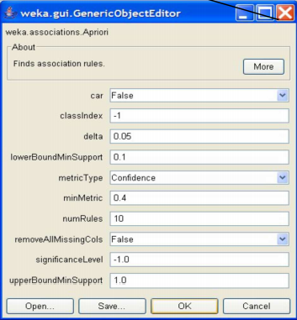

Right-click on the ‘Associator’ box, ‘GenericObjectEditor’ appears on your screen Click on the ‘Start’ button to execute the algorithm